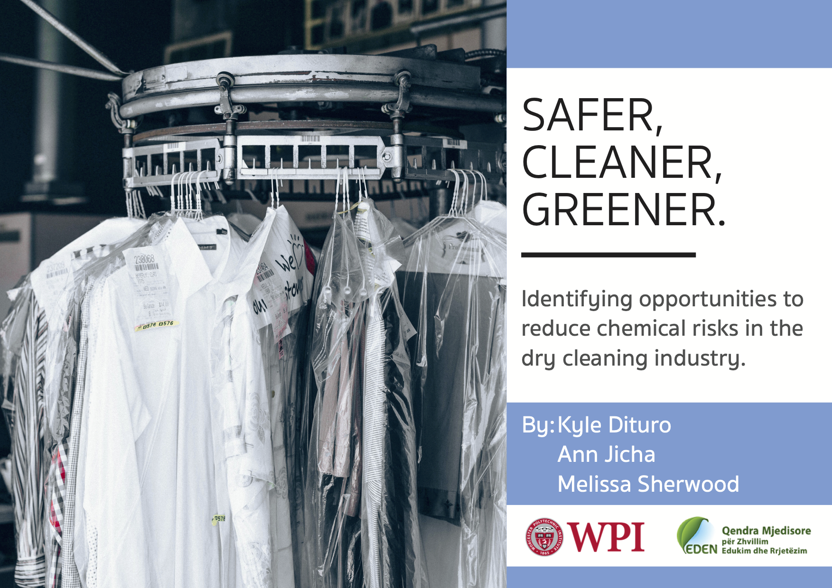

# 

**Safer, Cleaner, Greener:**

Identifying Opportunities to Reduce Chemical Risks in the Dry Cleaning Industry

# An Interactive Qualifying Project

# submitted to the Faculty of

# WORCESTER POLYTECHNIC INSTITUTE

# in partial fulfilment of the requirements for the

# degree of Bachelor of Science

in cooperation with

The Environmental Center for Development Education and Networking

Submitted on December 11, 2019

|  |  |  |
| --- | --- | --- |
| Submitted by:  Kyle Dituro  Ann Jicha  Melissa Sherwood |  | Submitted to:  Jonida Mamaj-Hafizi, Project Coordinator  Environmental Center for Development Education Networking  Advisors: Professor Robert Hersh  Professor Robert Kinicki |

# 

# *This report represents work of WPI undergraduate students submitted to the faculty as evidence of a degree requirement. WPI routinely publishes these reports on its web site without editorial or peer review. For more information about the projects program at WPI, see* [*http://www.wpi.edu/Academics/Projects*](https://nam03.safelinks.protection.outlook.com/?url=http%3A%2F%2Fwww.wpi.edu%2FAcademics%2FProjects&data=02%7C01%7Cmjsherwood%40wpi.edu%7Cecdfba6e3bc44407d44b08d77db591ce%7C589c76f5ca1541f9884b55ec15a0672a%7C0%7C0%7C637116091091456133&sdata=s8EipxFuUMAoUbPFo78khdacgP85sXUopaMYxa3YdDk%3D&reserved=0)*.*

# 

# Abstract

This project identified opportunities to reduce risk from the dry cleaning industry in Tirana, Albania. The team accomplished this by surveying dry cleaners and interviewing regulators. Additionally, to understand the public's knowledge of dry cleaners, we created an online survey. Research findings include that the dry cleaning industry in Tirana is largely unaware of safer practices available to them. In addition, dry cleaners are unwilling to switch to chemical alternatives due to financial limitations and low customer support. Our results show that the Albanian public is unaware of the dangers posed by chlorinated solvents used in dry cleaning. Recommendations include an activism campaign for our sponsor EDEN Center and offer strategies to dry cleaners to make their operations safer.

# Acknowledgements

Our team would like to thank all individuals and organizations that helped us make this project a success.

* Our Advisors Robert Hersh and Robert Kinicki, for their insightful feedback
* Jonida Mamaj-Hafizi, the Program Coordinator of Environmental Management Practices, for her guidance of this project
* Our Sponsor, Environmental Center for Development, Education and Networking
* Hera Kamani, for translating our surveys and interviews
* All other EDEN Center Employees and Volunteers
* Peter Christopher, for his insights and advice for us before coming to Albania
* All the dry cleaners that completed our surveys

# 

# Executive Summary

**Background**

The dry cleaning industry is a small but significant industry in terms of the impact it has on the environment and the health of anyone involved in the industry. The typical process of dry cleaning involves a hazardous chemical called perchlorethylene that can cause serious health and environmental effects. The chemical is a known carcinogen and is specifically harmful to those with continued exposure through activities such as operating a dry cleaning machine (EPA Integrated Risk Information System Division, 2012). Additionally, it can easily diffuse into the air and seep into water sources, significantly altering the environment in the process. Vapor intrusion, the process of volatile chemicals migrating into buildings above the contamination site, is one of the main methods of exposure to hazardous chemicals (Huang, Lei, Wei & Zeng, 2014). By taking precautions and obtaining training on how to handle the chemical, dry cleaners can significantly decrease their exposure to these hazardous substances they are exposed to. These precautions include regular inspections, extensive protective equipment and proper ventilation of the dry cleaner itself (OSHA, 2005). There are alternatives available to eliminate the need for perchlorethylene and the hazards it produces. Specific Alternatives include alcohol or water based wet cleaning or petroleum based solvents, such as high flash hydrocarbons (TURI, 2012). By decreasing or eliminating the amount of exposure in a dry cleaner, the business can obtain an overall better quality of life for themselves and their employees while simultaneously benefiting the environment.

The goal of this project was to identify opportunities to reduce risks to dry cleaning employees, the public, and the environment from the chemicals used in the dry cleaning businesses of Tirana, Albania. This was achieved through the following objectives:

1. Map dry cleaners currently operating in Tirana
2. Identify the current dry cleaning practices within Tirana
3. Determine the perspectives of dry cleaners on adopting greener practices
4. Determine the perspectives of the public on greener dry cleaning practices
5. Provide recommendations for safer practices and alternatives to hazardous chemicals

**Methods**

We devised extensive methods (see Figure 1) to complete our objectives that included research, surveys with dry cleaners and the public, and interviews of ministries and dry cleaners. Our first step was to map the locations of the dry cleaners around Tirana using Google maps and by walking through the city of Tirana (see Figure 2). After mapping, we completed surveys of dry cleaners in specific neighborhoods, totaling 15 surveys of the 30 dry cleaners we visited. This helped glean information on current dry cleaning practices regarding their usage of hazardous chemicals, how they manage them, and their perspectives on alternatives to perchlorethylene. The next step involved further narrowing down the list of dry cleaners to perform semi-structured interviews about more specifics of their processes. Additionally, we conducted an online survey of public citizens of Tirana to gauge their understanding of the dry cleaning industry and the role they may play in adopting greener solutions. Finally, by accumulating, processing and analyzing all our data, this investigation provides recommendations for dry cleaners, EDEN Center and Regulators in order to improve the general safety of the dry cleaning business in Tirana.

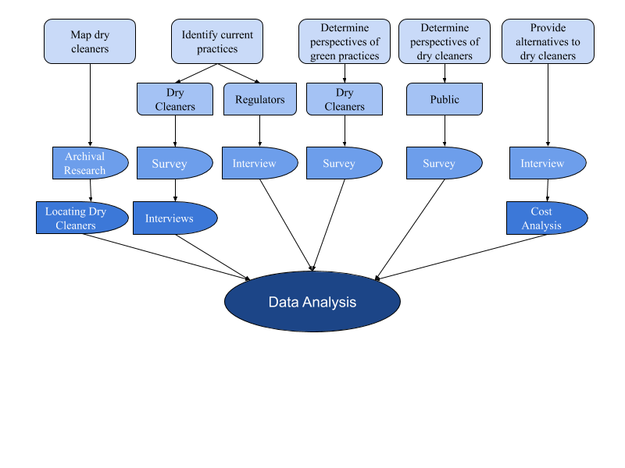

**Figure 1: Map of the Teams Methods**

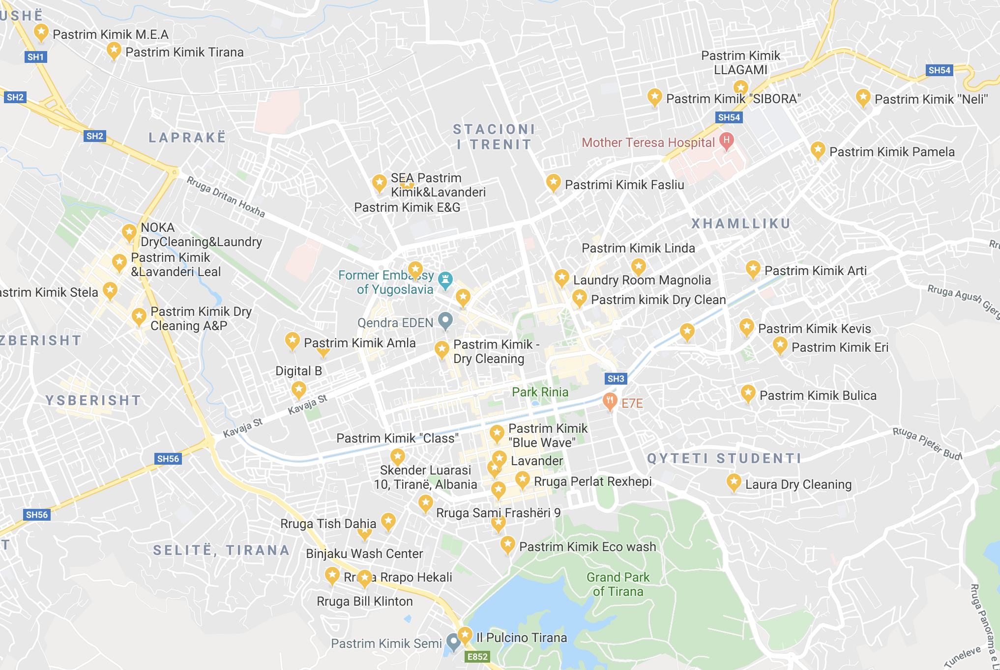

**Figure 2: Map of the Dry Cleaners in Tirana, Albania**

**Findings**

*Regulation*

Albanian regulation of the dry cleaning industry is not centralized. As in the United States, there is very little specific regulation for dry cleaners, and most of the oversight of the industry relates to the chemicals used in the process. Currently, the primary groups that deal with chemicals management of the dry cleaners are the National Environmental Agency and the Ministry of Tourism and Environment.

Albanian legislation related to dry cleaners is currently limited by finite regulatory resources including time, funding, and employees. Because of these limitations, the government is unable to create and enforce sufficient requirements to inform dry cleaning employees about mitigating risks induced by certain dry cleaning chemicals.

*Dry Cleaners*

In dry cleaning shops based in Tirana, perchlorethylene is the most commonly used solvent, and dry cleaners are ill prepared to manage the risk of handling the hazardous chemical. This lack of preparation stems from the fact that the Albanian government’s regulation towards dry cleaners is incomplete and potentially ineffective.

One of the key aspects of perchlorethylene management is regularly inspecting machines. Most of our sampled dry cleaners only inspected or checked on their machines when an obvious problem occurred, as opposed to a recommendation by the government of every six months. The number of dry cleaners who did not regularly inspect their machines is cause for concern. Inadequate machine venting was also an issue within the dry cleaners the group surveyed. The addition of venting in dry cleaners can decrease the amount of health effects from exposure to hazardous vapors. Several dry cleaning stores partially utilized personal protection equipment. However, most dry cleaners only received training on how to use the machine. This limited style of training practices may be unsafe to workers who are not taught how to properly manage perchlorethylene in the workplace when necessary.

Dry cleaners were relatively unaware of alternatives to perchlorethylene. Chemical supply companies in Albania offer alternatives to perchlorethylene, but dry cleaners are unmotivated or too financially strained to adopt them. When asked about their decision on chemical solvents, dry cleaners mention they simply use what their suppliers give them. Even when dry cleaners are aware of alternatives to perchlorethylene and how beneficial they are to the operators health and the environment, financial limitations prevent them from considering ecologically friendly machines. Additionally, two dry cleaners realized that dry cleaning was more expensive than wet cleaning but felt that the high initial cost to switch machines discourages dry cleaners from switching to a more environmentally benign system. Hence, dry cleaners in Tirana are unlikely to buy new machines unless their machine breaks.

*Public*

Our project included sending online surveys out to the general Albanian public through our sponsors mailing list and social media. We received 69 total survey responses, however; since many of EDEN Center’s contacts are actively invested in environmental health and awareness, it is hard for us to generalize our respondent’s opinions as representative of public citizens of Tirana.

Our survey of the public suggests that the sampled population is unaware of the operations of dry cleaners and hazardous chemicals that are part of Albanian dry cleaning practices. Even with the skewed data, the majority of respondents did not know anything about the chemicals or steps used in the process of dry cleaning. Additionally, our survey respondents are likely to take action after learning about the effects of perchlorethylene, for example finding a dry cleaner who does not use perchloroethylene. In addition, the survey also showed that the respondents are willing to pay slightly more for dry cleaning if it is ecologically friendly.

**Recommendations**

Dry cleaners can reduce their exposure from perchlorethylene used in dry cleaning machines through proper maintenance, ventilation and use of protective equipment (masks, gloves, etc). Since dry cleaners in our survey do not replace machines unless they are broken, day-to-day operational changes, such as regular maintenance, proper venting, and extensive training, can also help reduce risk. These steps will increase the safety of the machine operators, environment and public while simultaneously reducing the emissions from the machines to unwanted areas.

For EDEN Center we recommend an environmental campaign to educate the general public on the practices of dry cleaning and how it can affect them and the environment. The campaign should promote awareness of potential dangers (vapor intrusion, water supply contamination, and cancer risks) from dry cleaners, as well as educate customers to make informed decisions relating to dry cleaning, without being alarmist.

Since dry cleaners knowledge of training is very limited, regulators should require require dry cleaners to obtain as much information as possible from their suppliers and through well-defined employer training about the risks they are facing. This will enable them to make informed decisions about how to run their businesses and may independently make safer and more environmentally friendly choices when feasible.

# 

# Authorship

Ann Jicha is a Computer Science and Professional Writing double major with experience in technical writing.

Melissa Sherwood is a Mechanical Engineering major who has experience designing and conducting cost-benefit analysis for physical systems.

Kyle Dituro is a Math major with extensive background in systems optimization and algebra - having worked on multiple projects including the optimization of snow-plow routes in Worcester.

|  |  |  |
| --- | --- | --- |
| Section | Primary Author | Primary Editor |
| Abstract | Kyle | Ann |
| Acknowledgments | Melissa | Ann |
| Executive Summary | Melissa | Ann, Kyle |
| Chapter 1: Introduction | All | All |
| Chapter 2: Background | All | All |
| Typical Dry Cleaning Process | Melissa | Ann |
| Perchlorethylene | Kyle | Melissa |
| Waste Streams | Kyle | Melissa |
| Regulation of Perchlorethylene and Dry Cleaners in the United States | Ann | Kyle |
| Best Practices for Dry Cleaners Who Use Perchlorethylene | Ann | Melissa |
| Supporting Best Practices | Ann | Melissa |
| Green Alternatives | Melissa | Ann |
| Albanian Regulation of the Dry Cleaning Industry | Ann | Kyle |
| Our Sponsor | Ann | All |
| Chapter 3: Methods | All | Ann |
| Mapping Dry Cleaners Currently Operating in Tirana | Melissa | Ann |
| Identify the Current Dry Cleaning Practices within Tirana | Kyle | Melissa |
| Determine the Perspectives of Dry Cleaners on Adopting Greener Practices | Ann | Kyle |
| Determine the Perspectives of the Public on Greener Dry Cleaning Practices | Ann | Kyle |
| Provide Alternatives to Hazardous Chemicals or Recommendations for Greener Dry Cleaners | Melissa | Ann |
| Chapter 4: Findings | All | All |
| Dry Cleaners are Unevenly Distributed Throughout Administrative Units in Tirana | Melissa | Kyle |
| Dry Cleaners Predominantly Use Perchlorethylene as Their Solvent | Kyle | Ann, Melissa |
| Dry Cleaners Use Many Types of Machines and Cleaning Methods Within the Same Shop | Kyle | Ann |
| Dry Cleaners Have Varied Standards Of How Often to Inspect Machines | Ann | Melissa |
| There are Varied Techniques for Venting Shops Within Our Sample Population | Ann | Kyle |
| Employees Receive Incomplete Training On Machines, Perchlorethylene, and Protective Equipment | Ann | Ann |
| Dry Cleaners Have a Functional Understanding of Relevant Regulation | Ann | Melissa |
| Sample Awareness of Dry Cleaning Practices | Melissa | Kyle |
| Dry Cleaners are Unaware of Green Practices Within Their Industry | Melissa | Melissa |
| Dry Cleaners are Unwilling to Adopt Greener Practices due to Financial Limitations and Apathy from Their Customers | Melissa | Ann |
| Survey Participants were Generally Unaware of the Chemicals and Processes of the Dry Cleaning Industry | Kyle | Melissa |
| Survey Respondents are Likely to Take Action but Not Pay Significantly More for Greener Dry Cleaning Practices | Kyle | Ann |
| Chapter 5: Recommendations | Melissa | Ann |
| Recommendations for Dry Cleaners | Melissa | Ann |
| Recommendations for the Public | Melissa | Kyle |
| Recommendations for Regulators | Ann | Kyle |
| Chapter 6: Conclusions | Ann, Kyle | Melissa |

# Table of Contents

**Abstract** **2**

**Acknowledgements** **3**

**Executive Summary** **4**

**Authorship** **9**

**Table of Figures** **14**

**Table of Tables** **16**

**Chapter 1: Introduction** **17**

**Chapter 2: Background** **19**

2.1 Common Dry Cleaning Practices and Associated Risks 19

Typical Dry Cleaning Process 19

Perchlorethylene 23

Waste Streams 24

Regulation of Perchlorethylene and Dry Cleaners in the United States 26

2.2 Risk Reduction and Best Practices 29

Best Practices for Dry Cleaners Who Use Perchlorethylene 29

Green Alternatives 33

2.3 Dry Cleaning Industry of Albania 36

Albanian Regulation of The Dry Cleaning Industry 36

2.4 Environmental Center for Development Education and Networking 41

**Chapter 3: Methods** **42**

3.1 Mapping Dry Cleaners Currently Operating in Tirana 43

Online Background Research 43

Locating Dry Cleaners 45

3.2 Identify the Current Dry Cleaning Practices within Tirana 45

Survey of Dry Cleaners 45

Semi-Structured Interviews with Dry Cleaners 48

Interviews with Regulators 48

3.3 Determine the Perspectives of Dry Cleaners on Adopting Greener Practices 49

Survey of Dry Cleaners 49

3.4 Determine the Perspectives of the Public on Greener Dry Cleaning Practices 50

Survey of the Public 50

3.5 Provide Alternatives to Hazardous Chemicals or Recommendations for a Green Dry Cleaner 51

Cost Analysis 51

**Chapter 4: Findings** **53**

4.1 Mapping 53

Dry Cleaners are Unevenly Distributed Throughout Administrative Units in Tirana 53

4.2 Current Dry Cleaning Practices in Tirana 58

Dry Cleaners Predominantly Use Perchlorethylene as Their Solvent 58

Dry Cleaners Use Many Types of Machines and Cleaning Methods Within the Same Shop 59

Dry Cleaners Have Varied Standards for Machine Inspection Frequency 59

There are Varied Techniques for Venting Shops Within Our Sample Population 60

Employees Receive Incomplete Training On Machines, Perchlorethylene, and Protective Equipment 62

Dry Cleaners Have a Functional Understanding of Relevant Regulation 64

4.3 Perspectives of Dry Cleaners on Adopting Greener Practices 65

Dry Cleaners are Unaware of Green Practices Within Their Industry 65

Dry Cleaners are Unwilling to Adopt Greener Practices due to Financial Limitations and Apathy from Their Customers 66

4.4 Perspectives of Public on Greener Dry Cleaning Practices 66

Survey Participants were Generally Unaware of the Chemicals and Processes of the Dry Cleaning Industry 67

Survey Respondents are Likely to Take Action but Not Pay Significantly More for Greener Dry Cleaning Practices 69

**Chapter 5: Recommendations** **72**

5.1 Recommendations for Dry Cleaners 72

5.2 Recommendations for the Public 73

5.3 Recommendations for Regulators 73

**Chapter 6: Conclusions** **74**

**References** **75**

**Appendix A: Perchlorethylene Alternative Assessment Fact Sheet** **80**

**Appendix B: Summarized American Standards** **82**

**Appendix C: New Jersey Dry Cleaner Checklist** **86**

**Appendix D: In-Person Survey and Interview Considerations** **89**

**Appendix E : Tirana Dry Cleaner In-Person Survey Protocol** **91**

**Appendix F: Regulator Interview Protocol** **94**

**Appendix G: Public Survey Protocol** **96**

**Appendix H: Dry Cleaning Chemical Distributor Interview Guide** **102**

**Appendix I: Dry Cleaner Interview Guide** **105**

**Appendix J: Figures Not Used** **107**

**Appendix K: Deliverables** **112**

# Table of Figures

|  |  |
| --- | --- |
| Figure 2.1: Dry Cleaning Process with Inputs and Emissions | 3 |
| Figure 2.2: Perchlorethylene Based Dry Cleaning Flow Diagram | 4 |
| Figure 2.3: Transfer Machine vs. Dry-to-Dry Machine | 5 |
| Figure 2.4: Industrial Dryer Used in Dry Cleaners | 6 |
| Figure 2.5: Perchlorethylene Health Effects by Tier | 8 |
| Figure 2.6: Effects of Perchlorethylene on the Environment | 8 |
| Figure 2.7: Example of Vapor Intrusion | 9 |
| Figure 2.8: Worker Tips for Limiting Perchlorethylene Exposure | 16 |
| Figure 2.9: Dry Cleaner Approval Flow Diagram | 22 |
| Figure 2.10: Data Verification Flow Diagram | 23 |
| Figure 3.1 Project Flow Diagram | 26 |
| Figure 3.2: Map of Municipal Units of Tirana with Chosen Units Highlighted | 28 |
| Figure 3.3: Map of the Five Municipal Units Surveyed in Tirana | 31 |
| Figure 4.1: Dry Cleaners Located in Unit 5 of Tirana | 38 |
| Figure 4.2: Dry Cleaners Located in Unit 6 of Tirana | 38 |
| Figure 4.3: Dry Cleaners Located in Unit 1 of Tirana | 39 |
| Figure 4.4: Dry Cleaner Shop Fronts | 40 |
| Figure 4.5: Total Tirana Dry Cleaners Surveyed by Unit | 41 |
| Figure 4.6: Reasons Dry Cleaners Gave to Not be Surveyed | 41 |
| Figure 4.7: Chemicals Used by Dry Cleaners - Perc or Not Perc | 42 |
| Figure 4.8: Chemicals Used in Dry Cleaners | 43 |
| Figure 4.9: Frequency of Machine Inspection by Dry Cleaners | 44 |
| Figure 4.10: Dry Cleaner Ventilation Method | 45 |
| Figure 4.11: Employee Knowledge of Perchlorethylene Management | 47 |
| Figure 4.12: Protective Equipment Training | 48 |
| Figure 4.13: Dry Cleaner Perception of Regulation | 49 |
| Figure 4.14: Sample Familiarity with the Process of Dry Cleaning | 51 |
| Figure 4.15: Answers to True/False Survey Questions | 52 |
| Figure 4.16 Proximity of Respondents to Dry Cleaners | 53 |
| Figure 4.17: Likeliness of the Sample Population to Take Action | 54 |
| Figure 4.18: Customer Willingness to Pay More for Greener Practices | 55 |
| Figure A.1: Perchlorethylene Alternative Assessment Fact Sheet | 64 |
| Figure A.2: Financial Comparison of Perchlorethylene Alternatives | 65 |
| Figure G.1 Survey Logic | 82 |
| Figure J.1: Age of Respondents | 91 |
| Figure J.2: Gender of Respondents | 91 |
| Figure J.3: Residence of Respondents | 92 |
| Figure J.4: Awareness of Dry Cleaning Practices for People Who Live Near Dry Cleaners | 92 |
| Figure J.5: Importance of Factors to Respondents | 93 |
| Figure J.6: True/False Results for Respondents Who Live NEar Dry Cleaners | 93 |
| Figure J.7: Respondent’s Reasoning for not Using Dry Cleaners | 94 |
| Figure J.8: Reasons to Learn More About Dry Cleaning Processes | 94 |
| Figure J.9: Concern About the Risks of Dry Cleaning | 95 |

# Table of Tables

|  |  |
| --- | --- |
| Table 2.1: Pros and Cons of Wet Cleaning | 18 |
| Table 2.2: Pros and Cons of High Flash Hydrocarbon | 20 |
| Table 2.3: Cost Analysis of Perchlorethylene Alternatives | 24 |
| Table 3.1: Socio-Economic Variables of Tirana Units | 28 |
| Table 3.2: Cost Analysis Table | 36 |
| Table B.1: OSHA Regulation Summary | 66 |
| Table B.2: OSHA Worker Exposure Limits | 67 |
| Table B.3: EPA Regulation Summary | 67 |
| Table D.1: Introduction Questions in English | 73 |
| Table D.2: Introduction Questions in Albanian | 74 |
| Table E.1: Dry Cleaner Survey Question in English | 75 |
| Table E.2: Dry Cleaner Survey Question in Albania | 76 |
| Table F.1: Regulator Interview Questions in English | 78 |
| Table F.2: Regulator Interview Questions in Albanian | 79 |
| Table G.1: Public Survey Questionnaire in English | 80 |
| Table G.2: Public Survey Questionnaire in Albanian | 83 |
| Table H.1: Dry Cleaning Chemical Distributor Guiding Questions in English | 86 |
| Table H.2: Dry Cleaning Chemical Distributor Guiding Questions in Albanian | 87 |
| Table I.1: Dry Cleaning Guiding Questions in English | 89 |
| Table I.2: Dry Cleaning Guiding Questions in Albanian | 90 |

# 

# Chapter 1: Introduction

Many people around the world consider dry cleaning a commonplace and relatively harmless industry, yet serious health risks can arise from the typical dry cleaning process (EPA, 2012). These health risks stem from the solvent used in the dry cleaning process. Dry cleaners often use a hazardous solvent known as perchlorethylene (also known as perc) in order to clean items. Due to its non biodegradability as a chlorinated organic compound, perchlorethylene that escapes into the environment remains there (Huang, Lei, Wei & Zeng, 2014). In high doses over prolonged periods, the hazardous vapors can cause esophageal, lung and respiratory cancer (EPA, 2012). With acute exposure to perchlorethylene; neurological and physical damage, cancer, or even death can occur.

In order to minimize the negative effects of the chemicals used by the dry cleaning industry, organizations such as the Environmental Protection Agency (EPA), Occupational Safety and Health Administration (OSHA) and state agencies such as the Massachusetts Department of Environmental Protection (MassDEP) in the United States have developed standards and regulations. These regulations contain common workplace standards (related to ergonomic practices, basic fire prevention) and statements focusing on hazardous solvent management in order to protect workers (OSHA, 2005). There is also regulation targeted at dry cleaner waste disposal, in order to preserve the environment and minimize the impact of hazardous substances (EPA, 2015). Dry cleaning trade associations, and various state regulatory agencies help dry cleaners comply with regulations through summarizing documents, checklists, and trainings. (MassDEP, 2015). Stringent regulations combined with compliance assistance has made the dry cleaning industry safer.

Albanian legislation related to dry cleaners shares the same goals but is much less complete. Legislative and regulatory bodies are currently unusually limited by finite regulatory resources including time, funding, and employees. Because of these limitations, the government is unable to create or and enforce sufficient requirements for dry cleaners to inform themselves about chemical risk reduction techniques.

Dry cleaners have options to eliminate or reduce their reliance on perchlorethylene. ‘Green’ dry cleaners use chemical alternatives to perchlorethylene such as silicon or petroleum based solvents, in an effort to make the dry cleaning process safer (Green Dry Cleaning Solvents, 2017). Another alternative to a dry cleaning machine is a process called wet cleaning. This process uses water, biodegradable soaps and gentle washing to clean garments instead of chlorinated solvents that normally involve perchlorethylene (“WetCleanersUSA”, 2017). There is also new technology available that increases the amount of perchlorethylene that the machines reuse between cycles; allowing dry cleaners who wish to continue using perchlorethylene to still increase worker safety. So-called dry-to-dry closed looped machines operate in a closed system which continuously recycles perchlorethylene and limits worker exposure (OSHA, 2005).

In an attempt to help address dry cleaning industry safety, our sponsor, the Environmental Center for Development Education and Networking (EDEN Center) wanted to get a clearer picture of this rarely studied industry. Their primary goal was to explore to what extent dry cleaners know about potential risks to employees, the public, and the environment from hazardous chemicals in their workplace. They also wished to explore strategies to mitigate risks that Albanian dry cleaners are implementing or could implement in the future.

The goal of this project was to identify opportunities to reduce risks from dry cleaning operations in Tirana to employees, the environment, and the public. To accomplish this, the team mapped the current dry cleaning businesses in Tirana, conducted surveys of dry cleaners, and the public, and in-depth stakeholder interviews. The team found that the sampled dry cleaners in Tirana are largely unaware of greener practices. Sampled dry cleaners broadly adhere to safety baselines, but they do not feel a sense of urgency to increase safety measures. These businesses are also unable to switch to safer, greener alternative systems due to financial burdens and low support from their customer base. Additionally, the team discovered that the general public has minimal knowledge of the risks and environmental impact of dry cleaning. After analyzing our findings, we drafted educational material to increase awareness of potential chemical risks, and created a list of recommendations for safer practices.

# Chapter 2: Background

## 2.1 Common Dry Cleaning Practices and Associated Risks

### Typical Dry Cleaning Process

Usually, a dry cleaning process consists of four steps illustrated in Figure 2.1. The first is when the dry cleaner receives the clothes from the customers and inspects the stains on the clothes. If there are large, visible stains on the garments, the stains are pretreated with chemicals before being washed. The clothes are then sorted into categories by weight, color and fabric type (Gary, Lynda, & Avima, 2011). The operator places them in a large dry cleaning machines that automatically fills with a liquid solvent. Depending on the type of dry cleaner, the solvent is either petroleum based or a synthetic solvent. Synthetic solvents, such as perchlorethylene and trichlorotrifluoroethane, are more common and carcinogenic (EPA, 1981).

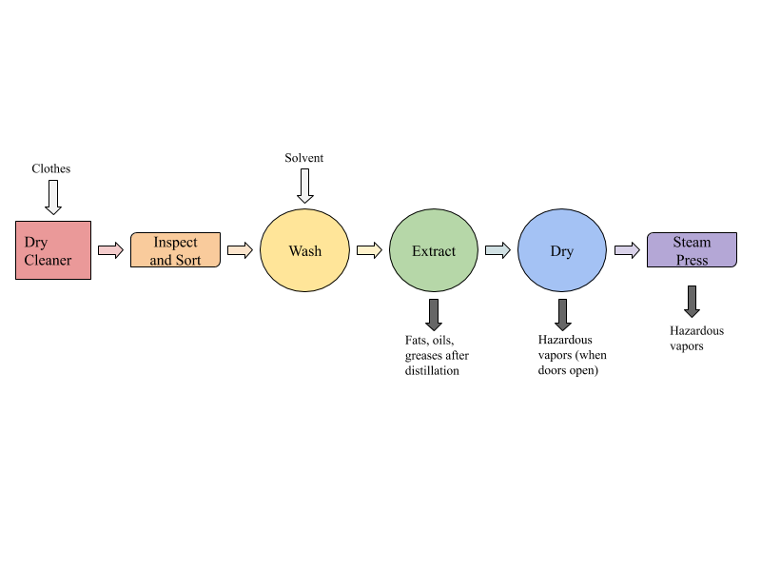

**Figure 2.1: Dry cleaning Process with Inputs and Emissions**

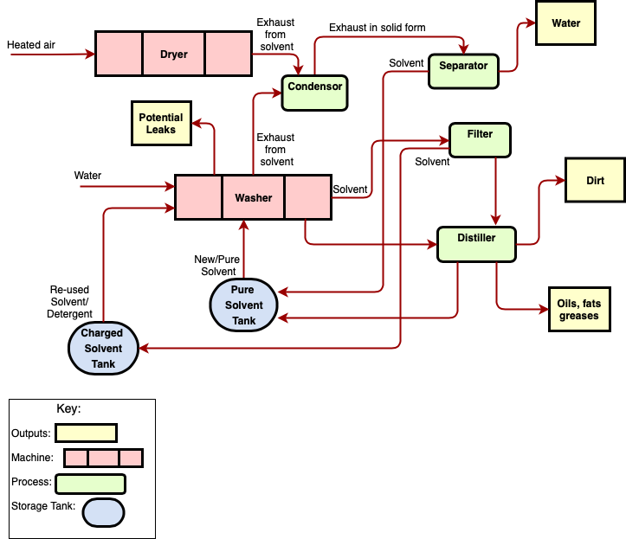

**Figure 2.2: Perchlorethylene Based Dry Cleaning Flow Diagram**

Figure 2.2 outlines a typical process that uses perchlorethylene in a dry cleaning machine along with ways the solvent can be reused, where it is emitted, and potential leaks. Usually, a synthetic machine, contains two solvent tanks; one pure solvent and the other “charged” solvent. Charged solvent contains water and detergent in addition to already used solvent. The clothes are typically cleaned in the charged solvent and then rinsed in the pure solvent tank. While the clothes are inside the machine, they are gently rotated to loosen the dirt from the stains. Next, the dirt is filtered out of the machine through a distillation process (EPA, 1981). Once all of the dirt and stains are removed from the clothes, part of the solvent is filtered and returned to the charged solvent tank. The small remaining part, that did not fit through the filter, is distilled to separate any oils, fats or greases in the solvent that were not removed during filtration. Once distilled, the solvent is returned to the pure solvent tank for reuse. The clothes are then dried by tumbling them in heated air to extract all the solvent still on the clothes. Solvent can also be recovered from the drying process via a carbon absorber attached to a refrigerated condenser. This condenser removes about 2,000-8,6000 ppm of perchlorethylene vapors from the air, which is a very significant amount. The system is a closed-loop because no vapor escapes to the outside atmosphere, reducing the hazardous risks to operators and the environment. The carbon absorber comes into play during the cool down cycle when the carbon absorbs the perchlorethylene vapors in the air until normal concentration levels are reached (Grout and Sinsheimer, 2004). After the solvent is recovered from these processes, it is sent back to the pure solvent tank to be reused on the next wash (CDC, 1997). Finally, the clothes are removed after drying and pressed to evaporate any remaining solvent on the clothes and remaining odor that results from soaking in the solvent (Gary, Lynda, & Avima, 2011). When the remaining hazardous solvent evaporates from the clothes, it turns into a hazardous vapor instead which is harmful to breathe. This is one specific reason ventilation and regulation of dry cleaners is very important to consider.

There are two types of typical dry cleaning machines, transfer machines and dry-to-dry machines. The main difference between the two is that dry-to-dry machines complete the entire process in one machine, whereas there are two separate washing and drying machines in a transfer process. The machines look very similar, as shown in Figure 2.3, however transfer machines require an industrial dryer that is separate from the washer (Figure 2.4). Another difference between the two is that transfer machines can use petroleum solvents or synthetic solvents but dry-to-dry machines only use synthetic solvents (EPA, 1981).

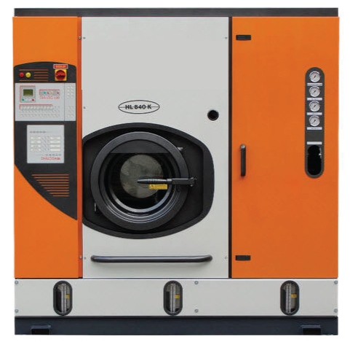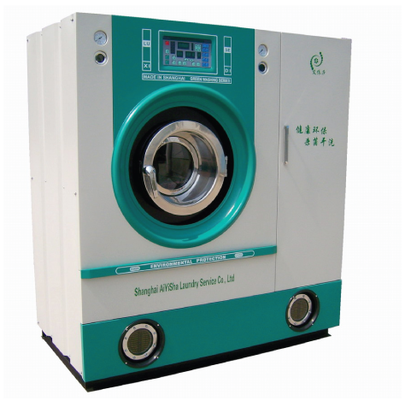

**Figure 2.3: Transfer Machine (left) vs Dry-to-Dry Machine (right)**

**(*Dry Cleaning Chillers)***

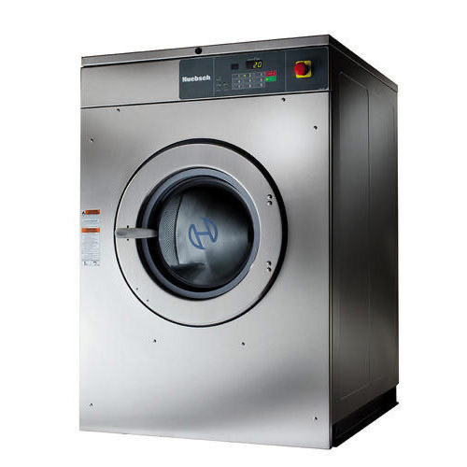

**Figure 2.4: Industrial Dryer used in Dry Cleaners (*Industrial Drying Machine*)**

Transfer machines are older and require an operator to manually switch the clothes from washing to drying machines. This step exposes operators to the hazardous solvents typically used in a dry cleaning machine. The exposure is significant because the operator not only directly touches the solvent soaked clothes but also opens the door of the machine, letting hazardous vapor leak out into the air. This due to the solvent inside the machine producing a vapor while the clothes are soaking and becoming clean. United States factories no longer manufacture transfer machines due to the extreme risks they impose on the operators, however, some dry cleaners might still use these outdated machines inside their shops (Gary, Lynda, & Avima, 2011).

There are two types of dry-to-dry machines, vented or ventless. Vented dry-to-dry machines have the ability to vent the solvent vapors produced during the process to either the atmosphere outside the dry cleaner or to a recovery system to decrease exposure to hazardous vapors. On the other hand, ventless machines do not have this ability and act as closed systems until the door the operator opens the door. In this system, once the operator opens the machine door the ventless machine will discharge hazardous chemical vapor to the environment inside the dry cleaner. While the door is closed, the ventless machine recovers the vapor and sends it back to the drying drum of the machine. As a consequence of this process, large portions of solvent still remain in the drying drum (CDC, 1997)

### 

### Perchlorethylene

Perchlorethylene - commonly shortened to “perc” - is a powerful solvent most commonly used in the dry cleaning process. In some estimates, about 80% of dry cleaners utilize perchlorethylene in their operations (Bureau of Toxic Substance Assessment New York State Department of Health, 2015). Due to its potency as a solvent, it is adept at removing stains from fabric.

While an effective stain remover, perchlorethylene also poses risks to those who are exposed to it as vapor. In concentrations of the air higher than 100 ppm over an eight hour time period, perchlorethylene has been shown to increase the chances of developing cancers such as Non-Hodgkin's lymphoma and bladder cancer (Papker, Bahlman, Leidel, Stein, Thomas, Wolf, Baier, 2016). The EPA has published an extensive report regarding the toxicity of perchlorethylene, citing liver cancer, esophageal cancer, lung and respiratory cancer, cancer of the immune system, and reproductive cancer resulting from chronic overexposure to perchlorethylene. Acute exposure to high levels of perchlorethylene can be fatal. Researchers and experts have not determined a specific threshold of overexposure to cause cancer, as the level of exposure to cause cancer is different in every case study. There are no specific, agreed upon numbers for the level of exposure that cancer starts to become a risk as the findings vary greatly throughout case studies. However, exposure to the solvent every day increases the risk of developing cancer (EPA Integrated Risk Information System Division, 2012). Researchers have also shown that perchlorethylene to have neurological and physical effects in high doses. Numerous human and animal studies have provided evidence to suggest that exposure to perchlorethylene negatively affects faculties such as color vision, visuo-spatial memory, vigilance, information processing, and reaction time (EPA Integrated Risk Information System Division, 2012). Generally, literature regarding perchlorethylene categorizes the negative effects into three categories: acute effects, chronic effects, and cancer hazards. See Figure 2.5 for detailed effects from each tier.

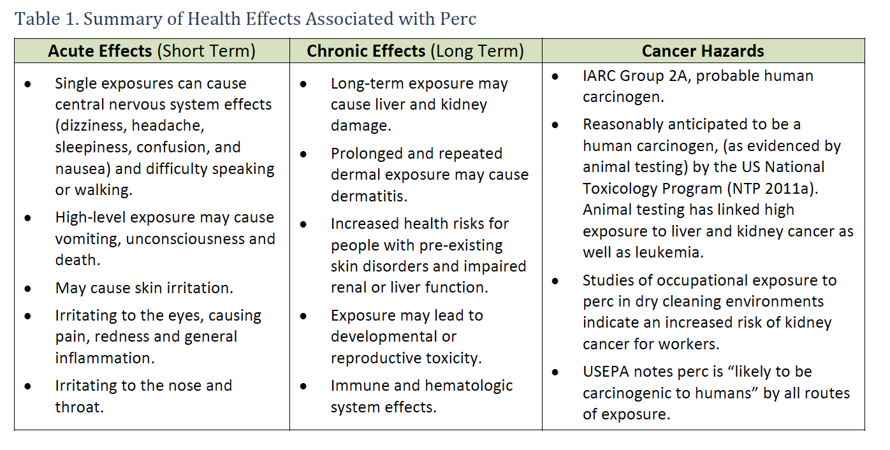

**Figure 2.5: Perchlorethylene Health Effects by Tier (TURI, 2012)**

### 

### Waste Streams

Due to its volatility and persistent nature, perchlorethylene can easily diffuse into the air, seep into water sources and contaminate food as Figure 2.6 shows (Huang, Lei, Wei & Zeng, 2014).

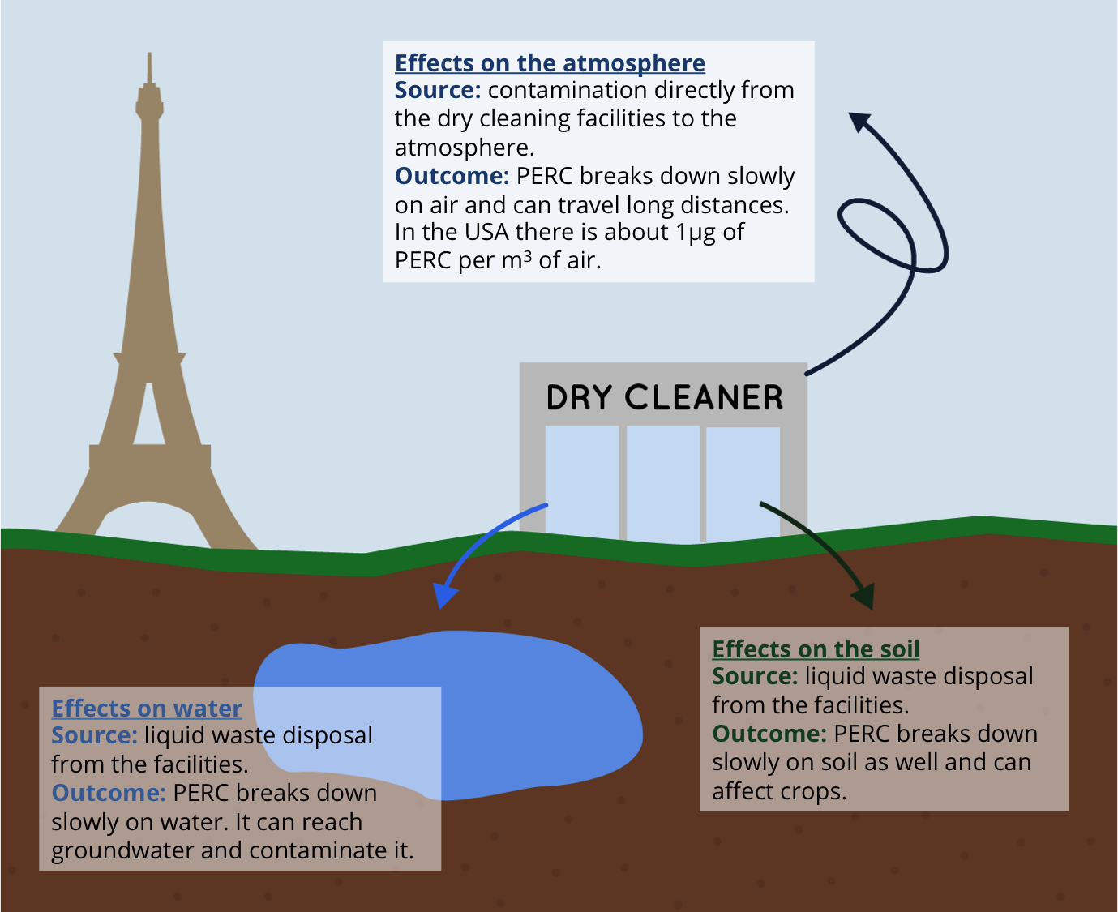

**Figure 2.6: Effects of Perchlorethylene on the Environment (CRI, 2016)**

*Air*

Volatile properties of perchlorethylene contribute to how easily its hazardous vapors contaminate the air. Perchlorethylene can easily turn into vapor and escape into the air both inside and outside the contamination site. Near a dry cleaning business, indoor exposure to perchloroethylene is more harmful than outdoor exposure. Researchers have reported that indoor air concentrations in apartments above dry cleaning shops at 4.9 mg/m3. This is cause for concern when compared to normal levels of perchlorethylene in the United States (roughly 1µg of perchlorethylene per m³ of air) since this reported indoor level is nearly five times the normal concentration (EPA Integrated Risk Information System Division, 2012).

The vapors from the solvent escape during the transfer process or from steam-pressing the clothing after cleaning, and accounts for almost 53% of perchlorethylene lost in the dry cleaning process (Schnapf, 2014). These vapors escape not only into the air but also through soil, structures, vents and into buildings. Researchers term this “vapor intrusion”, and Figure 2.7 depicts how it works. Once the vapors enter buildings near the source, they spread throughout the building, exposing everyone inside (Heinrich, 2012).

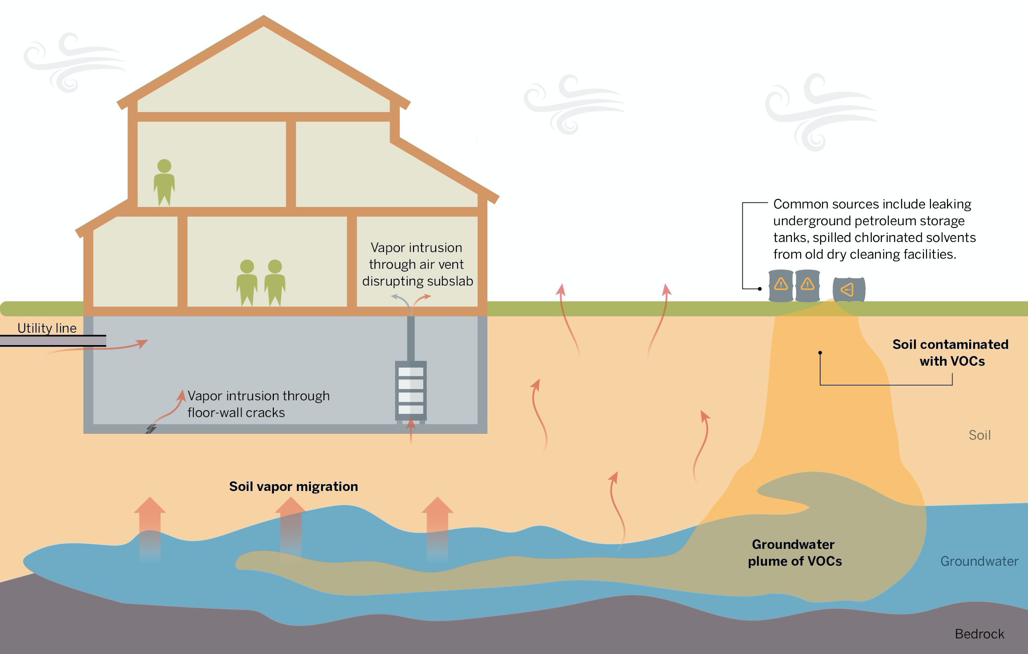

**Figure 2.7: Example of Vapor Intrusion (LCHD, MDEQ, MDHHS, 2018)**

*Water*

Almost all of the water used in perchlorethylene based dry cleaning processes becomes contaminated from close proximity to the solvent. Perchlorethylene can contaminate water in the distillation process, steam cleaning process or even when mopping the floor near perchlorethylene based machines (Schnapf, 2014). Vapors escaping from the machines or steam can enter water nearby. However, this is unlikely due to its low aqueous solubility. Researchers have detected hazardous contamination has been detected in drinking water, groundwater or surface water only when the body of water is in the vicinity of a highly contaminated site. (EPA Integrated Risk Information System, 2012).

*Food*

Since perchlorethylene is naturally soluble with fats and lipids, it is very common for it to bind with the lipid molecules in margarine, oils, meats, and other fatty foods stored in places where perchlorethylene is in the air. In particular, researchers observed elevated perchlorethylene levels in food samples obtained from grocers located near dry cleaners (EPA Integrated Risk Information System Division, 2012). In addition to contaminating food, perchlorethylene also easily contaminates breast milk. Due to its lipid solubility, researchers have shown that milk from human mothers, cows, and goats all retain perchlorethylene at high concentrations, specifically up to 43 μg/L (Food and Drug Administration, 2003). Because of this danger, experts highly recommend that dry cleaners not operate next to establishments which produce or sell food.

### 

### Regulation of Perchlorethylene and Dry Cleaners in the United States

The chlorinated solvents which dry cleaners use are potentially dangerous, so governments must regulate the industry in order to ensure the safety of dry cleaning workers and the general public. Regulatory agencies in the United States concentrate this regulation on limiting incidental exposure to hazardous chemicals both in the workplace and in the environment, as well as minimizing harms of this exposure. American regulation of this industry attempts to balance the desire of stakeholders (e.g. regulators, dry cleaners, and the public) to keep people safe, the ability of small businesses to follow complex regulation, and the safety of the environment (Massachusetts Department of Environmental Protection, 2015). Extended summaries of the standards we discuss in this section appear in Appendix B.

In the workplace, stringent regulations from the Occupational Safety and Health Administration (OSHA), the Environmental Protection Agency (EPA), state environmental agencies and local public health departments require dry cleaners to operate safely. OSHA does not provide specific dry cleaner regulation, although it expects that dry cleaners adhere to general workplace safety such as guidance related to fire safety, hazardous vapors, and hazardous waste (OSHA, 2005). Additionally, OSHA expects dry cleaners to comply with its guidance concerning perchlorethylene, and take all appropriate measures to make the workplace safer per the Occupational Safety and Health Act.

OSHA’s general standards that apply to dry cleaners contain basic requirements about levels of dangerous substances and general workplace preparedness with a focus on worker safety. The regulations impose a maximum exposure limit of 100 ppm over 8 hours for any given worker, along with several other time-based exposure ceilings. Summaries of these ceilings appear in Appendix B. The broad-strokes regulation also includes instructions for perchlorethylene handling for all applicable industries. This encompasses providing personal protective equipment (PPE) when dry cleaners expect high exposure to the chemical, and delivering hazard training to all workers on the effects of extreme exposure to perchlorethylene and proper handling procedures (OSHA, 2005). The regulatory measures address many of the fundamental needs of workers dealing with perchlorethylene and the dry cleaning industry workplace environment. Furthermore, even the agencies that create the regulation think that industry should follow higher standards in order to keep their workers as safe as possible.

Federal regulators in the United States intend their regulations to protect the environment from being dry cleaning contamination. The EPA regulates hazardous waste generators using the amount of waste generated, and applies a myriad of standards for how to manage waste for each type of generator based on the kinds of waste. These types include spent dry cleaning solvent, filter cartridges, and wastewater (Environmental Protection Agency, 2015). A comprehensive table of data reporting requirements and other requirements for dry cleaners from the EPA appears in Appendix B. The EPA’s broad environmental protection acts including the Clean Air Act and the Clean Water also apply to perchlorethylene pollution (Environmental Protection Agency, 2015). To this end, the EPA reserves the right to collect data on generators and respond to heavy releases of hazardous material through the Toxic Substances Control Act and The Comprehensive Environmental Response, Compensation, and Liability Act (Environmental Protection Agency, 2015).

Agencies on the state and local level in the United States can be more specific in their guidance regarding workplace safety and pollution for dry cleaners. These agencies are also more able to collaborate with each other and dry cleaners to maintain a higher standard of safety and simultaneously ensure dry cleaners can reasonably operate as businesses while attempting to follow regulations (Steele-Perkins, Giles. Personal Communication, 3 September, 2019). The Massachusetts Department of Environmental Protection (MassDEP) requires dry cleaners to submit a yearly compliance form, and performs occasional random inspections. In addition, they provide more explicit regulation on venting placement to prevent vulnerable parties like children and seniors from being exposed to significant levels of dry cleaning chemicals (Massachusetts Department of Environmental Protection, 2015). In California, legislators have chosen to phase out perchlorethylene completely from the dry cleaning process by 2023 (California Air Resources Board, 2017). New Jersey local legislature provides dry cleaners with a checklist to keep their businesses in compliance (New Jersey Department of Environmental Protection, nd). A full version of this checklist appears in Appendix C. Regulators generally pair these stricter state and local level requirements on dry cleaners with easily digestible resources, including handbooks and other guidance, to aid dry cleaners in complying with regulation for the good of public and environmental health.

American dry cleaners have many layers of responsibility on the local, state, and national level. These regulatory protections can be detailed or extremely general, and it is the burden of the agencies imposing them to ensure dry cleaners can reasonably follow them while also protecting workers, the general public, and the environment overall.

## 2.2 Risk Reduction and Best Practices

### Best Practices for Dry Cleaners Who Use Perchlorethylene

In addition to regulation, many of the regulatory agencies that oversee dry cleaners provide guidelines for dry cleaners to keep their businesses as safe as possible. While regulators highly recommend dry cleaners follow these guidelines, the law does not require that dry cleaners follow them. Organizations specifically dealing with dry cleaners, and groups who informally aid this industry provide additional best practices (National Cleaners Association, 2018).

*Inspection and Maintenance*

The first step for dry cleaners attempting to keep their workplace safe is inspection and maintenance. The goal of inspection is to ensure the building has operational safety measures as required by law but more regular inspections, especially inspections of the machines, will detect hazards earlier. Rapid detection and response to hazards keeps workers safer. This protects against so-called “fugitive emissions”, or harmful vapors escaping the dry cleaning machine at unexpected times; such as when a part is leaking (OSHA, 2005). The administration postulates that leaks account for roughly 25 percent of overall perchlorethylene emissions (OSHA, 2005), and so preventing leaks is vital in order to keep air quality below OSHA perchlorethyelene air regulation standards. As mentioned in section 2.1, OSHA requires perchlorethylene levels to be at or below 100ppm in the air, but it recommends that these levels actually be at 25ppm or below (OSHA, 2005). Actions as simple as having workers follow manufacturer guidelines can reduce fugitive emissions from a machine and necessary maintenance.

*Updated Machine Technology*

If it is economically feasible in the workplace for dry cleaners, businesses should replace their machines with newer models, since newer machines and newer parts often expose workers to less perchlorethylene and reuse the chemical more efficiently (OSHA, 2005). A device to monitor perchlorethylene levels in the air may also prove helpful to ensure that the business is meeting safety standards (OSHA, 2005). In general, the design of a dry cleaning machine is the cause of the level of operator chemical exposure. An updated machine can control the exposure from loading and unloading by concentrating the perchlorethylene in the machine cylinder, and directing where the air in the machine cylinder goes during the loading and unloading process. Machines that follow these few procedures greatly reduce the amount of exposure of hazardous vapors on the operators. Specific updates include using an inert gas to prevent dangerous chemical reactions, and being able to control temperature and vapor concentrations inside the dry cleaning machine (CDC, 1997).

*Ventilation*

The second measure dry cleaning businesses can take in improving general safety is to exceed requirements for proper machine and workplace ventilation. Proper venting in the workplace can help to prevent the concentration of dangerous vapor in any one area per regulatory requirements (OSHA, 2005), but through detailed planning of improved venting, fans, and respirators, employers can increase the airflow beyond the published requirements (OSHA, 1989). This planning could include drastic renovations to a building plan to maximize airflow through windows to machines, but dry cleaners can also accomplish this through more limited means. In order to protect the public and the environment in addition to their employees, dry cleaners must also carefully consider venting placement.

The two different types of machines discussed in section 2.1, transfer machines and dry-to-dry machines, require different venting approaches. Transfer machines inherently expose workers to more perchlorethylene because the operator must move the clothing from the machine containing the solvent to a machine to dry the clothing (Schnapf, 2014). This type of machine is older, relatively uncommon, and banned in parts of the United States due to higher potential for risk (MassDEP, 2015). Because this process involves this higher exposure step, generalized venting or windows in the building are vital. The placement of venting should also consider where the dry cleaner is in relation to homes and businesses. Excessive venting to the wrong area could harm members of the public. Dry-to-dry machines are safer because the clothes do not have to be moved midway through the process, but they can still present problems (EPA, 2015). The machines generally should have built-in mechanisms to ensure perchlorethylene does not escape and the vapors are appropriately vented out of the shop. Modern dry-to-dry machines include a carbon absorber and a refrigerated condenser for this purpose (Schnapf, 2014). Older dry-to-dry machines may not have these features, or may only have one of them, but business can add them. Shops can regularly improve these parts, along with the other venting technology (Earnest, G. et. al, 1997).

*Training and Handling*

The final significant change a dry cleaner can make to increase safety while still using perchlorethylene in the dry cleaning process is to increase worker training. Shop owners should already train workers in machine operation, hazardous substance handling, and accessing other safety resources in accordance with regulations (OSHA, 2005). Employers should train workers on the use of personal protective equipment including solvent-resistant gloves, goggles, and for vulnerable points in the dry cleaning process (Earnest, G. et. al, 1997). The premise is that if dry cleaning businesses increase this training and give workers the most information possible about the machines they are operating, then their exposure to perchlorethylene will be less. Changes as small as instructing workers to change their posture when loading and unloading the machine can make a significant difference in worker’s level of exposure (OSHA, 2005). Figure 2.8 provides other tips to limit exposure to perchlorethylene.

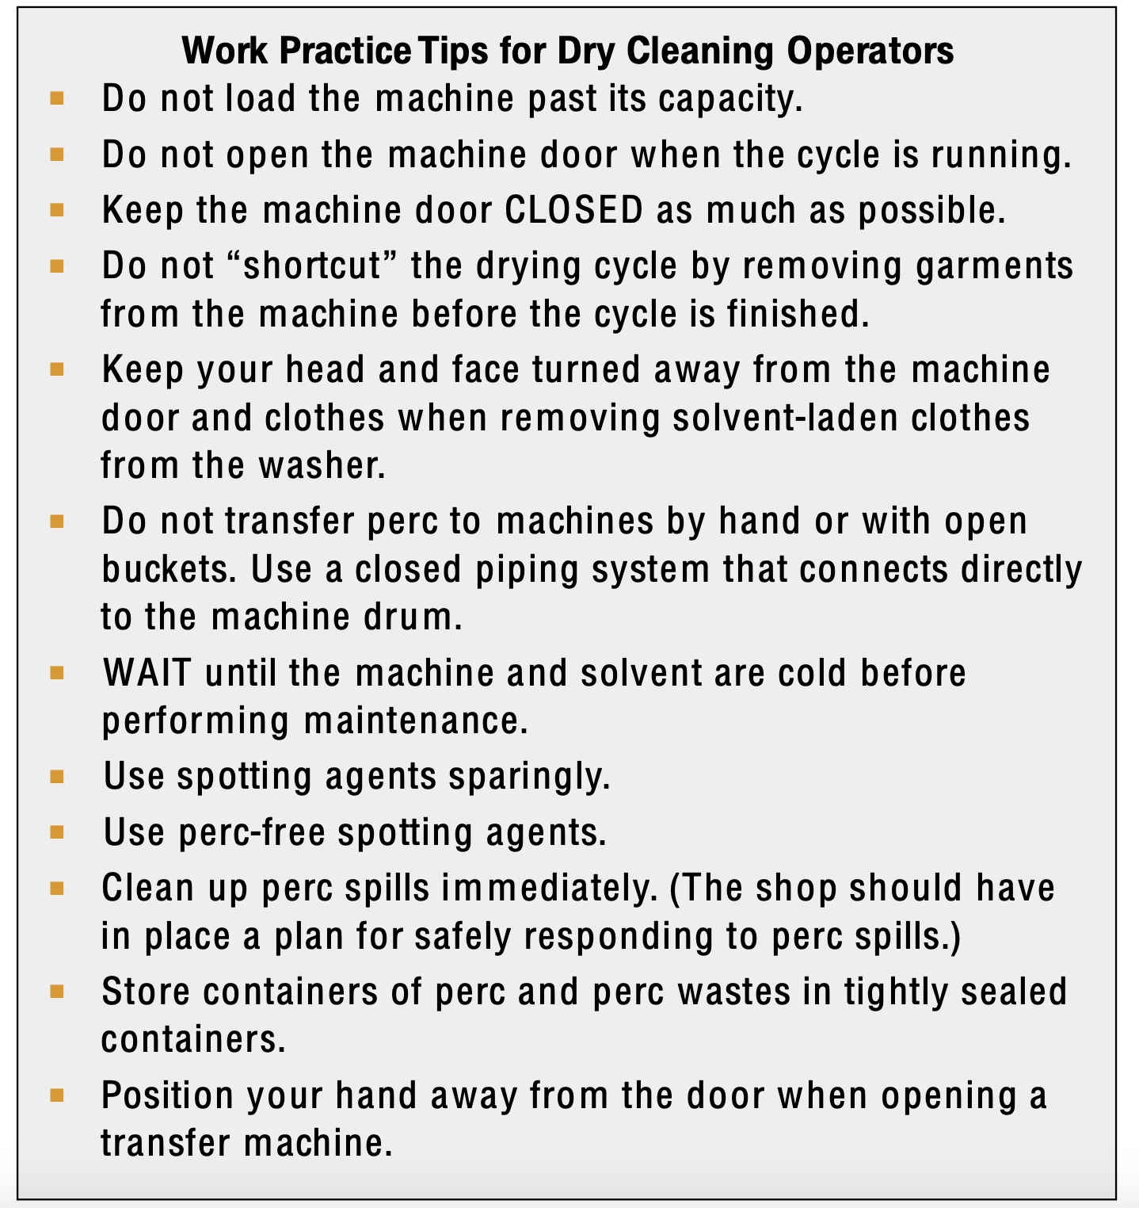

**Figure 2.8: Worker Tips for Limiting Perchlorethylene Exposure**

**Supporting Best Practices**

The extensive and detailed regulations and guidance for dry cleaners is not easy to follow for an industry composed of many small businesses. To combat this potential difficulty, various groups provide dry cleaners with support.

In the United States, regulators generally provide dry cleaners with clarifying resources to aid them in understanding and following regulation. In Massachusetts, MassDEP has introduced a comprehensive website, workbook for compliance, and multiple phone helplines in order to ensure dry cleaners understand and comply with regulations (Massachusetts Department of Environmental Protection, 2015). OSHA offers consultations with businesses, and recommends the use of stewardship programs operated by perchlorethylene suppliers that provide information about hazards and best management practices for chemicals (OSHA, 2005). This kind of regulatory assistance usually focuses on ensuring that dry cleaners can more easily understand what they need to do to reduce risk from operation, rather than the consequences (eg, fines) for non-compliance.

Trade organizations also provide substantial assistance. One example is the Retail Compliance Center; an organization to aid small businesses in complying with industry-specific regulations. The Center provides resources to dry cleaners for training, increasing sustainability through chemical choice and reduced energy consumption, and interpreting regulations (Retail Compliance Center, 2017). Another more dry-cleaner specific example is the Dry Cleaning and Laundry Institute International, which offers advice emphasizing training (Dry Cleaning and Laundry Institute International, 2018). There are numerous similar organizations across the United States and in other countries (National Clothesline, 2018). Donors or dues fund these organizations, and the organizations have conferences, message boards, and networks of other dry cleaners to clarify safe practices. They work from within the industry to provide specific advice and exchange information between dry cleaners; providing another set of potentially helpful information.

### Green Alternatives

Even though there are best practices that exist to mitigate hazardous effects of a dry cleaning machine, the only way to eliminate them is to switch to water-based wet cleaning, alcohol-based wet cleaning, a high flash hydrocarbon solution or updating the machine technology. These alternatives to perchlorethylene can reduce workers and machine operator’s exposure to hazardous vapors and substances, as well as limit the amount that enters the environment.

*Wet Cleaning*

The main difference between wet cleaning and dry cleaning, although there are many, is that wet cleaning mainly uses water and biodegradable soaps to wash the clothes instead of a hazardous solvent (Toxic Use Reduction Institute, 2012). Table 2.1 displays the many pros and cons to this process. There are major differences between perchlorethylene based machines and wet cleaning machines. Wet cleaning is not a perfect alternative to dry cleaning, but it is effective in reducing the amount of hazardous waste produced, the cost of operating and the risk posed to workers. A complete comparative outline appears in Appendix A, which includes the TURI Fact Sheet that compares perchlorethylene to wet cleaning.

|  |  |
| --- | --- |
| **Pros of Wet Cleaning** | **Cons of Wet Cleaning** |
| No exposure to perchlorethylene for operators of the machine | Produces industrial wastewater |
| Reduce amount of perchlorethylene regulation the dry cleaner has to abide by | Customer skepticism |
| Lowers cost from decreasing electricity use, a less expensive machine and eliminating solvent | Higher cost per pound cleaned |
| Water soluble stains more easily removed | Lower load capacity |
| Machines are usually less expensive than chemical solvent based machines | Much more water is used |
| Growth of customer base if advertising environmentally friendly methods |  |
| Clothes finish brighter and better smelling |  |

**Table 2.1: Pros and Cons of Wet Cleaning (TURI, 2012 & CDC, 1997)**

The three main incentives for dry cleaning businesses to consider switching from dry cleaning to wet cleaning are: health benefits; reduced amount of regulation; and lower costs. Wet cleaning is significantly safer than perchlorethylene-based cleaning, and is likely to improve quality of life for operators. By eliminating perchlorethylene in the shop, an owner can become more comfortable knowing they are not putting any employees at risk to the health effects of the chemical (CDC, 1997). Furthermore, wet cleaning can save a dry cleaner money since the machine uses less electricity, and the operating costs are lower (TURI, 2012). Finally, wet cleaning reduces the amount of regulation dry cleaners need to follow. Once the dry cleaner stops using perchlorethylene in favor of processes like wet cleaning which involve non-hazardous chemicals, they no longer have to follow complex hazardous chemical regulations. Instead, wet cleaning produces Industrial Waste Water (IWW) which is used water contaminated with soaps and/or biodegradable detergents and any dirt washed out of the clothes. Regulators do not consider this water hazardous because no hazardous chemical present in the process of wet cleaning (TURI, 2012). Dry cleaners that use wet cleaning have to follow significantly less regulation than traditional dry cleaners.

*Alcohol-Based Wet Cleaning*

Based on our interview in Tirana with a dry cleaner supply store that promotes ecological based products, alternatives to perchlorethylene-based systems are available in Albania. The main alternative available is a type of wet cleaning system that uses an alcohol-based solution instead of a solvent in the dry cleaning process. This is different than the wet cleaning in the United States which uses water instead of a solution or solvent. These solutions are a good alternative to perchlorethylene and benefit dry cleaners, customers and the environment. Because they are alcohol formulations, the solutions are biodegradable with low aquatic toxicity. These characteristics make this alternative safe for the environment, especially when compared to perchlorethylene. This type of wet cleaning is very appealing to dry cleaners as it saves both time and cost in the cycle. Textiles are quicker to dry, machine cycle times are shorter, the machine uses less energy than traditional dry cleaning machines, and finishing is easier because there are less wrinkles in the clothing from the washing process. The solution prevents discoloring, keeps colors bright and leaves a clean fragrance, unlike perchlorethylene (Confidential Source, 19 November 2019).

*Petroleum Based Solvents*

Instead of using a synthetic solvent such as perchlorethylene, or investing in a wet cleaning machine, there are other solvent options that can reduce hazardous waste and associated risks. These alternatives include petroleum-based solvents such as Stoddard solvent, 140-F (EPA, 1981) and DF-2000™ (TURI, 2012). More dry cleaners are switching to petroleum based solvents as awareness about synthetic solvent hazards increases. Petroleum based solvents are made of hydrocarbons and have a high flashpoint, meaning the temperature of the solvent has to be higher for it to give off vapor, and so this reduces the amount of vapor contaminating a dry cleaner (EPA, 1981). Dry cleaners cannot use perchlorethylene machines with hydrocarbon solvents, so if dry cleaners want to change their solvent to a high flash point hydrocarbon, they would have to buy a new machine. The TURI Fact Sheet, located in Appendix A, shows specific comparisons between perchlorethylene and high flash hydrocarbons and includes cost, health and environmental differentiations. These machines produce waste in the form of solid waste from filter cartridges, and liquid solvent residue. Regulators do not consider this waste to be hazardous. Dry cleaners instead manage the hydrocarbons as waste oil, which is easier to handle than hazardous waste, and is one of the reasons a dry cleaner switch to a hydrocarbon alternative to perchlorethylene. A complete pro con list of high flash hydrocarbons, such as DF-2000™, is below in Table 2.

|  |  |
| --- | --- |
| **Pros of High Flash Hydrocarbons** | **Cons of High Flash Hydrocarbons** |
| No exposure to perchlorethylene and its hazardous effects for operators of the machine | Usually a more expensive machine |
| Eliminates hazardous waste produced | Produces waste oil which is toxic to aquatic systems |
| Average cost per pound cleaned is lower | Cycle time is a little longer |
| High flash point which produces less vapor from the machines | Can cause skin irritation if garments are not completely dry of solvent |
| Less regulatory burdens placed on dry cleaners | Uses more electricity |
| Solvent is less expensive than perchlorethylene |  |

**Table 2.2: Pros and Cons of High Flash Hydrocarbon**

## 2.3 Dry Cleaning Industry of Albania

### Albanian Regulation of The Dry Cleaning Industry

The Albanian government does not centralize Albanian regulation of the dry cleaning industry. There is very little specific regulation for dry cleaners in Albania, and most of the oversight of the industry focuses on the chemicals used in the process. The Albanian central government restructured the ministries in charge of chemicals management in 2018, and is set to change them again in 2020 with the re-introduction of a designated Chemicals Office for Albania. Currently, the primary groups that deal with chemicals management related to dry cleaners are the National Environmental Agency and the Ministry of Tourism and Environment.

In order to open a dry cleaner, interested parties must apply to the Regional Agency of Environment for a Type C environmental permit. To obtain the permit, the potential dry cleaner must pay 10,000 Albanian lek (ALL) to the Ministry of Environment. In addition, the applicant must provide technical documentation about the technology (e.g. the machine and chemicals used by the dry cleaner) and information about the location for the future dry cleaning shop. Lastly, they must have a summarized environmental report from the Ministry of Environment or generated by the business and signed by the Ministry of Environment (Verdict of Minister’s Council nr 417, 25 June 2014). The national inspector for the Ministry of Environment and Tourism conducts the inspection in order to make the environmental report. Figure 2.9 depicts the flow of this process.

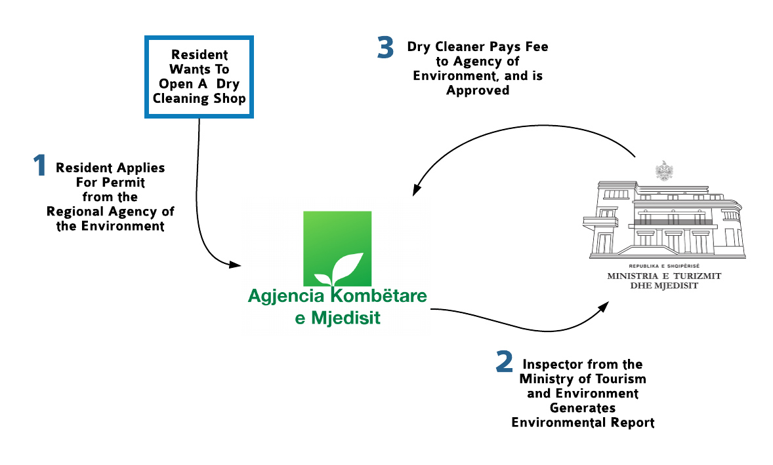

**Figure 2.9: Dry Cleaner Approval Flow Diagram**

Once the dry cleaner receives the permit and begins operation, the regulation they must follow primarily relies on self-monitoring. Dry cleaners must pay 2,000 ALL annually to the Regional Agency of Environment. Every six months, they must submit lab results for the National Agency of Environment’s evaluation. These lab results display chemical levels within the cleaning solutions. If the employees at the National Agency deem the results unsatisfactory or untrustworthy, they start the process Figure 2.9 displays, and inform the Ministry of Tourism and Environment. The Ministry then seeks approval from the Ministry of the Economy to send the single inspector for this portion of the government to visit the dry cleaning premises. According to our interviewees, this system is overwhelmed. The government also expects dry cleaners to ensure that their shops do not contain unsafe levels of chemicals, and to work to limit contamination of the surrounding area through processes like water treatment and proper venting of high levels of toxic fumes to extremely populated buildings.

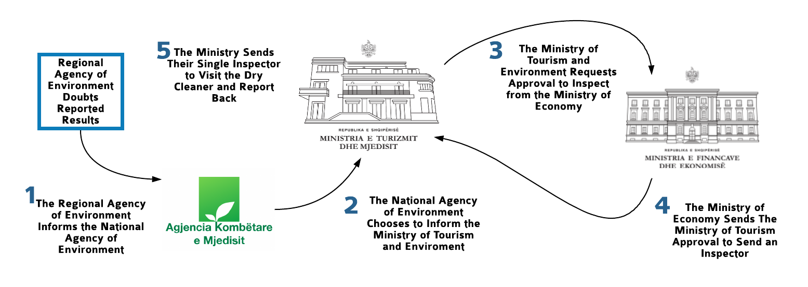

**Figure 2.10: Data Verification Flow Diagram**

Other ministries handle other aspects of chemicals management that dry cleaners themselves do not need to know. A handful of ministries are responsible for disseminating information to the public related to dangers of chemicals related to dry cleaning. The Ministry of Health manages the protection of public health, and NGOs, including EDEN Center, advocate for more public awareness about potentially harmful chemicals. Other responsibilities for regulating dry cleaners, especially the regulations relating to chemical transport and disposal, are fragmented across many ministries.

**Cost analysis**

Table 4.2 displays the cost comparison of three alternatives to a perchlorethylene based machine, from in section 2.2, in both US dollars and Albanian Lek. We chose these three alternatives based on how feasible they were to implement in Albania, and include: water based wet cleaning, alcohol based wet cleaning and an alternative solvent high flash point hydrocarbons. The information on water based wet cleaning, the most popular alternative in the United States, originates from a study conducted by the Toxic Use Reduction Institute on alternatives to perchlorethylene in the dry cleaning industry (TURI, 2012). Alcohol based wet cleaning is an alternative available in Albania, as we learned from an anonymous Albanian dry cleaning chemical supply store. The team obtained data on this system through an interview with the confidential dry cleaning supply store with knowledge on the costs of switching to this type of wet cleaning. Finally, data obtained for high flash point hydrocarbons, a reasonably priced alternative in the US, originates from the previously mentioned TURI study (TURI, 2012).

The data comparison shows that ultimately the cost of alcohol based wet cleaning is less expensive than a perchlorethylene based dry cleaning. This is due to many factors, including costs of a new machine, electricity, the solvent or detergent and water. Alcohol based wet cleaning has a cheaper machine, uses less electricity and has no cost of water. The only increase in price stems from the cost of the solvent since the alcohol solution is new and more expensive than perchlorethylene. The difference in machine price, however; ultimately results in the greater cost of perchlorethylene based dry cleaning.

|  |  |  |  |  |  |
| --- | --- | --- | --- | --- | --- |
| Technique | Cost of new machine | Electricity | Cost of solvent  or detergent | Cost of Water | Average cost per pound cleaned |
| Perc based machines | 3,679,506 ALL  $33,000.06 | 252 ALL/100lb  $2.272/100lb | 1,885 ALL/Gallon  $17/Gallon | N/A | 113 ALL  $1.02 |
| Wet Cleaning (Water Based) | 3,992,400- 6,764,900 ALL  $36,000- $61,000 | 88 ALL/100lb  $0.794/ 100lb | 2,772- 3,437 ALL/Gallon  $25-$31/ Gallon | 0.776  ALL/ Gallon  $0.007/ Gallon | 121 ALL  $1.10 |
| Wet Cleaning (Alcohol Based) | 2,208,303 ALL  $19,912.56 | Similar to water based wet cleaning | 5,538ALL/  Gallon  $49.94/Gallon | N/A | Unknown |
| High Flash Point Hydrocarbons | 3,105,200- 8,317,500 ALL  $38,000- $75,000 | 337 ALL/ 100 lb  $3.039/100lb | 1,552- 1,885 ALL/Gallon  $14-$17/  Gallon | N/A | 97 ALL  $0.88 |

**Table 2.3: Cost Analysis of Perchlorethylene Alternatives**

## 2.4 Environmental Center for Development Education and Networking

Our sponsor EDEN Center is a fifteen year old environmental advocacy non-governmental organization aiming to, “contribute to sustainable development and a healthy environment through the provision of services in partnership with stakeholders” (EDEN Center, n.d.). It is one of the most active environmental advocacy organizations in Tirana, and it has a strong network of related organizations both nationally and globally.

In addition to its many roles in the network of environmental protection agencies, EDEN Center attracts enthusiastic volunteers. This volunteer base is an essential link between awareness of EDEN Center’s project and action from the public. In collaboration with its volunteers and other organizations, the EDEN Center has successfully run a variety of environmental awareness campaigns. These campaigns strive to raise awareness to environmental and sustainable development issues within the country.

Currently, EDEN Center is working on programs related to waste and pollution. To this end, the organization sought to learn more about how the dry cleaning industry in Tirana produces waste, and how dry cleaners can mitigate the risks associated with this waste. In addition, EDEN Center wanted to explore the amount dry cleaners knew about potential risks to themselves, the public, and the environment from hazardous chemicals in their workplace. As an NGO experienced in collaborating with the government, EDEN is aware that government regulation of dry cleaners is underdeveloped. Though this project, the EDEN Center hopes to gain a more complete understanding of the human and environmental risks posed by the Albanian dry cleaning industry.

# 

# 

# Chapter 3: Methods

The goal of this project was to identify opportunities to reduce risks to dry cleaning employees, the public, and the environment from the chemicals used in the dry cleaning businesses of Tirana, Albania. To realize this project goal, we identified the following objectives:

1. Map dry cleaners currently operating in Tirana
2. Identify the current dry cleaning practices within Tirana
3. Determine the perspectives of dry cleaners on adopting greener practices
4. Determine the perspectives of the public on greener dry cleaning practices
5. Provide recommendations for safer practices and alternatives to hazardous chemicals

Figure 3.1 conveys how our objectives and methods fit together to accomplish these goals. The first tier represents our five objectives, directly underneath is the stakeholders involved in the objectives. From there arrows point to the methods the team used to accomplish the objectives. All methods point to the final step in our data collection: analysis. The sections of this chapter are organized by each objective and the methods used to accomplish it.



**Figure 3.1: Project Flow Diagram**

## 3.1 Mapping Dry Cleaners Currently Operating in Tirana

### Online Background Research

To locate dry cleaners in Tirana, we first searched for dry cleaners on Google Maps by using the Albanian phrase for dry cleaner (“pastrim kimik”) as a search term. The project team then used Google searches to find websites or guidebooks that mention the location of dry cleaners in Tirana. The group created a spreadsheet with all the dry cleaners we found. This spreadsheet included each dry cleaner’s address, contact information, hours of operation, administrative unit, neighborhood, and the website (if applicable). With this information, the team created its own map of the dry cleaners in Tirana with each dry cleaner's name, address, and administrative unit.

The team selected three out of the eleven administrative units of Tirana to examine, shown in Figure 3.2, because it was not feasible for this investigation to visit every dry cleaner in the city in seven weeks. The three units we chose were 1, 5 and 6. The team chose these units based on size, demographics, location and the number of dry cleaners we located online in each. Table 3.1, below, shows the socio-economic variables of the chosen units from the 2012 Living Standards Measurement Survey conducted in Tirana. The information from these variables, as well as information from EDEN Center volunteers, enabled the team to choose units with varied demographic characteristics. We chose unit 5 because it contains many densely populated and relatively affluent neighborhoods including Blloku, Selita, and Tirana e Re. The team assumed that in these neighborhoods, dry cleaners would have more customers due to high population counts and residents with more disposable income. Our next selection was a unit with the opposite characteristics: Unit 6 that has the highest amount of poverty when compared to other sections of the city. The Living Standards survey shows that 18% of the families living in Tirana who need economic assistance reside in this unit, and unemployment is highest in this area. The unemployment coefficient in Table 3.1 represents the number of unemployed citizens over the number of citizens in the labor force (Dumani, Bici, Dumani, Subashi, Kondi, 2018). These two units also appear on opposite ends of the average age spectrum, which the team believes further diversified the potential customer bases of sampled dry cleaners. Finally, we selected unit 1 because it is a statistical medium between the other two units in terms of wealth, poverty and population density (Dumani, Bici, Dumani, Subashi, Kondi, 2018). Moreover, this unit is located farther away from the other two sectors, which allowed us to sample dry cleaners in a wider geographic area of Tirana.

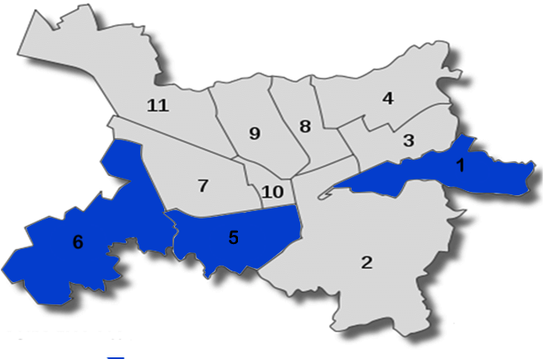

**Figure 3.2: Map of Municipal Units of Tirana with Chosen Units Highlighted**

|  |  |  |  |  |  |  |  |
| --- | --- | --- | --- | --- | --- | --- | --- |
| Unit | Population (people) | Density (people per km2) | Unemployment Coefficient (unemployed/  citizens) | Poverty Head  count | # of Dry Cleaners on Google Maps | Dry Cleaners per  Population | Average Age (years) |
| 1 | 27,032 | 7,100 | 0.254 | 10.4% | 3 | 1:9,011 | N/A |
| 5 | 46,776 | 16,059 | 0.163 | 5.7% | 9 | 1:5,197 | 38.2 |
| 6 | 34,847 | 6,033 | 0.297 | 14/5% | 4 | 1:8,712 | 34.8 |

**Table 3.1: Socio-Economic Variables of Tirana Units (Dumani, Bici, Dumani, Subashi, Kondi, 2018)**

### Locating Dry Cleaners

The team walked along main streets that could contain businesses not listed on Google Maps, and explored side streets near where other dry cleaners appeared. We completed the mapping as a group in three days, one unit per day. This method elicited more information about the location of the operating dry cleaners (type of building, etc) and the existence of dry cleaners with no online presence. As a team, we took notes of the characteristics at each dry cleaner, searched for venting, and took photos of the outside and surroundings. The characteristics we recorded in our notes included the surroundings of dry cleaners (what type of building the dry cleaner is in, neighboring businesses or stores, if there are apartments nearby, if there is anything notable about location), if they had obvious ventilation, and any notable advertising slogans and imagery. These characteristics informed the specific questions the team asked the dry cleaners during interviews.

The team created a map of our walking paths, including all the dry cleaners we visited and the new ones discovered. The final step was to remove dry cleaners found online but which we discerned were permanently closed.

## 3.2 Identify the Current Dry Cleaning Practices within Tirana

### Survey of Dry Cleaners

To aid in identifying current dry cleaning practices, the group’s first step was to conduct in-person surveys with both owners and employees of dry cleaners, depending on who was available at the business. These surveys helped the team to determine the practices of dry cleaners firsthand, and place their practices in a broader context of the Tirana dry cleaning industry. Specific questions from the surveys with dry cleaners and survey protocols are in Appendix E. The purpose of these questions was to gain information on the following subjects:

* The types and characteristics of machines used in the dry cleaning process (e.g., how old the machines are)
* The kinds of chemicals used in the process and how they are handled at different stages of the process
* The kinds of training workers receive, and regular operational procedures they follow
* How long the dry cleaner has been open
* How large of a clientele they serve and the amounts and what categories of items these clients bring to the dry cleaners

In order to prepare for potential language barriers, EDEN provided volunteer translators to accompany the team when conducting in-person surveys. The project team trained the volunteers before beginning interviews. This training included reviewing the interview questions with the volunteers to ensure they knew the precise context of the questions being asked. We also made sure that the volunteers understood the information we would like to receive from the question so they could translate the questions more effectively. The translators provided feedback if they believed we phrased the original questions poorly for dry cleaners to understand in Albanian.

The team conducted a number of preliminary tests of the survey before conducting formal versions. We conducted these tests on three randomly selected dry cleaners based on proximity to the EDEN Center office. At each of these surveys, a translator accompanied a different member of the team to the dry cleaning shop. The member of the team and accompanying translator conducted the in-person survey to gauge the effectiveness of the questions, as well as to identify any information that the questionnaire did not adequately explore. The group then updated the survey structure based on examining the quality of responses. After conducting the initial three sets of surveys, we felt more data would improve the quality of our findings. We decided to survey select dry cleaners in two additional units; all dry cleaners in unit 7 and, due to time constraints, a single dry cleaner in unit 2. These units were chosen by the team and volunteer translators as a convenience sample. The five units we surveyed are highlighted in Figure 3.3.

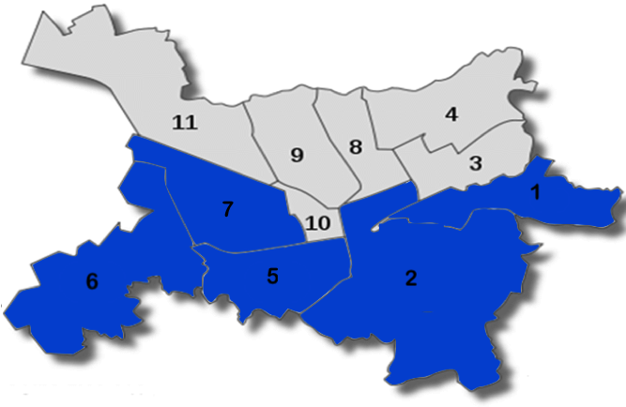

**Figure 3.3 Map of the Five Municipal Units Surveyed in Tirana**

In order to analyze the data, the team first compiled the survey responses into spreadsheet form. The team made a spreadsheet for each unit, and one for Tirana as a whole. We gave responses to qualitative questions a corresponding number based on content so the team could examine the frequency of common responses to each question. We categorized the answers into groups based on similar qualities. For example; when we asked from what country a dry cleaner acquired its machine, we recorded a zero if they got it from Italy, a 1 if from Germany, a 2 if from Turkey, and a 3 if they got machines from both Italy and Germany. This categorization did not alter the data in any way, and was mostly for convenience’s sake to aggregate and analyze the data. We left the quantitative answers as is.

Statistical analysis consisted of performing significance tests to determine correlation between various dry cleaner practices recorded in the survey responses. As an example, we checked if the proximity of a respondent’s home to a dry cleaner affected how much they know about dry cleaners. By comparing the means of the distributions of the data via T-Tests, we measured whether or not the data sets were statistically related. The hypotheses for these tests are the mathematically usual null and alternative hypotheses for T-Tests. In other words for two given properties *X*  and *Y,* every null-alternative pair (*H0*, *Ha*)is of the form *H0 =* “There is no relationship between *X* and *Y*”, and *Ha =* “There is a statistical relationship between *X* and *Y*”. For our previous example about proximity; *H0  =* “There is no statistical relationship between the respondent's proximity to a dry cleaner and their knowledge about dry cleaning practices” and *Ha* = “There is a statistical relationship between the respondent’s proximity to a dry cleaner and their knowledge about dry cleaning practices” (Petruccelli, Nandram, & Chen, 2001). These T-tests helped identify similarities to gauge the general process of dry cleaners in Albania.

### 

### Semi-Structured Interviews with Dry Cleaners

After the group conducted surveys in the selected districts, we created scripts for follow-up interviews. These interviews were intended to ask dry cleaners who enthusiastically provided information during the survey, more in-depth questions.

The information the team hoped to gain included:

* If workers experienced negative health effects which they attributed to perchlorethylene
* How workers would respond to spills and required maintenance
* Ways in which employees dispose of wastewater, muck, and old machine parts
* More information about how chemicals are stored and accessed in a dry cleaning shop

Like the surveys, a single team member and an accompanying translator conducted these interviews. The questions for these interviews appear in Table I.1 in Appendix I.

Team members stored their notes in collective documents for each interview, and used this information to provide further context to the findings from the dry cleaner surveys.

### 

### Interviews with Regulators

In order to identify current Albanian regulations that apply to dry cleaners, the group interviewed two regulators at the Ministry of Tourism and Environment. The team sought to learn about the following topics:

* The strengths and flaws of current regulation
* Regulatory enforcement mechanisms
* What regulation was considered ineffective

Our sponsor in the EDEN Center, Jonida Mamaj, scheduled and served as our translator for these meetings. The questions for this interview appear in Appendix F.

We stored the data from the regulator interviews as a collective document of notes from the team, and in the form of a transcript which a volunteer translated from Albanian for the group. Team members summarized this information in order to contextualize the responses of dry cleaners about industry regulations.

## 3.3 Determine the Perspectives of Dry Cleaners on Adopting Greener Practices

### Survey of Dry Cleaners

The group’s first course of action with respect to this objective was to determine the extent to which dry cleaners have the ability and willingness to change from a perchlorethylene based system. To this end, the team surveyed dry cleaners on the following topics:

* The cost of the dry cleaner’s current equipment and operations
* How much the dry cleaner knew about “greener” alternatives to their current system and what they perceived to be the cost
* What, if any, non-monetary factors, such as worse quality, other risks or too much maintenance, discouraged them from switching to “greener” alternatives

Appendix E outlines these specific questions, along with the previous section’s survey questions. The team also asked questions about regulation relating to dry cleaning to determine the extent to which dry cleaners were aware of and complied with regulations. Lastly, the team inquired if dry cleaners are aware of the risks and dangers associated with operating a dry cleaning business, and whether or not the risks influence their decisions to adapt their dry cleaning method. We asked about their knowledge of the dangers of perc, and how to properly mitigate those dangers. The survey results informed a final deliverable of an educational pamphlet for dry cleaners about these risks.

These questions appeared in the same survey of dry cleaners performed in the previous objective, and the team analyzed the combined data as a whole.

## 3.4 Determine the Perspectives of the Public on Greener Dry Cleaning Practices

### Survey of the Public

The group developed a survey in order to ascertain the public’s attitudes towards greener alternatives to the typical dry cleaning process. This survey also examined the extent to which the public is aware of the risks that chronic exposure to perchlorethylene might pose to dry cleaners. The questions include details such as:

* How aware the public is about various potential risks of the dry cleaning industry?
* How much information does the public have about dry cleaners and perchlorethylene?
* How receptive would they be to accepting higher costs for dry cleaning due to the industry adopting safer practices?

Appendix G displays the full survey along with Figure 3.4 which is a diagram of the survey logic. The group translated this survey into Albanian and released it on the online survey platform Qualtrics. EDEN Center volunteers and employees distributed the survey link.

As the background chapter notes, the public attitudes towards a “greener” dry cleaning industry may be a significant incentive for the industry to enact change. The survey also serves the dual purpose as a means of subtly educating survey responders on potential risks from dry cleaning. The group strived to ensure any educational information in the survey was not alarmist in order to limit the stress of the public while still encouraging curiosity.

The group stored responses to this survey in the Qualtrics platform and in spreadsheet form. Analysis of this survey was similar to the analysis of the dry cleaner survey. Statistical analysis consisted of performing hypothesis tests (T-Tests) in order to correlate the properties of the respondents with their opinions on the dry cleaning industry. This also helped to form an impression of the average survey respondent’s opinion about greener dry cleaning practices.

## 3.5 Provide Alternatives to Hazardous Chemicals or Recommendations for a Green Dry Cleaner

The team created two deliverables: a pamphlet to educate dry cleaners about alternatives and best practices, and educational materials, such as flyers, for EDEN Center to educate the public about current practices in the dry cleaning industry so that they can make informed choices.

### 

### Cost Analysis

In order to obtain data to develop recommendations of alternatives, we conducted a cost analysis. Specifically, this step focused on the feasibility of alternative solutions to using perchlorethylene based dry cleaning machines, including water based wet cleaning, alcohol based wet cleaning, and petroleum-based alternative solutions to perchlorethylene.

Table 3.2 shows the framework for the cost analysis which depicted the cost of each alternative categorized by the cost of electricity, water, a new machine, and the solvent or detergent being used. This analysis utilizes two studies conducted by the Toxic Use Reduction Institute. The first assessed alternatives to perchlorethylene which included a financial comparison between seven different alternatives to perchlorethylene (TURI, 2012), found in Appendix D. The second study was based on a specific dry cleaner in Massachusetts, focusing on the feasibility and cost comparison of professional wet cleaning to perchlorethylene dry cleaning (Onasch, 2010). Specifically, we discussed water based wet cleaning because it is the most popular in the United States, alcohol based wet cleaning, since our research confirms there are a few dry cleaners who implement this method in Albania, and high flash point hydrocarbons because it is a relatively inexpensive option. The team verified the costs of alternatives through documents from our sponsor and an interview with a dry cleaning chemical supply store. This distributor was a supply company promoting the use of more environmentally friendly dry cleaning options. They sell alternatives to perchlorethylene, different detergents and wet cleaning equipment. The topics we discussed in this interview included what alternatives to perchlorethylene that are available in Albania, their costs, the number of dry cleaners in Tirana that use alternatives, the most commonly used alternatives to perchlorethylene, and how easy it is to change dry cleaning methods. This interview occurred with one volunteer from EDEN to translate and all members of the group. Table H.1 in Appendix H outlines the questions for this interview.

After synthesizing this data, the team provided evidence to dry cleaners in the form of an educational pamphlet (see Appendix K) about the cost and availability of alternatives to perchlorethylene. The pamphlet also included a section on best practices to reduce hazardous exposure, such as inspection, ventilation and protective equipment. This was given to our sponsor to distribute at their discretion.

|  |  |  |  |  |  |
| --- | --- | --- | --- | --- | --- |
| Technique | Cost of new machine | Electricity | Cost of solvent  or detergent | Cost of Water | Average cost per pound cleaned |
| Perc based machines |  |  |  |  |  |
| Wet Cleaning (Water Based) |  |  |  |  |  |
| Wet Cleaning (Alcohol Based) |  |  |  |  |  |
| High Flash Point Hydrocarbons |  |  |  |  |  |

**Table 3.2: Cost Analysis Table**

# 

# Chapter 4: Findings

In this chapter, the team presents the information we found through our surveys to dry cleaners and the public and the interviews we conducted with dry cleaners, regulators and a dry cleaning supply store. Section 4.1 discusses the current dry cleaning practices in Tirana, including information on dry cleaners locations across Tirana, machines, solvents, training, and general dry cleaner knowledge. Section 4.2 reviews the perspectives of dry cleaners and their opinions on alternatives to perc. Finally, Section 4.3 identifies the perspectives of the public on dry cleaning practices and their current knowledge about the dry cleaning industry. These findings show that, in Tirana, both employees in the dry cleaning industry and the general public are unaware of the extent of the dangers of perchloroethylene in the dry cleaning industry.

## 4.1 Mapping

### Dry Cleaners are Unevenly Distributed Throughout Administrative Units in Tirana

We focused on the locations and characteristics of dry cleaners to determine if there were any differentiating characteristics between the three chosen units in Tirana. As mentioned in our methods, the themes our team concentrated on were density, signage, surroundings, and response rate. The density of dry cleaners in each unit varied greatly, likely as a result of the differences in population between the units, as described in Table 3.1 of Section 3.1. The 14 dry cleaners of unit 5, located from both Google Maps and the teams observation, appear in Figure 4.1 as yellow stars. This unit has the greatest population of dry cleaners and the largest amount of dry cleaners per capita at approximately 1 to every 5,197 people.

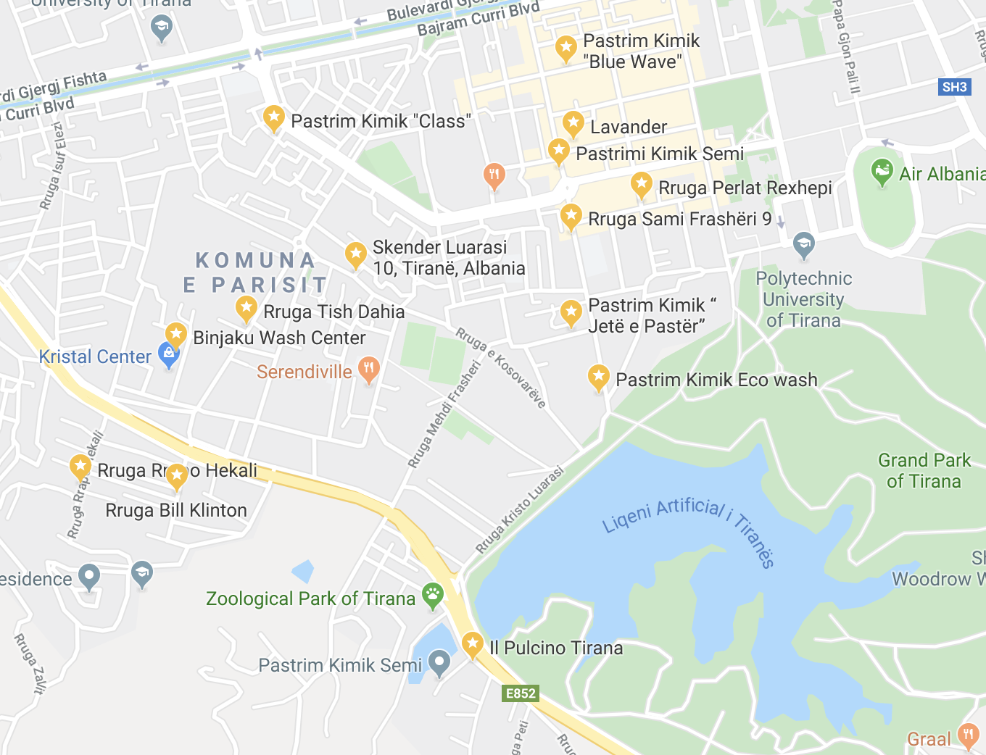

**Figure 4.1: Dry Cleaners Located in Unit 5 of Tirana**

Shown in Figure 4.2, unit 6 has a very low density of dry cleaners, especially when compared to unit 5. The team located a total of 4 dry cleaners in this unit; 10 less than unit 5. Even though unit 6 is larger than unit 5, the population is about 10,000 less than unit 5 and it contains fewer dry cleaners. The number of dry cleaners per capita is around 1 to every 8,712 people.

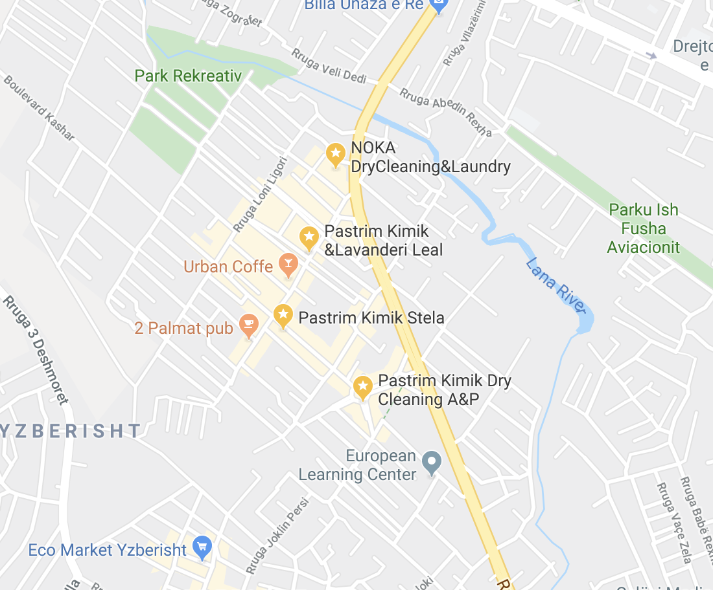

**Figure 4.2: Dry Cleaners Located in Unit 6 of Tirana**

The number of dry cleaners in unit 1, as depicted in Figure 4.3, is even less than that of unit 6. We located only 3 dry cleaners in this unit, since it is one of the smallest units in Tirana. The population of unit 1 is roughly 20,000 less than unit 5 and so the number of dry cleaners per capita is roughly 1 to 9,011 people.

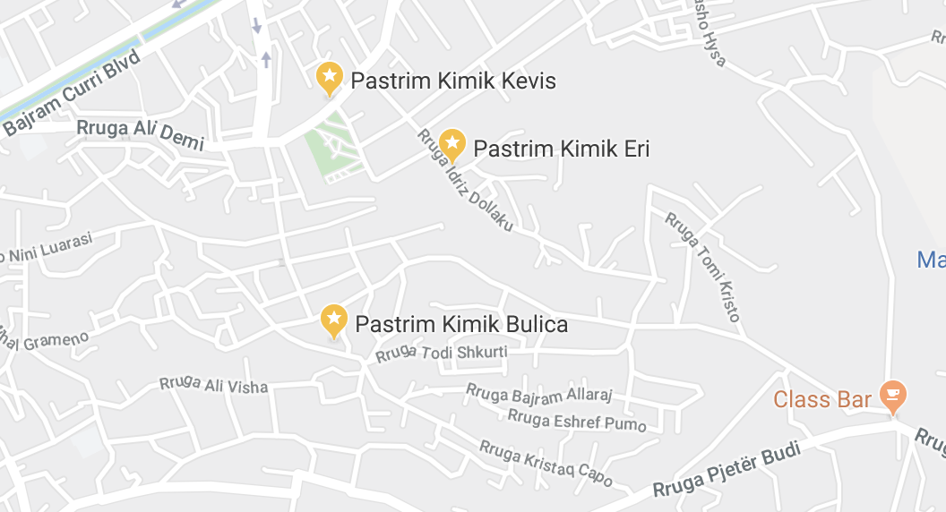

**Figure 4.3: Dry Cleaners Located in Unit 1 of Tirana**

Despite the differences in density throughout the units, our team found through our observations that the characteristics of these dry cleaners were very uniform across the units. The surroundings of these dry cleaners consisted of other small businesses, shops and places to eat. Additionally, the location of 100% of dry cleaners we observed were in buildings whose top floors were residences for Albanian citizens. Figure 4.4 depicts the characteristics of surroundings of dry cleaners, including stores they are next to, apartments they are below and where they are located in buildings.

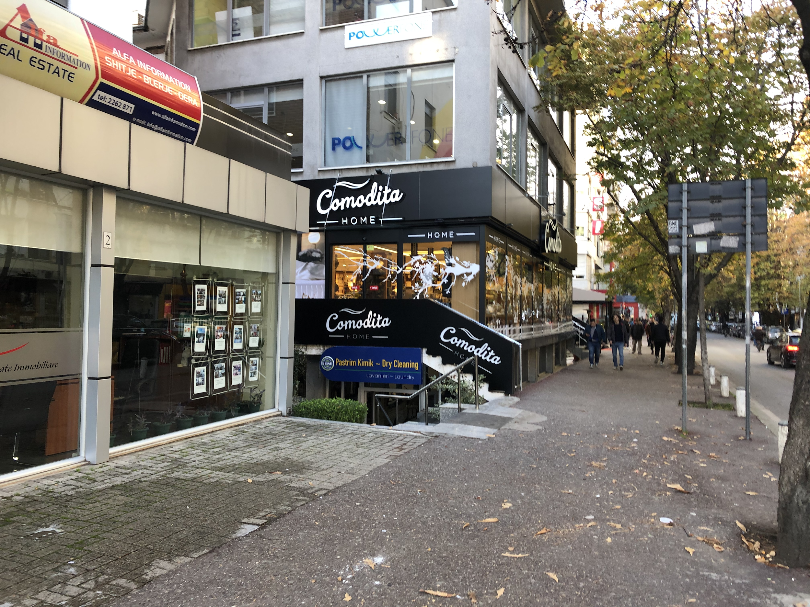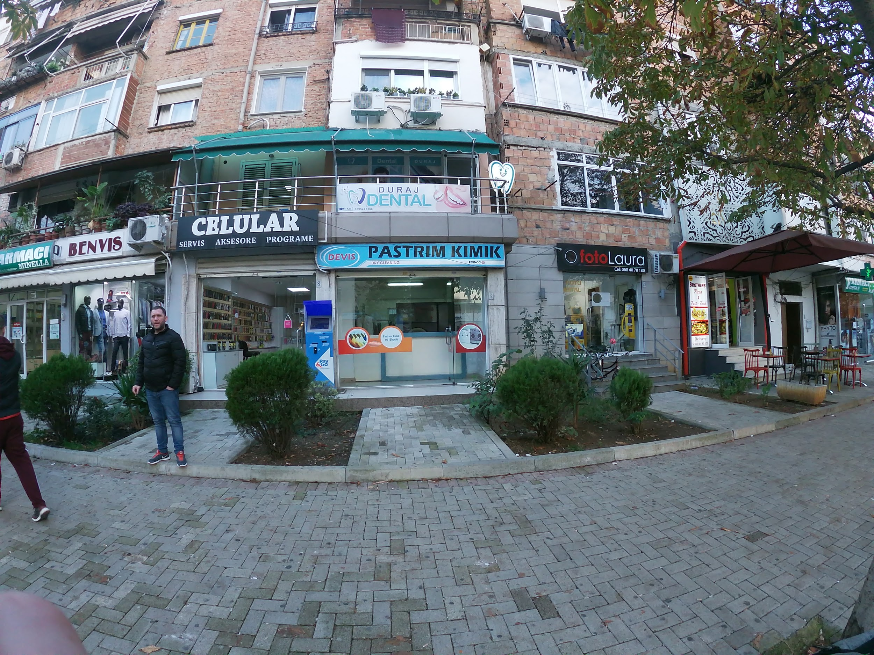

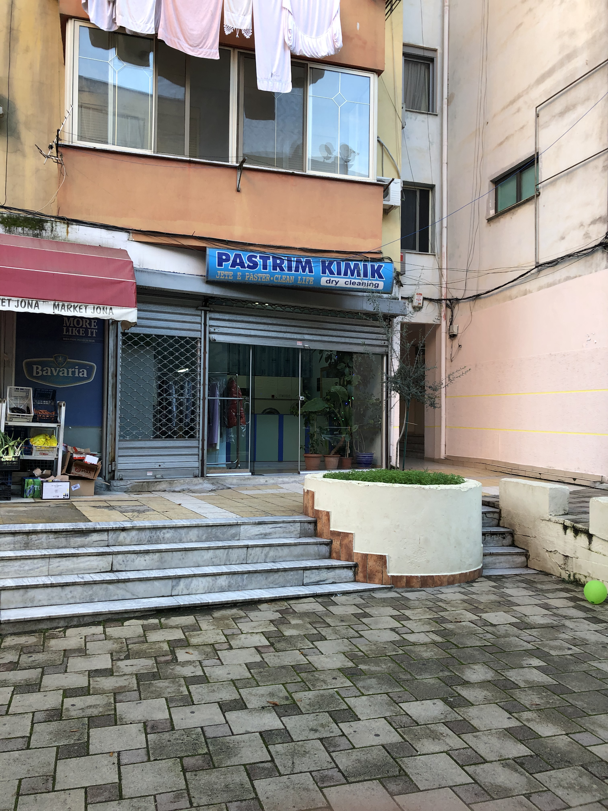

**Figure 4.4: Dry Cleaner Shop Fronts**

The response rate of dry cleaners to our surveys was also very consistent throughout the units. Figure 4.5 depicts the total amount of dry cleaners that were willing to talk to us within each unit, which resulted to around 50% for each unit. By adding two more units to our study (as discussed in section 3.1), we were able to increase our survey responses to 15 out of 30 dry cleaners, resulting in a response rate of exactly 50%.

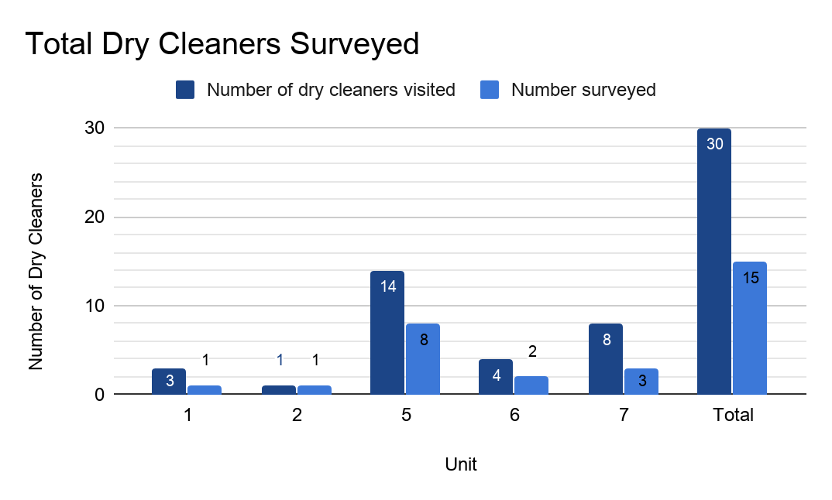

**Figure 4.5: Total Tirana Dry Cleaners Surveyed by Unit (n = 30)**

As Figure 4.6 displays, dry cleaners often refused to be surveyed because they were either too busy to answer our questions, or simply unwilling to speak to us. Occasionally, we encountered an employee who would claim that they did not have enough information to talk with us. Of the 16 dry cleaners who we did not survey, seven of them refused to speak to us for reasons not explained. In one survey, a team member had to convince the employee that we were not affiliated with the Albanian government before they were willing to participate. Overall, dry cleaners were skeptical towards our team’s project.

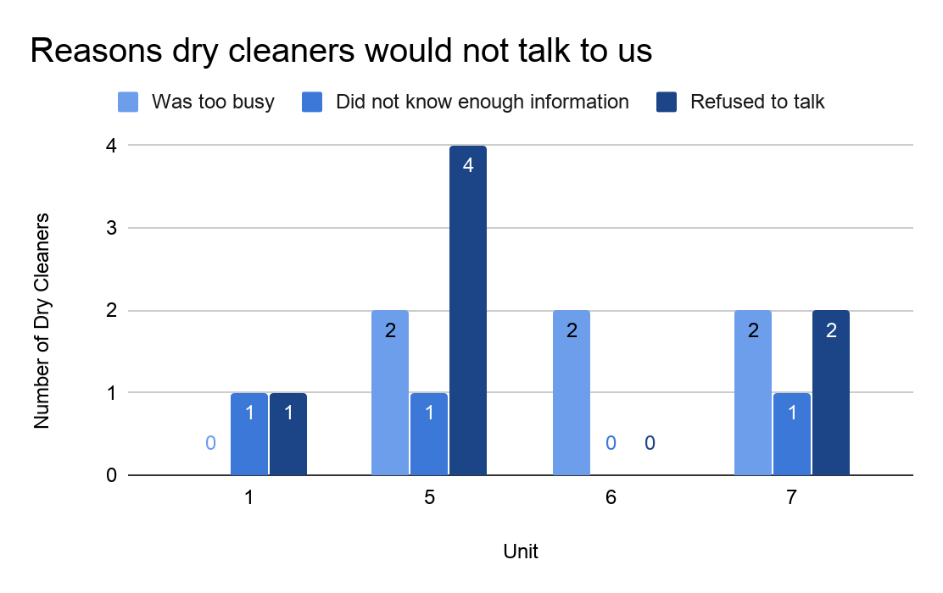

**Figure 4.6: Reasons Dry Cleaners Gave to Not be Surveyed (n = 16)**

## 4.2 Current Dry Cleaning Practices in Tirana

The team obtained a reasonable picture of current dry cleaning practices within our sample of the city of Tirana. These practices can be categorized as: the types of machines and solvent most commonly used, the solvent training a dry cleaner receives, and how they are managing the chemicals used in their machines.

### 

### Dry Cleaners Predominantly Use Perchlorethylene as Their Solvent

From our sample size of 15 dry cleaners, 12 (80%, as shown in Figure 4.7) stated explicitly that they use perchlorethylene in some part of their operations. Four of the dry cleaners reported that they used some kind of "professional detergent" that was not a solvent. Only one dry cleaner the team surveyed responded that they switched from perchlorethylene to wet cleaning. As displayed in Figure 4.8, 53% of dry cleaners told us that they use both perchlorethylene and either wet cleaning or a regular washing machine in their business. This shows that while perchlorethylene is the most prominent chemical these dry cleaners use, it is not the only product used by dry cleaners.

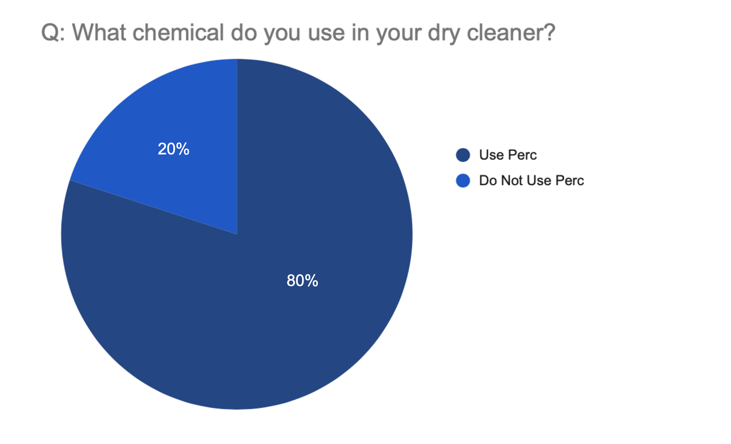

**Figure 4.7: Chemical Used by Dry Cleaners - Perc or Not Perc (n = 15)**

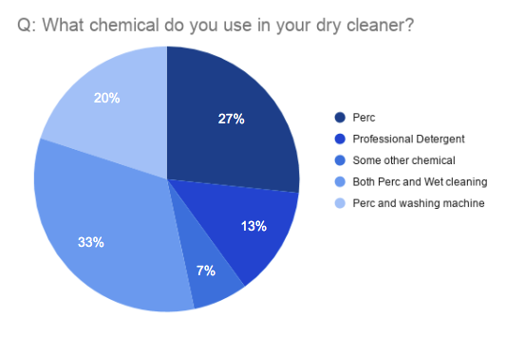

**Figure 4.8: Chemicals Used in Dry Cleaners (n = 15)**

### Dry Cleaners Use Many Types of Machines and Cleaning Methods Within the Same Shop

The surveyed dry cleaners reported having widely varied quantities and types of machines. The establishments ranged from reportedly having as many as 6 distinct machines to having as few as a single machine. Of the 15 dry cleaners surveyed, 8 had either two or three machines. During multiple surveys, dry cleaners stated that they used a regular washing machine in order to cut costs as using a perchlorethylene based machine is expensive due to the cost of the chemical.

While a number of dry cleaners reported that they used wet cleaning in their operation, it is unclear as to whether or not this is actually the case. When questioned about what they meant by 'wet cleaning’ the cleaner's response would sometimes reveal that they did not know what wet cleaning was, or had misconceptions about whether or not they were using it (e.g. a washing machine uses water, therefore it is wet cleaning).

### Dry Cleaners Have Varied Standards for Machine Inspection Frequency

One of the key aspects of perchlorethylene management is regularly inspecting machines for leaks, exhausts and abnormal behavior. As displayed in Figure 4.9, many Albanian dry cleaners do not inspect as often as the Albanian government requires (every six months). The team found that 53% of dry cleaners stated that they inspect their machines monthly or daily, which would potentially be adequate to catch potential problems, such as leaks, with the machines as they arise. In addition, 20% of dry cleaners said that they inspected their machines periodically, or between monthly and yearly. Thirteen percent of dry cleaners said that they inspect their machines “when there is a problem.” This implies that dry cleaners only check on the machines when they see problems arising in the quality of their dry cleaning or if they observe an obvious warning sign of a broken machine, like pooled solvent from a leak. The number of dry cleaners who did not regularly inspect their machines was cause for concern.

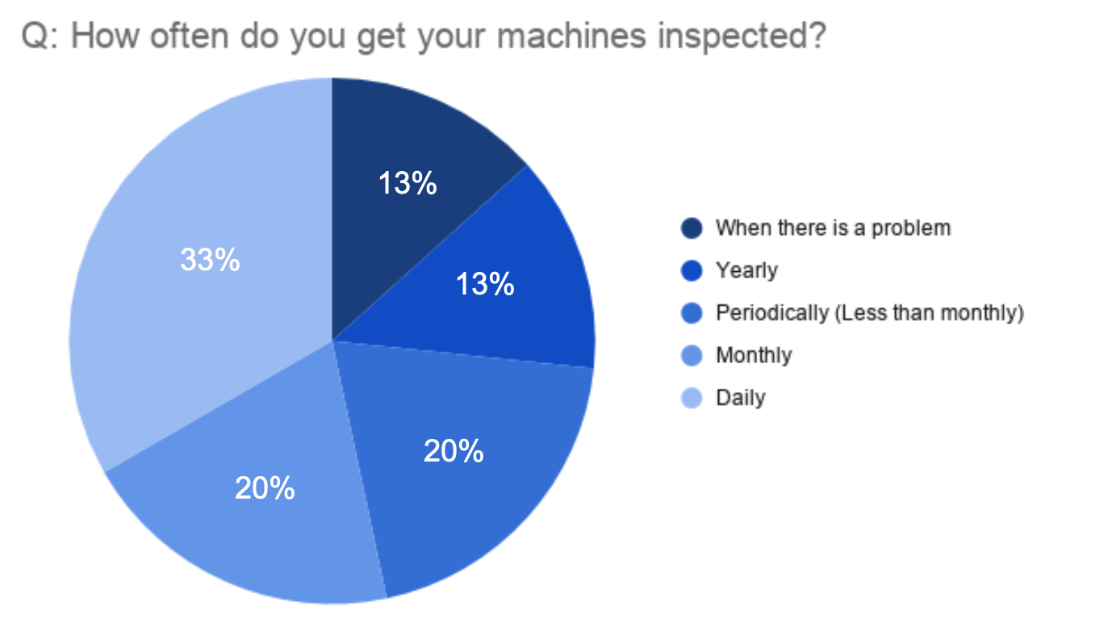

**Figure 4.9: Frequency of Machine Inspection by Dry Cleaners (n = 15)**

### There are Varied Techniques for Venting Shops Within Our Sample Population

Inadequate machine venting was prevalent within the dry cleaners the group surveyed. The data suggested varied methods of venting fumes out of the shop, as Figure 4.10 displays. The majority of dry cleaners stated that they used some form of aeration system, which they described as a selection of tubing connected to their machine which transports the fumes from the machine to outside of the shop. Even though this type of system vents the vapors from the machine, it does not vent the area where employees steam the garments, therefore only partially reducing perchlorethylene fume exposure. The next most common method of venting was windows. This method is cheap, but it is not always optimal. Windows are especially ineffective when processes occur far from the windows in enclosed shops, or when shop owners close windows due to weather. Furthermore, 36% of dry cleaners responded with a method other than aeration or windows. One dry cleaner noted that they used a “carbon filter” - likely the carbon absorber required of dry cleaners operating under OSHA regulation in the United States that allows dry cleaners to use older machines more safely. Less encouragingly, one respondent stated that they knew their shop had venting but they did not know where. Another respondent in the semi-structured dry cleaner interviews revealed that they knew their shop should have ventilation but that it did not. They chose to simply leave the shop for extended periods after dry cleaning cycles to avoid being exposed to the fumes. Only 7% of dry cleaners said that their shop had no venting. Although the majority of sampled dry cleaners stated they were venting their shops, they can improve their venting methods.

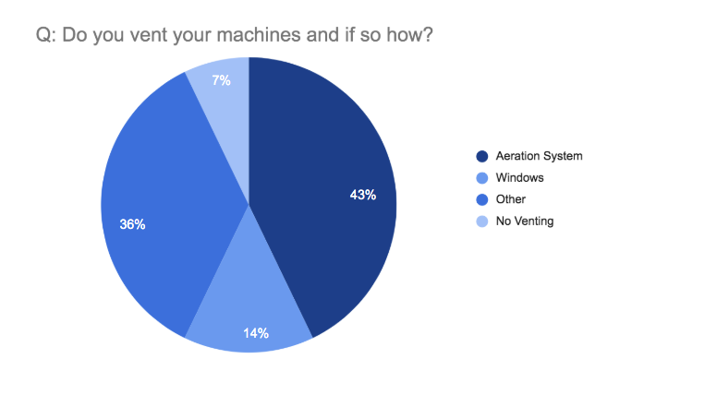

**Figure 4.10: Dry Cleaner Ventilation Method (n = 14)**

### Employees Receive Incomplete Training On Machines, Perchlorethylene, and Protective Equipment

Our research indicated that Tirana dry cleaners knew of the basic health hazards perchlorethylene can cause when repeatedly exposed. When the team asked in dry cleaner surveys if the employees knew about the dangers of perchlorethylene, 63% of dry cleaners who use perchlorethylene responded that they knew about the dangers of the chemical. Many of those dry cleaners added that they had learned about these dangers from the label on the perchlorethylene packaging. This labeling includes health hazards, fire hazards and emergency action for fires, spills and leaks. Dry cleaners who rely exclusively on labels for information on chemicals risks may not know key information about perchlorethylene management not included on the label, or may, due to lack of training, not fully understand the summarized emergency procedures.

The team found training on how to properly handle perchlorethylene to be extremely limited. As shown in Figure 4.11, 70% of dry cleaners using perchlorethylene stated that they managed the chemical simply by putting it into the machines directly from the package and did not describe taking any protective measures. The next largest group of respondents (20%) reported using some form of protective equipment, including gloves, masks, or special clothing. This group did not all describe using all protective equipment measures, and did not describe how they dealt with waste from the dry cleaning process. Only 10% of those surveyed were able to describe to the team how they and their machine safely managed perchlorethylene.

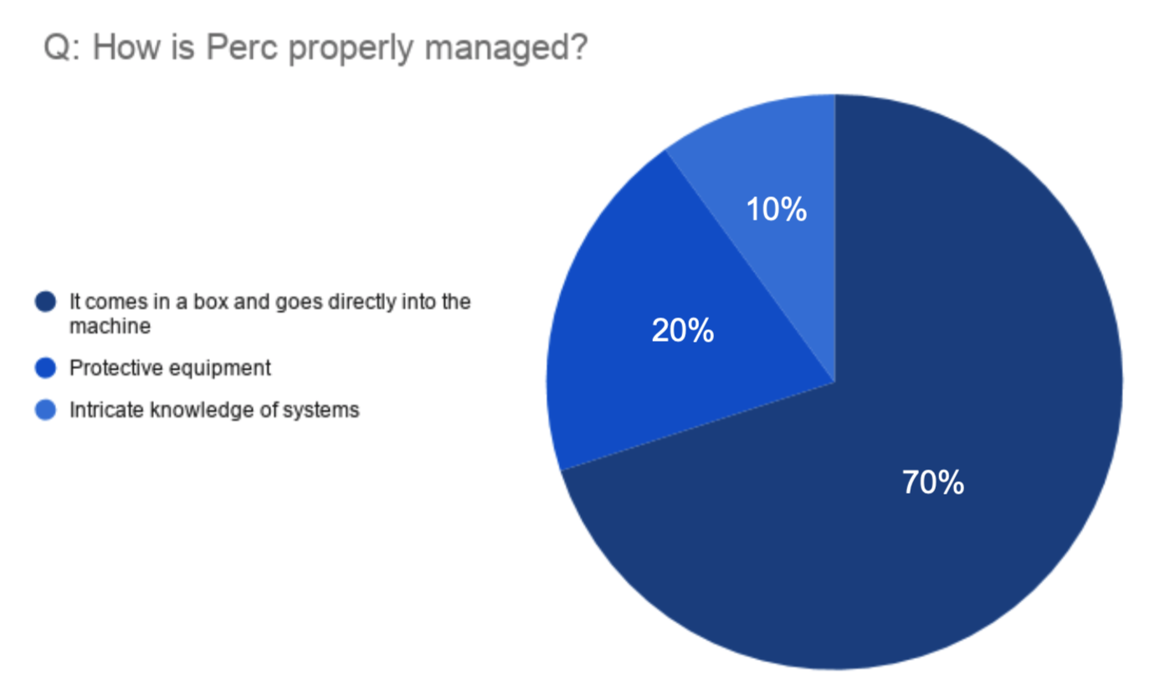

**Figure 4.11: Employee Knowledge of Perchlorethylene Management (n = 10)**

Many said their machine supplier or their employer gave them at least some training on general protective equipment (e.g. gloves, masks, special clothing). As shown in Figure 4.12, 78% of respondents mentioned receiving training in some form, and 57% of respondents mentioned a form of protective equipment their employer or supplier trained them to use. Three dry cleaners specifically mentioned their training did not include using protective equipment, only how to operate the machines. This limited style of training practices, while sufficient to operate a dry cleaner day to day, may be unsafe to workers who are not taught how to use protective equipment to handle perchlorethylene in the workplace when necessary.

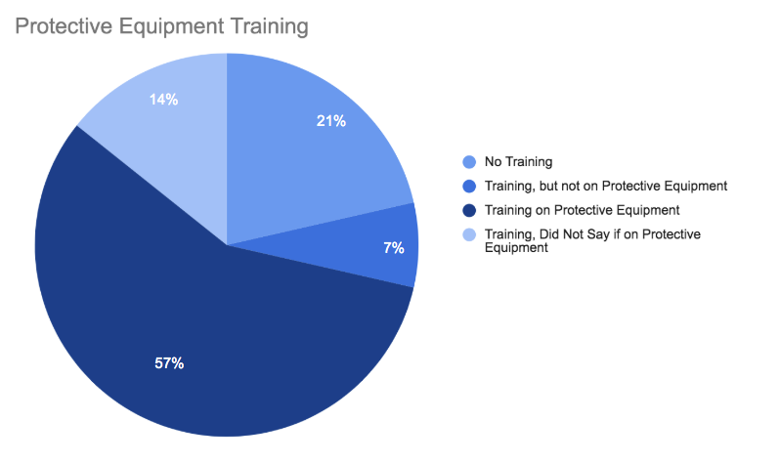

**Figure 4.12: Protective Equipment Training (n = 13)**

### Dry Cleaners Have a Functional Understanding of Relevant Regulation

Regulators in Albania composed standards in the hopes that dry cleaners will follow them and therefore maintain minimum levels of safety in their business. In our survey of dry cleaners, we asked participants about how the government regulated their business. Figure 4.13 displays their responses as a word cloud, where the size of the word corresponds to frequency of response. The most mentioned topic was environmental permit with 57% of respondents mentioning it, the second was hygiene (general workplace cleanliness) with 50%, and the third was taxes with 43%. All but one of the respondents mentioned at least one step in the permit process or the permit itself. No respondents mentioned waste, or wastewater treatment. The majority of the respondents were correctly able to talk with a functional level of knowledge about the system which regulated them.

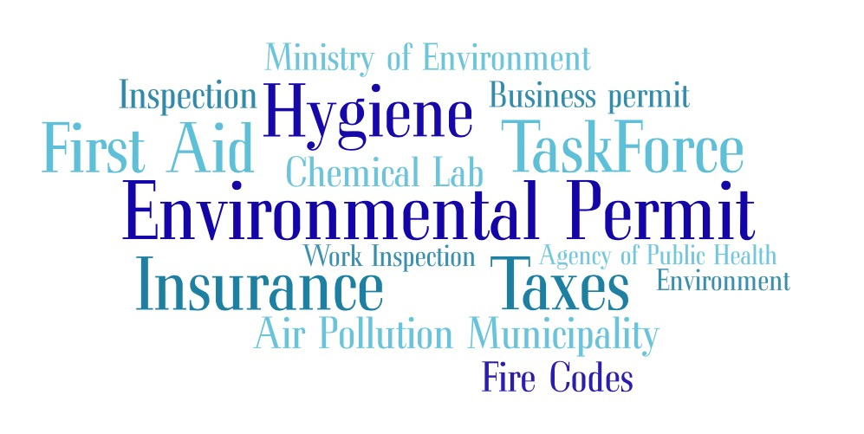

**Figure 4.13: Dry Cleaner Perception of Regulation**

## 4.3 Perspectives of Dry Cleaners on Adopting Greener Practices

### Dry Cleaners are Unaware of Green Practices Within Their Industry

Dry cleaners had limited knowledge about alternative practices to using the solvent perchlorethylene in their machines. When asked if they knew about any alternatives, 58% were aware of alternatives namely, many that responded yes clarified that they were unsure of specifics. Two respondents that said they were aware of alternatives, but expressed doubt that any dry cleaners would implement alternatives in Albania due to the technology and price of the new machines and alternatives. Our in-depth interviews discovered that dry cleaners primarily get information about solvents, detergents, and their eco-friendly counterparts from their suppliers. All dry cleaners who spoke about their suppliers in in-depth interviews and surveys said they simply use the materials the suppliers send to them.

### Dry Cleaners are Unwilling to Adopt Greener Practices due to Financial Limitations and Apathy from Their Customers

Out of the six dry cleaners who were aware of alternatives to perchlorethylene, but did not use them, all six claimed that financial limitations were the only factor preventing them from switching their machine to be more ecologically friendly. Furthermore, two out of those six mentioned that dry cleaning was more expensive than wet cleaning but felt that the high initial cost to switch machines discourages dry cleaners from switching to a more environmentally benign system.

Dry cleaners in Tirana are not likely to update or convert their machines unless their existing one breaks down and can no longer function. Based on our 15 surveys with dry cleaners, the typical age of their business is 10 years and the typical age of the machine is 12 years (due to secondhand machines). A T-Test found that there is sufficient evidence to suggest that the number of years a dry cleaner has been operating in Tirana can be a good predictor for the age of the primary machine that they use. In other words, dry cleaners do not often update their machines. Since feasible alternatives almost always need a completely new machine, this is a possible reason why dry cleaners are not aware of or switching to alternatives. If their machine can last up to 15 years (Onasch, 2010), the business rarely has to think about new machines, including ecologically friendly ones. Even if they are aware of alternative machines, dry cleaners do not have the finances to pay the initial cost of a new machine until time has passed to save money, and their machine is not properly functioning anymore.

## 4.4 Perspectives of Public on Greener Dry Cleaning Practices

Our sponsor distributed the survey to its volunteers and contact list which could lead to selection bias. This list contained mainly young female activists: 76% of our sample was female, 85% of it was under the age of 30, and 54% were between the ages of 21 and 30. As a result of their involvement with EDEN Center or EDEN Center volunteers, our sample may have been especially enthusiastic about seeing environmentally friendly changes around Albania. This impacts our survey significance since the general public may be less invested in environmental sustainability than our sample population.

### 

### Survey Participants were Generally Unaware of the Chemicals and Processes of the Dry Cleaning Industry

The majority of our sampled population reported that they “do not know anything about the chemicals or steps used in the dry cleaning process”, as depicted in Figure 4.14.

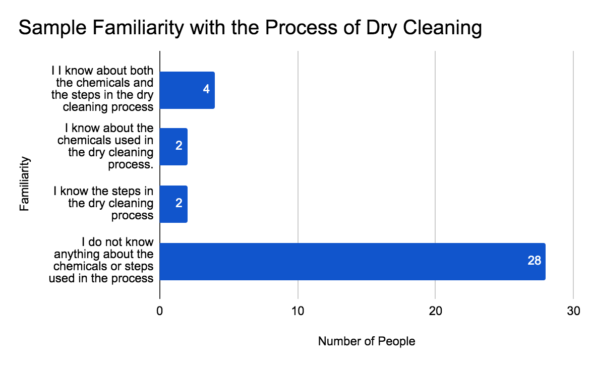

**Figure 4.14: Sample Familiarity with the Process of Dry Cleaning (n = 36)**

Specifically, when it comes to the chemical perchlorethylene and the dangers associated with it, respondents are also uninformed. The majority or survey participants, 78% as shown in Figure 4.15, were unable to identify perchlorethylene as a harmful chemical. However, 48% were unaware that perchlorethylene is a carcinogen which is one of the chemicals most alarming traits. Forty six percent of respondents did not believe a person would be at risk to the perchloroethylene effects if they did not work directly with the chemical which also correlates to their belief that getting your clothes cleaned will not cause adverse health effects on the customer. Surprisingly, 61% of the respondents do believe there are laws that specifically regulate the dry cleaning business, however we do not know if they believe the laws are related to health or environmental risks. This is especially concerning considering the majority of our respondents are environmentally conscious, and even they have limited knowledge of the hazards.

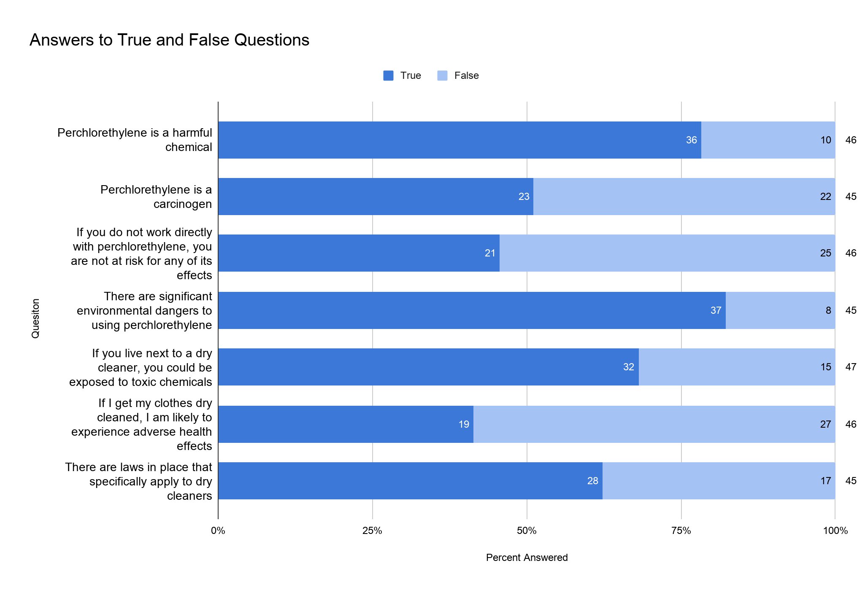

**Figure 4.15: Answers to True/False Survey Questions**

We could not find any correlation between the unit where respondents lived and how much they knew about the dry cleaning process. Notably, people who live close to dry cleaners have no more significant amount of knowledge then the remainder of the surveyed population. Based on Figure 4.16, we based proximity on the 44% of people who answered they live above/next to a dry cleaner or on the same street as a dry cleaner. Of this subset of respondents, 87% answered that they do not know anything about the dry cleaning process or chemicals. This means that even close proximity to a dry cleaning business will not motivate interest in the processes or potential risks of harmful chemicals of the business.

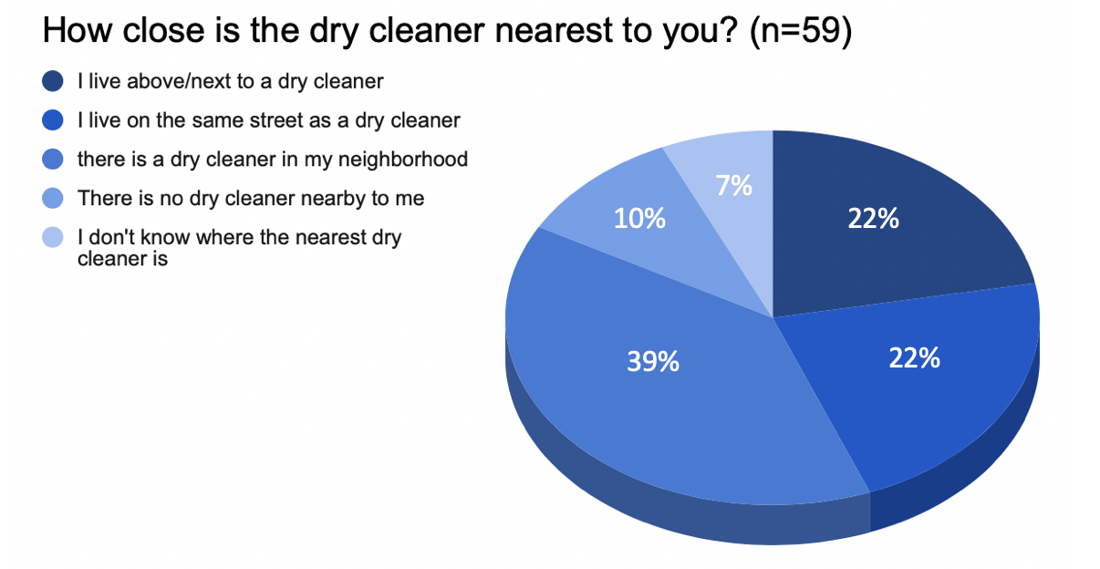

**Figure 4.16: Proximity of Respondents to Dry Cleaners**

### 

### Survey Respondents are Likely to Take Action but Not Pay Significantly More for Greener Dry Cleaning Practices

Our survey respondents are also likely to take action, potentially as a result of their aforementioned preferences for ecological choices. At the end of the survey, we provided respondents with a short passage detailing some dangers of perchlorethylene (See Appendix G, Table 2.9, Question C21 for the full blurb). Figure 4.17 depicts how when we asked what actions the respondents would be willing to take, based on their new knowledge of perchlorethylene, more than half of our sample answered that they were extremely likely to take action. These actions include: searching for dry cleaners using alternative solvents, wash more clothing my themselves, ask the dry cleaner about the chemicals they use and ask the dry cleaner to consider alternative chemicals. Since these responses were likely biased by our sample population who are interested in making ecologically friendly improvements, one cannot use this data to represent the entire general public in Tirana.

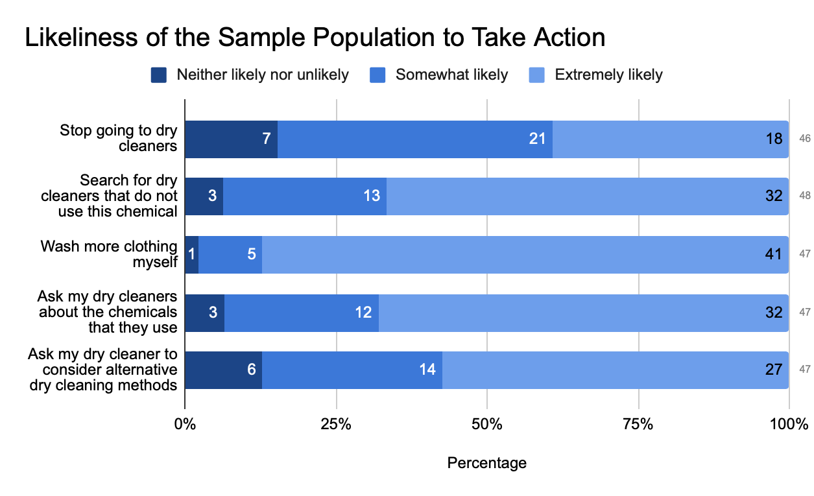

**Figure 4.17: Likeliness of the Sample Population to Take Action**

Our results from asking respondents about dry cleaning price, shown in Figure 4.18, verify that our sample is willing to pay slightly more to have their clothes dry cleaned in an environmentally friendly fashion along with their willingness to take non-monetary action. Of the 69 respondents, 62% said they would be willing to pay more, while 38% said they would be unwilling to pay more. The majority of those willing to pay more were willing to pay only a little more (~133% of normal price). The general population, which may be less inclined to favor environmental practices than our potentially biased sample of young female activists, may be less willing to pay for this industry shift.

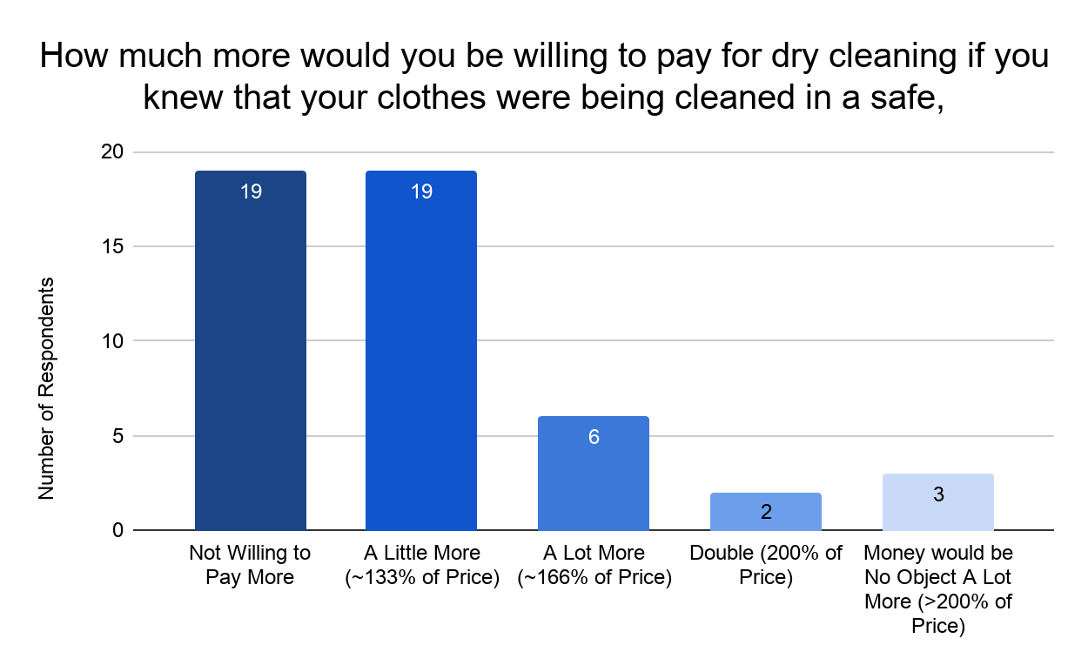

**Figure 4.18: Customer Willingness to Pay More for Greener Practices (n = 49)**

# Chapter 5: Recommendations

Through field work this investigation found that dry cleaners do not prioritize detailed training on chemicals management or chemical alternatives. Additionally, we discovered that our sample of residents in Tirana has limited knowledge of the risks posed by dry cleaning practices and the chemicals used in the process. There is need to inform and educate both dry cleaners and the public about more environmentally friendly dry cleaning alternatives and short term practices to reduce risks to employees and the public. The next three sections offer recommendations for dry cleaners, the Albanian public, and regulators, respectively.

## 5.1 Recommendations for Dry Cleaners

Dry cleaners can reduce their exposure from perchlorethylene used in dry cleaning machines through proper maintenance, ventilation and use of protective equipment (masks, gloves, etc). Since dry cleaners in our survey do not replace machines unless they are broken, day-to-day operational changes, such as regular maintenance, proper venting, and extensive training, can also help reduce risk. Proper maintenance entails frequent inspection of the machine to make sure it emits no unwanted hazardous vapors are emitted. Proper venting in a dry cleaner is also a key factor to reduce hazardous emissions and is usually found in newer machine technology. Dry cleaners can add ventilation measures like carbon absorbers to older machines so an entire machine replacement is not necessary. Due to the fact that most dry cleaners operate underneath apartments, we also recommend avoiding venting into areas which might expose tenants to the fumes. Finally, when handling and managing perchlorethylene, dry cleaners should use personal protective equipment including solvent resistant gloves, and goggles. Suppliers and employers should train workers on how to limit their exposure to perchlorethylene from their machines. These steps will increase the safety of the machine operators and reduce the emissions from the machines to unwanted areas.

To educate dry cleaners about these issues, we have created fact sheets (see Appendix J), not only on alternatives to a perchlorethylene based system but also on practical measures dry cleaners can take to reduce the risk without switching their machines. The team provided our sponsor with the facts sheets to distribute at their own discretion.

## 5.2 Recommendations for the Public

This project recommends the EDEN Center launch an environmental awareness campaign on reducing risk from dry cleaning practices targeted at the general public. This campaign is needed because our online survey found that people are unaware of the risks from dry cleaning practices and may not be easily motivated to independently do research. This is shown from our data addressing the actions the respondents are willing to take to decrease environmental impact. The purpose of this campaign is to simultaneously educate them on the potential dangers (vapor intrusion, water supply contamination, and cancer risks), and provide individuals with a reason to care without being alarmist. The campaign should promote awareness of hazardous emissions from dry cleaners, as well as educate customers to make informed decisions relating to dry cleaning. A sustained effort from organizers to raise public awareness could potentially be a passive force for change in the dry cleaning industry, by equipping the public with the knowledge required to routinely make more ecological and healthy choices.

We created sample educational material (see Appendix J) for EDEN Center to use in this public campaign. The team gave these materials to our sponsor for them to distribute at their own discretion.

## 5.3 Recommendations for Regulators

Due to the fact that Albanian regulators are in the process of shifting their regulation to adhere to European Union standards, we have no broad regulatory suggestions. The single step we recommend is to require dry cleaners to obtain as much information as possible from their suppliers and through well defined employer training about the risks they are facing. This will enable them to make informed decisions about how to run their businesses and may independently make safer and more environmentally friendly choices when feasible. Although this regulation is difficult to enforce, it is worthwhile because even if a small number of suppliers and dry cleaners follow it, there will be a net benefit of increased safety in the industry.

# Chapter 6: Conclusions

During our background research at Worcester Polytechnic Institute (WPI), and our fieldwork in Tirana, the team has attempted to learn to what extent dry cleaners are cognizant of the risks they face. Our investigation indicates that dry cleaners are inconsistently trained about how to handle perchlorethylene. In addition, regulations for dry cleaners are extremely limited in scope, and are not enforced well enough to ensure dry cleaner safety. Dry cleaners are - for the most part - unaware of green alternatives to perchlorethylene, and if they are aware they are unwilling to switch to green alternatives due to financial limitations. We also discovered that within our sample population, these people were either unaware of the risks of the dry cleaning industry, or understandably confused by them. Our project team hopes that by prioritizing dry cleaner education, these businesses will continue taking steps to reduce risk in their workplace to protect employees, the environment, and residents of Tirana.

# 

# References

Bureau of Toxic Substance Assessment New York State Department of Health. (2015). Tetrachloroethylene (Perc) in Indoor and Outdoor Air. Retrieved 8 October 2019 from <https://www.health.ny.gov/environmental/chemicals/tetrachloroethene/>

California Air Resources Board. (2017). Dry Cleaning Program. Retrieved 23 September 2019

from <https://ww3.arb.ca.gov/toxics/dryclean/dryclean.htm>

CDC - NIOSH. (1997). Control of Exposure to Perchlorethylene in

Commercial Dry Cleaning [PDF Document]. Retrieved 30 September 2019 from

<https://www.cdc.gov/niosh/docs/hazardcontrol/pdfs/hc19.pdf?id=10.26616/NIOSHPUB97157>

Centre for Research and Interdisciplinary (CRI). (2016). Effects of Perc on the Environment.

Retrieved 1 October 2019 from <http://2016.igem.org/Team:Paris_Bettencourt/About_Perc>

Dry Cleaning and Laundry Institute International. (2018). Flexible Dry Cleaning Training.

Retrieved 23 September 2019 from <https://www.dlionline.org/Education>

Dry Cleaning Chillers. (n.d). Dry Cleaning Machinery. Retrieved 23 September 2019 from

[www.drycleaningchiller.com/dry-cleaning-machinery/](http://www.drycleaningchiller.com/dry-cleaning-machinery/)

Dumani, B., Bici, R., Dumani, N., Subashi, B., & Kondi, A. (2018). Dissemination of

Demographic and Socio-Economic Developments in Tirana with Special Attention to

Youth Education [PDF file]. *Journal of Educational and Social Research*, 8, 93-108. https://doi.org/10.2478/jesr-2018-0020

Earnest, G.S, Spencer, A.B., Smith, S.S., Heitbrink, W.A., Mickelsen, R.L., McGlothlin, J.D., &

Ewers, L.M. (1997). Control of Health and Safety Hazards in Commercial Dry Cleaners:

Chemical Exposures, Fire Hazards, and Ergonomic Risk Factors. Retrieved 23

September 2019 from

<https://www.cdc.gov/niosh/docs/97-150/default.html#Typical%20Drycleaning%20Process>

Eco Wash Albania. (n.d.). What We Do. Retrieved 23 May 2019 from <https://ecowash.al/>

EDEN Center. (n.d.). About Us [Translated Webpage]. Retrieved 23 September 2019 from [www.eden-al.org/index.php/al/rreth-nesh/profili](http://www.eden-al.org/index.php/al/rreth-nesh/profili)

Environmental Protection Agency (EPA). (2015). RCRA in Focus, Dry Cleaning [PDF file].

Retrieved 23 September 2019 from

<https://www.epa.gov/sites/production/files/2015-01/documents/dryclean.pdf>

Environmental Protection Agency (EPA). (1981). Chapter 4: Evaporation Loss Sources, AP 42,

Fifth Edition, Volume I. Retrieved 23 September 2019 from <https://www3.epa.gov/ttn/chief/ap42/ch04/index.html>

Environmental Protection Agency (EPA). (2008). National Perchlorethylene Air Emission Standards For Dry Cleaning Facilities[PDF file]. Retrieved 23 September 2019 from <https://www.epa.gov/sites/production/files/2015-06/documents/fact_sheet_dry_cleaning_july2008.pdf>

EPA Integrated Risk Information System Division. (2012). Toxicological Review of Tetrachloroethylene (Perchloroethylene) In Support of Summary Information on the Integrated Risk Information System (IRIS) [PDF file]. CAS, (127). Retrieved 23 September 2019 from <https://cfpub.epa.gov/ncea/iris/iris_documents/documents/toxreviews/0106tr.pdf>

Fann, N. (2005). Perchloroethylene Dry Cleaners Refined Human Health Risk Characterization[PDF file]. Retrieved 23 September 2019 from <https://www.epa.gov/sites/production/files/2015-06/documents/riskassessment_dry_cleaners.pdf>

Food and Drug Administration (FDA). (2003). Total Diet Study Summary of Residues Found Ordered by Pesticide Market Baskets [XML file]. Retrieved 23 September 2019 from <https://ntrl.ntis.gov/NTRL/dashboard/searchResults.xhtml?searchQuery=PB2005108087>

Gary, E. S., Lynda, E., & Avima, R. M. (2011). Laundries, Garment and Dry Cleaning.

Retrieved 2 October 2019, from

<http://iloencyclopaedia.org/component/k2/169-100-personal-and-community-services/laundries-garment-and-dry-cleaning>

Giles, S. (2019). *Personal Communication.*

Green Dry Cleaning Solvents. (2017). Retrieved 2 October 2019 from

<https://www.sgs.com/en/news/2017/08/safeguards-12417-green-dry-cleaning-solvents>

Grout, C. & Sincheimer, P. (2004, September 30). Comparison of energy and water use of five

garment care technologies: Evaluation the potential for an electricity rebate program for

professional wet cleaning [PDF file]. *Pollution Prevention Education and Research Center Urban and Environmental Policy Institute*. Retrieved 23 September 2019 from <http://scholar.oxy.edu/cgi/viewcontent.cgi?article=1386&context=uep_faculty>

Heinrich, Janel. (September, 2012). An Overview of PCE Contamination of Indoor Air from

Vapor Intrusion [PDF file]. *Public Health Madison and Dane County*. Retrieved 23 September 2019 from <https://www.publichealthmdc.com/documents/PCEVaporIntrusionReport.pdf>

Huang, B., Lei, C., Wei, C., & Zeng, G. (2014). Chlorinated volatile organic compounds

(Cl-VOCs) in environment — sources, potential human health impacts, and current remediation technologies. *Environment International*, *71*, 118–138. [https://doi.org/](https://doi.org/10.1080/0002889778507753)10.1016/j.envint.2014.06.013

International Fabricare Institute (IFI). (1989) Reducing Vapor Exposure: OSHA compliance

[PDF file]. *International Fabricare Institute*, 13(5), 1-8. Retrieved 23 September 2019

from

<https://pdfs.semanticscholar.org/fa45/87a1e315d066dd8dafab3388e776d0d89de4.pdf>

Industrial Drying Machine. (n.d.). Retrieved 23 September 2019 from

<https://www.indiamart.com/proddetail/industrial-drying-machine-16657235973.html>

Livingston County Health Department (LCHS), Michigan Department of Environmental Quality

(MDEQ, & Michigan Department of Health and Human Services (MDHHS). (2018). Vapor Intrusion. Retrieved 23 September 2019 from <https://www.livgov.com/health/eh/Pages/Vapor-Intrusion.aspx>

Massachusetts Department of Environmental Protection (MassDEP). (2015). Dry Cleaners

Environmental Certification Workbook [PDF file]. Retrieved 23 September 2019 from

<https://www.mass.gov/files/documents/2016/08/xh/dcwkbk.pdf>

National Cleaners Association. (2018). About NCA. Retrieved 23 September 2019 from

<http://www.nca-i.com/about.html>

National Clothesline. (2018). Trade Association Guide. Retrieved 23 September 2019 from

<http://www.natclo.com/tag.htm>

New Jersey Department of Environmental Protection. (n.d.). Dry Cleaner Checklist [PDF file].

Retrieved 23 September 2019 from

<https://www.state.nj.us/dep/aqes/sbap/docs/p2cklist.pdf>

Occupational Safety and Health Administration (OSHA). (2005). Reducing Worker Exposure to

Perchloroethylene (PERC) in Dry Cleaning [PDF file]. Retrieved 23 September 2019

from <https://www.osha.gov/dsg/guidance/perc.pdf>

Occupational Safety and Health Administration (OSHA). (n.d.). Personal Protective Equipment.

Retrieved 23 September 2019 from

<https://www.osha.gov/SLTC/personalprotectiveequipment/>

Onasch, Joy, P.E. (2011). A feasibility and cost comparison of perchloroethylene dry cleaning to professional wet cleaning: Case study of Silver Hanger Cleaners, Bellingham, Massachusetts. *Journal of Cleaner Production*, 19(5), 477–482. https://doi.org/10.1016/j.jclepro.2010.07.015

Papker, J. C., Bahlman, L. J., Leidel, N. A., Stein, H. P., Thomas, A. W., Wolf, B. S., & Baier, E. J. (2000). Tetrachloroethylene (perchloroethylene). *American Industrial Hygiene Association Journal,* 39(3), A-23-A-29. <https://doi.org/10.1080/0002889778507753>

Petruccelli, J., Nandram, B., & Chen, M.-H. (2001). *Applied Statistics for Engineers and Scientists*, 43(1), 103. https://doi.org/10.1198/tech.2001.s554

Renner, M. & Taylor-Powell, E. (2003). *Analyzing Qualitative Data*. Madison, WI: Board of

Regents of the University of Wisconsin System.

Retail Compliance Center. (2017). Dry Cleaning. Retrieved 23 September 2019 from

<http://www.retailcrc.org/RegGuidance/Pages/virtual-store.aspx?s=Dry+Cleaning>

Schnapf, L. (2014, November). Dry Cleaners: The Environmental Scourge of Commercial

Real Property. *The Practical Real Estate Lawyer*, 30 (6), 31-48.

Toxics Use Reduction Institute (TURI). (2012). Assessment of Alternatives to Perchlorethylene for the Dry Cleaning Industry. Retrieved 3 October 2019 from <https://www.turi.org/Our_Work/Business/Small_Businesses/Dry_Cleaning>

Toxics Use Reduction Institute (TURI). (2019). Massachusetts Safer Alternatives Fact Sheet. Retrieved 8 October 2019 from <https://www.turi.org/TURI_Publications/TURI_Chemical_Fact_Sheets/Fact_Sheet_-_Alternatives_to_Perchloroethylene_Used_in_Professional_Garment_Care>

Towle, E., Bruno, J., Hemingway, J., & Eaton, S. (n.d.). *Pharmaceutical Waste Disposal:*

*Current Practices in Tirana, Albania.* Worcester Polytechnic Institute.

United States Department of Health and Human Services. (2002). Toxicological Profile for Tetrachloroethylene. *ATSDR’s Toxicological Profiles*. <https://doi.org/10.1201/9781420061888_ch147>

WetCleanersUSA. (n.d.). Non-Toxic, Environmentally Safe: Wet Cleaning Alternative to Dry

Cleaning. Retrieved 3 October 2019 from

<http://wetcleanersusa.com/wcu/>

# Appendix A: Perchlorethylene Alternative Assessment Fact Sheet

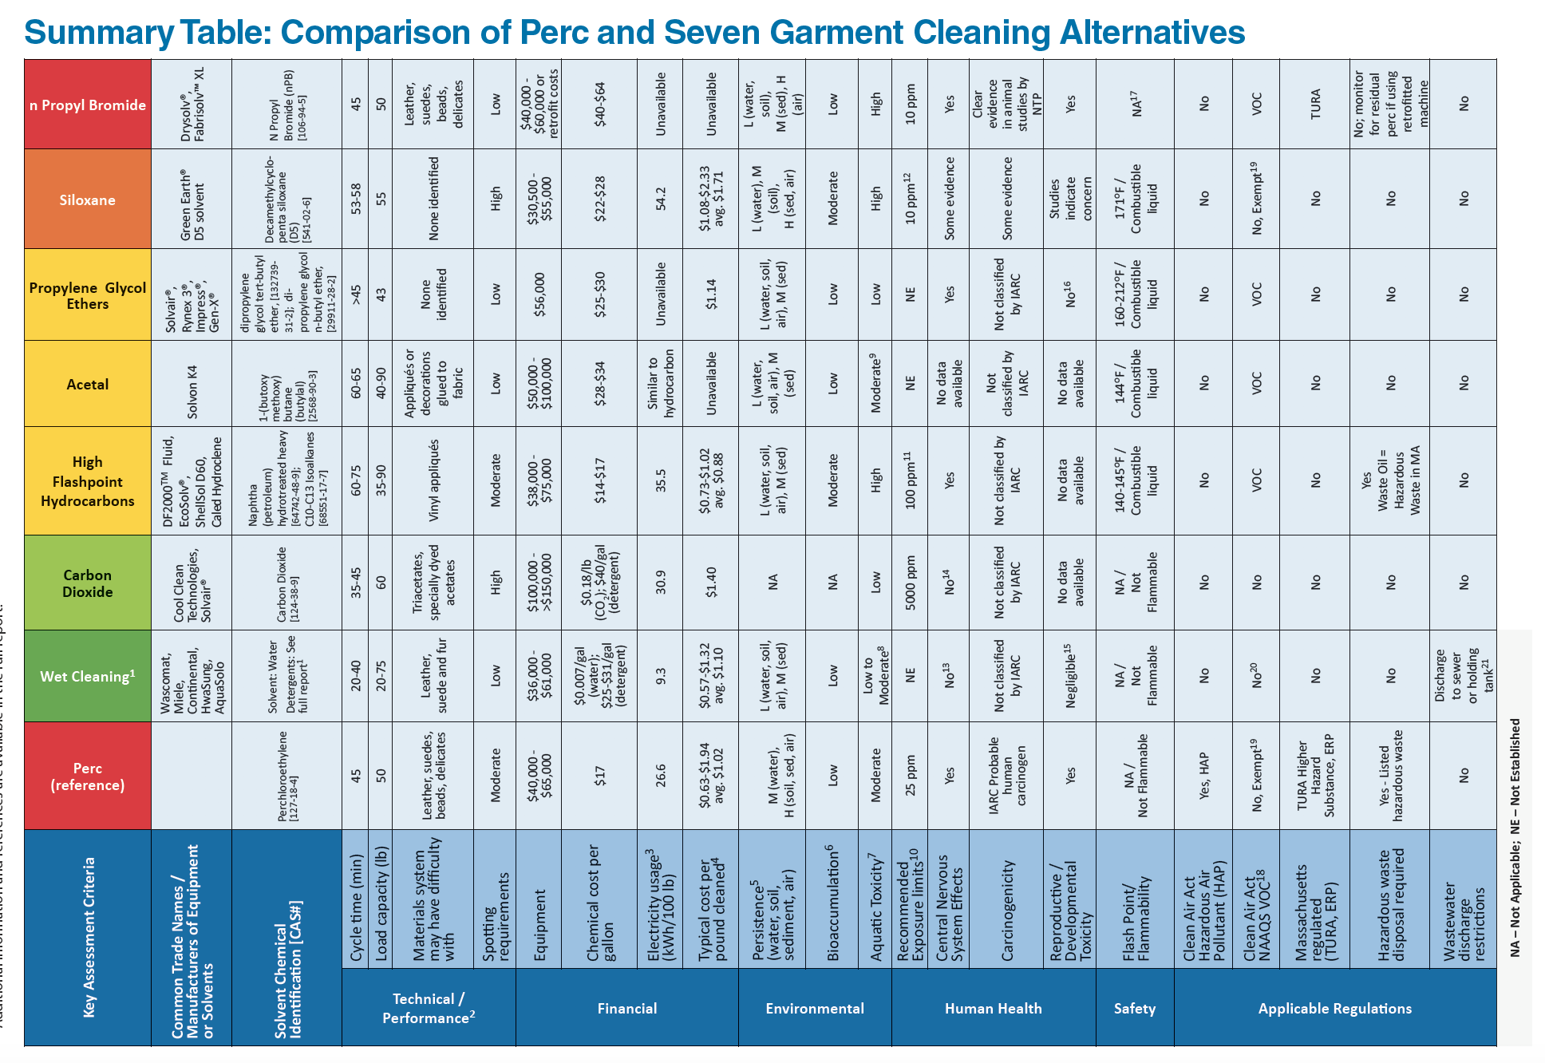

**Figure A.1: Perchlorethylene Alternative Assessment Fact Sheet (TURI, 2019)**

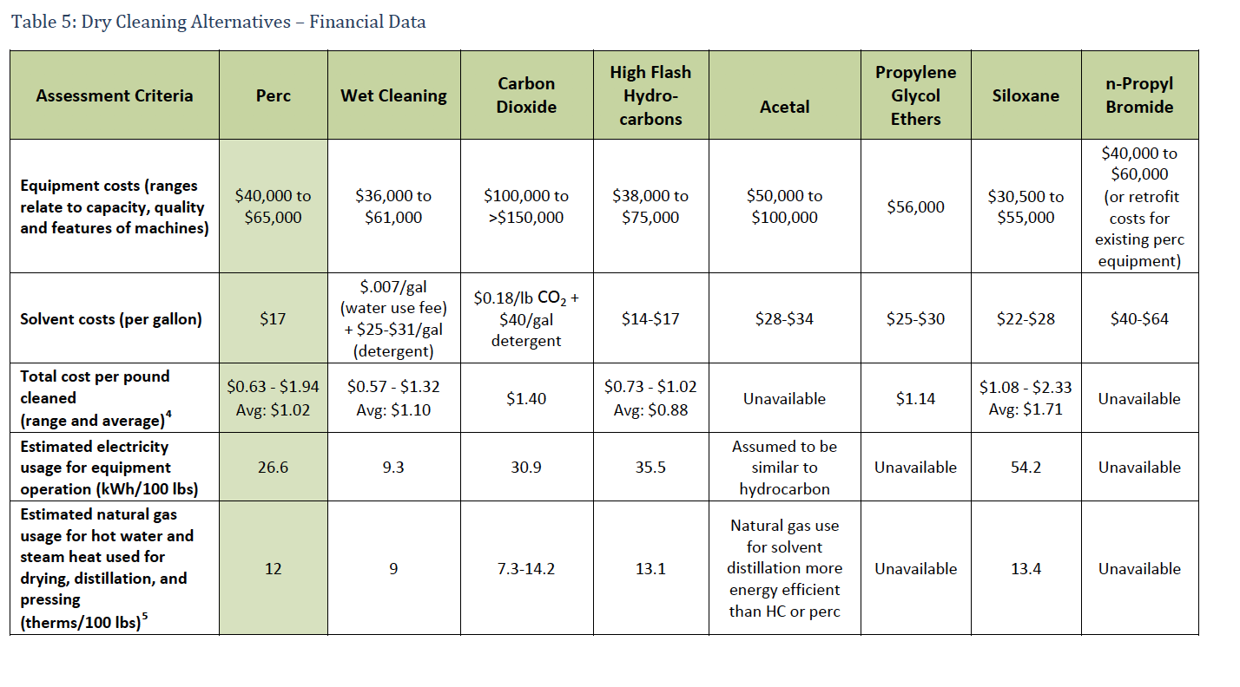

**Figure A.2: Financial Comparison of Perchlorethylene Alternatives**

# 

# Appendix B: Summarized American Standards

**OSHA**

This agency provides no specific regulation for dry cleaners, but regulation of broader topics apply to the industry. Information from this table is partially from the OSHA guidance on Perchlorethylene (OSHA, 2018).

**Table B.1: OSHA Regulation Summary**

|  |  |
| --- | --- |
| **Topic** | **Explanation** |
| Worker Exposure Limits for Perchloroethylene | See Table B.2 below. |
| Hazard Communication (29 CFR 1910.1200) | Information about chemical hazards, like perchlorethylene, must be available and understandable to workers. This requirement includes proper training for handling any hazardous material, materials safety data sheets, and appropriate labeling. |
| General Requirements for Personal Protective Equipment ([29 CFR 1910.132](https://www.osha.gov/sites/default/files/enforcement/directives/CPL_02-01-050.pdf)) | Broadly providing, maintaining, and training on personal protective equipment necessary to keep employees safe. In this case, this would be equipment to limit employee exposure to perchlorethylene: gloves, masks, and appropriate ventilation. |
| Respiratory Protection (29 CFR 1910.134) | This subpart of the Personal Protective Equipment requirement mandates that employers will provide NIOSH-certified respiratory equipment where it is necessary to protect the health of employees. |

**Table B.2: OSHA Worker Exposure Limits (OSHA, 2018)**

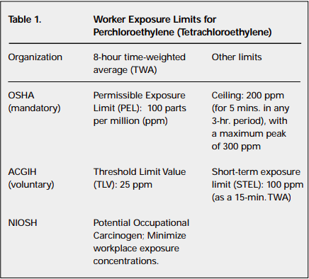

**EPA**

This agency varies its dry cleaner regulation based on the size of the dry cleaner.

This table is a condensed and paraphrased version from the EPA’s RCRA in Focus document. If you would like more information, examine the RCRA in Focus documentation.

Large Quantity Generators (LQGs) generate greater than or equal to 1,000 kg of hazardous waste per month, or greater than 1 kg of acutely hazardous waste per month.

Small Quantity Generators (SQGs) generate between 100 kg and 999 kg of hazardous waste per month.

Conditionally Exempt Small Quantity Generators (CESQGs) generate less than or equal to 100 kg of hazardous waste per month, and less than or equal to 1 kg of acutely hazardous waste per month.

**Table B.3: EPA Regulation Summary**

|  |  |  |  |  |
| --- | --- | --- | --- | --- |
| **Topic** | **LQGs** | **SQGs** | **CESQGs** | **Explanation** |
| EPA Identification Number | ✓ | ✓ |  | Each facility needs an identification number so that the EPA can track hazardous waste activities. |
| Hazardous Waste Identification | ✓ | ✓ | ✓ | Facilities test to see if they produce hazardous waste per the RCRA standards. |
| Used Oil Standards | ✓ | ✓ | ✓ | If the facility uses oil, they must follow separate waste disposal standards for it. |
| Waste Counting | ✓ | ✓ | ✓ | Facilities figure out how much waste they produce to learn their generator status. |
| Accumulation Area | ✓ | ✓ |  | Some facilities can choose to collect waste in an area near where it was made, and the amount of waste may or may not be limited before it must be disposed of. |
| Other Accumulation Areas (Time and Quantity Limits) | ✓ | ✓ | ✓ | If the facility cannot have a satellite waste area, they must follow stricter regulations involving when waste is removed and how much waste can stay in the area. |
| Storage Unit Requirements | ✓ | ✓ |  | Storage units for accumulating waste must be kept in good condition, and meet a stringent set of standards. |
| Air Emissions | ✓ |  |  | Large generators must follow the RCRA Organic Air Emission standards. |
| Preparedness and Prevention | ✓ | ✓ |  | Facilities must be prepared for events like fires and other emergency scenarios. |
| Contingency Plan | ✓ | ✓ |  | Large facilities must file a plan for minimizing hazards in the event of a fire or emergency spill, and both large and small facilities must take appropriate measures to make sure emergency information is available including having an on call emergency coordinator. |
| Personnel Training | ✓ | ✓ |  | Facility personnel must be educated about hazardous waste handling and emergency plans. |
| DOT Packaging | ✓ | ✓ | ✓ | Before being transported, waste must be packaged and labeled in accordance with DOT requirements. |
| Off Site Management of Waste | ✓ | ✓ | ✓ | Hazardous waste sent off site must, unless otherwise exempt, must be sent to a hazardous waste treatment storage and disposal facility or recycling facility. |
| Onsite Management of Waste |  |  | ✓ | If a CESQG qualifies as one of a specific category of facility, it may treat waste onsite or send their waste to a facility that does qualify. |
| Manifest | ✓ | ✓ |  | Hazardous waste being transported must be accompanied by enough copies of a detailed document with information about the waste’s treatment process that all stakeholders can have one copy to keep and one copy to update and send back to the generator. |
| Land Disposal Restriction (LDR) Notification | ✓ | ✓ |  | Any waste sent off site must meet LDR treatment standards, and be accompanied by a paper that either verifies that it meets these standards or is exempt from them. |
| Hazardous Waste Minimization | ✓ | ✓ |  | LQGs are required to have a program in place to reduce the volume of toxic waste they produce, and take steps to ensure they minimize present and future threats from their waste. LQGs and SQGs must sign a certificate of hazardous waste minimization, and SQGs must make a good faith effort to select the best method to minimize risks that that they can afford. |
| Biennial Report | ✓ |  |  | LQGs must submit twice-yearly reports of waste management activity every even-numbered year so that government entities can track trends in hazardous waste management. |
| Recordkeeping | ✓ | ✓ |  | LQGs must maintain personnel training records, the last 3 years of biennial reports, the last 3 years of manifests, and the last three years of hazardous waste determination tests. SQGs must keep the last three years of manifests and hazardous waste determination tests. |

# 

# Appendix C: New Jersey Dry Cleaner Checklist

This information is from the New Jersey Small Business Environmental Assistance Program’s Dry Cleaner Checklist.

|  |  |
| --- | --- |
|  |  |

# Appendix D: In-Person Survey and Interview Considerations

**Preventing Bias:**

The team made it clear to the subject that the interview is confidential, and met in a place tailored to the interviewee in order to ensure the interviewee felt comfortable and able to share their genuine answers.

**Introductory Statement:**

This statement was given to all individuals surveyed or interviewed in person.

Përshëndetje/ Hello! We are a group of American students studying the current dry cleaning system in Tirana. We are working with EDEN to perform this research. EDEN is the Environmental Center for Development, Education, and Networking, and it is a Tirana-based non-governmental organization. Our team would like to interview you about dry cleaning practices. If possible, we would like to record this interview, but if you are uncomfortable with that we can take notes instead. If you do participate, you can choose not to answer any of the questions we ask you. Your responses will be used as data in our report for our school and for EDEN. Your participation in this interview will be confidential. The report will be available online at EDEN’s discretion, and if you would like we can send you a copy of the completed report. Before we start, do you have any questions for us?

**Introduction Questions**

These questions were asked for all in-person subjects.

**Table D.1: Introduction Questions in English**

|  |  |
| --- | --- |
| I1 | Do we have your permission to record this interview? |
| I2 | Do we have your permission to quote this interview in our report to EDEN? |

**Table D.2: Introduction Questions in Albanian**

|  |  |
| --- | --- |
| I1 | A kemi lejen tuaj për të regjistruar këtë intervistë? |
| I2 | A kemi lejen tuaj për ta cituar këtë intervistë në raportin tonë për EDEN? |

**Concluding Statement**

Thank you for taking the time to speak with us. Is there anything else you think we could have asked, or anything else you would like to tell us? Would you like to review our notes, or the recording of the interview? If we make a transcript, would you like to review it? If you have any questions about the interview or our work, you can reach us through email, phone, or through the EDEN center at -insert email/phone number/EDEN contact information-. Thank you so much for your time.

# 

# Appendix E : Tirana Dry Cleaner In-Person Survey Protocol

**Name of Dry Cleaner and Relation (owner or employee):**

**Date and Time:**

**Attendees:**

**Location:**

**Table E.1: Dry Cleaner Survey Questions in English**

|  |  |  |  |
| --- | --- | --- | --- |
| Number | Question | Employee | Owner |
| A1 | How long has your business been open? |  | X |
| A2 | About how many people do you dry clean for on a given day? | X | X |
| A3 | What kinds of items do you clean? | X | X |
| A4 | How many items of clothing do you clean on an average day? | X | X |
| A5 | How many people work here? | X | X |
| A6 | What chemicals do you use to wash clothing? | X | X |
| A7 | (if they are using perc) Are you aware of the dangers of Perc? | X | X |
| A8 | (if they are using perc) What steps do you currently take in properly managing perc? | X | X |
| A9 | How old is your dry cleaning machine? |  | X |
| A10 | Do you have separate machines for drying and washing? | X | X |
| A11 | What training do you give new workers about the process?/Were you given any training? | X | X |
| A12 | If they train/if you were trained, were they/you trained to use protective equipment and if so what? | X | X |
| A13 | Do you vent your machines and if so how? | X | X |
| A14 | How often do you inspect your machines, or get your machines inspected? | X | X |
| A15 | How much did your current machines cost? |  | X |
| A16 | When and where did you buy your current equipment? |  | X |
| A17 | What do you do with the chemicals after they are used? | X | X |
| A18 | (if they are using perchlorethylene) How aware are you of any alternative systems to the one that you currently use? |  | X |
| A19 | (if they do know about alternatives) Are you aware of how much it would cost you to switch to a different solvent? |  | X |
| A20 | (if they do know about alternatives and are not using them) What, if anything, is preventing you from changing systems? |  | X |
| A21 | What controls does the government apply to your business? Which institutions apply them? |  | X |

**Table E.2: Dry Cleaner Survey Questions in Albanian**

|  |  |  |  |
| --- | --- | --- | --- |
| Numër | Question | Employee | Owner |
| A1 | Prej sa kohësh është i hapur ky biznes? |  | X |
| A2 | Sa klientë vijnë përafërsisht në ditë për pastrim kimik? | X | X |
| A3 | Cfarë lloj artikujsh merrni për pastrim kimik? | X | X |
| A4 | Sa është sasia e artikujve mesatarish në ditë? | X | X |
| A5 | Sa është numri i punonjësve? | X | X |
| A6 | Çfarë detergjentësh përdorni për larjen e rrobave? | X | X |
| A7 | A jeni në dijeni të rreziqeve nga perkloroetileni? (nëse përdorin) | X | X |
| A8 | Nëse është më shumë se 5, Cfarë hapash ndiqni për ta menaxhuar sasinë e perkloroetilenit? | X | X |
| A9 | Sa të vjetra janë makineritë e larjes? |  | X |
| A10 | A i keni proceset e larjes dhe tharjes së rrobave në një makineri apo në makineri të ndara? | X | X |
| A11 | Çfarë trajnimesh kanë marrë punonjësit për të kryer të gjithë procesin e pastrimit kimik? | X | X |
| A12 | Nëse janë të trajnuar/jeni të trajnuar, a jeni trajnuar për të përdorur veshje mbrojtëse dhe nëse po, cfarë tjetër? | X | X |
| A13 | A përdorni ventilim për makinën larëse? Nëse po, si? | X | X |
| A14 | Sa shpesh i kontrolloni makineritë larëse? | X | X |
| A15 | Sa kushtoi makineria larëse e fundit? |  | X |
| A16 | Kur dhe ku i keni blerë pajisjet e fundit larëse? |  | X |
| A17 | Si i trajtoni kimikatet pasi janë përdorur? | X | X |
| A18 | A jeni në dijeni për sisteme të tjera alternative të pastrimit kimik? (nëse përdorin perc) |  | X |
| A19 | (Nëse Po) A jeni në dijeni sesa mund të kushtojë nëse përdorni një substancë tjetër larëse? |  | X |
| A20 | Nëse dinë alternativa të tjera por nuk i përdorin, Çfarë po ju ndalon që të ndryshoni sistemin larës përveç detyrimit financiar? |  | X |
| A21 | Cfarë kontrollesh kryhen në biznesin tuaj nga institucionet shtetërore? Cilat institucione kryejnë kontrolle? |  | X |

# 

# 

# Appendix F: Regulator Interview Protocol

**Interview Subject and Name of Institution:**

**Date and Time:**

**Attendees:**

**Location:**

**Table F.1: Regulator Interview Questions in English**

|  |  |
| --- | --- |
| Number | Question |
| B1 | Do we have your permission to record this interview? |
| B2 | Do we have your permission to use your name in a quote in our report to EDEN? |
| B3 | What is your connection to dry cleaning regulation? What responsibilities towards this area does your institution have? |
| B4 | What risks from the dry cleaning industry are you most concerned with limiting? |
| B5 | What is your opinion about the current system for dry cleaner chemicals management? |
| B6 | What are the challenges around regulating small businesses like dry cleaners? |
| B7 | In the U.S., many dry cleaners do not comply with laws related to pollution. Do you think the same is true here? |
| B8 | What, in your opinion, is the hardest part of the legislation for dry cleaners to adhere to? The easiest? |
| B9 | What incentives could, in your opinion, increase or decrease compliance of a chemicals management policy? |
| B10 | Are there any trade organizations that help dry cleaners in Albania? |
| B11 | What information from our work would be most helpful to you? |
| B12 | Is there anything else you want to tell us? |

**Table F.2: Regulator Interview Questions in Albanian**

|  |  |
| --- | --- |
| Numër | Pyetje |
| B1 | A kemi lejen tuaj për të regjistruar këtë intervistë? |
| B2 | A kemi lejen tuaj për të përdorur emrin tuaj në një citim në raportin tonë për EDEN? |
| B3 | Cila është lidhja juaj me rregulloren e pastrimeve kimike? Çfarë përgjegjësish ka institucioni ku ju punoni ndaj kësaj fushe? |
| B4 | Për cfarë pjese të pastrimit kimik jeni më e shqetësuar ? (ajrimi, trajtimi ujrave, përdorimi kimikateve në dedergjent etj) |
| B5 | Cili është mendimi juaj për sistemin aktual për administrimin e kimikateve të pastrimeve kimike? |
| B6 | Cilat janë sfidat për rregullimin e bizneseve të vogla si pastrimet kimike? |
| B7 | Në SH.B.A., shumë biznese të pastrimeve nuk respektojnë ligjet në lidhje me ndotjen. A mendoni se e njëjta gjë ndodh dhe këtu? |
| B8 | Cila, sipas mendimit tuaj, është pjesa më e vështirë e legjislacionit që bizneset e pastrimit kimik t'i përmbahen? Po më e lehta? |
| B9 | Cilat stimuj, sipas mendimit tuaj, mund të rrisin ose ulin përputhshmërinë e një politike të menaxhimit të kimikateve? |
| B10 | A ka ndonjë organizatë tregtare që ndihmon në bizneset e pastrimit kimik në Shqipëri? |
| B11 | Çfarë informacioni nga puna jonë do të ishte më e dobishme për ju? |
| B12 | A ka ndonjë gjë tjetër që doni të na tregoni? |

# 

# Appendix G: Public Survey Protocol

Welcome to our online survey! We are a group of American students working with EDEN (link to EDEN’s website) researching hazardous waste practices in Tirana, and we appreciate your responses. The information you provide will be used as data in a report given to our school and EDEN. Your participation is optional and completely anonymous. Feel free to skip any questions you do not wish to answer.

**Table G.1: Public Survey Questionnaire in English**

|  |  |
| --- | --- |
| Number | Questions |
| C1 | Do you live in Tirana? (yes, no) |
| C2 | (If answer to P1 is yes) In what administrative unit do you live? (1: Ali Demi, 2: Bulevardi Bajram Curri, Bulevardi Zhan D’Ark, Qyteti Studenti, Sauku, 3: Brryli, Xhamlliku, 4: Kinostudio, Babrru, Allias, 5: Blloku, Selita, Tirana e Re, 6: Kombinati, Yzberishti, 7: 21 Dhjetori, Ish-Fusha e Aviacionit, 8: Selvia, Medreseja e Tiranës, 9: Lagji e Trenit, Brraka, Don Bosko (upper part), 10: Central Tirana, 11: Lapraka, Instituti, Don Bosko (lower part)) |
| C3 | How old are you? (under 18, 18-20, 21-30, 31-40, 41-50, 51-60, 65+) |
| C4 | What is your gender? (Male, Female, Other) |
| C5 | How close is the dry cleaner nearest to you? (I live above/next to a dry cleaner, I live on the same street as a dry cleaner, There is a dry cleaner in my neighborhood, there is no dry cleaner nearby to me, I don’t know where the nearest dry cleaner is) |
| C6 | (if the answer to P5 is I live above/next to a dry cleaner or I live on the same street as a dry cleaner) Do you have any particular positive or negative stories that stem from living near a dry cleaner? (Leave blank if no) |
| C7 | How important to you are the following factors when selecting a dry cleaner to use?  (Chose: Important, moderately important or not at all important for each factor) (Cost, Quality of Dry Cleaning, Speed of Dry Cleaning, Location, Friendliness, Availability of chemical alternatives, Reputation) |
| C8 | Are there any other factors in your selection? (Leave blank for no) |
| C9 | In an average month, how often do you visit dry cleaners? (0, 1, 2, 3, 4, 5+) |
| C10 | (if the answer to P9 is 0) Why do you not visit dry cleaners? (Choose as many options as apply: high cost, no need, too far away, health risk, environmental concern other (with text box)) |
| C11 | (if the answer to P9 is not 0) What kinds of items do you have dry cleaned? (check all that apply: shirts, pants, suits/wedding dresses, skirts, rugs, sheets, tablecloths, napkins, furniture, other (with text box)) |
| C12 | About how much money (in ALL) do you usually spend on a single visit to a dry cleaner? (Text Box) |
| C13 | Which of the following statements best describes your familiarity with the processes used to dry clean your items? (I know about both the chemicals and the steps in the dry cleaning process, I know about the chemicals used in the dry cleaning process, I know the steps in the dry cleaning process, I do not know anything about the chemicals or steps used in the process) |
| C14 | (If the answer to P13 is: I do not know anything about the chemicals or steps used in the process) What would make you want to learn more about the dry cleaning process? (Select all that apply: cost difference, concern for the environment, health issues, other) |
| C15 | Are you concerned about the risk posed by dry cleaners? (Yes, a little, no) |
| C16 | (If the answer to P13 is NOT: I do not know anything about the chemicals or steps used in the process) How did you learn this information? (Choose all that apply: Reading signage, looking at a website, dry cleaner telling customers, asking the dry cleaner, other) |
| C17 | (If answer to P16 is: asking the dry cleaner, looking at a website or other) why did you choose to do this research? (Choose all that apply: To make sure that my items could be dry cleaned, out of curiosity, out of concern for safety, other) |
| C18 | How strongly did this information affect your decision to get your clothes dry cleaned? (Not at all, a little bit, a lot, it was the most significant aspect of my decision) |
| C19 | (answer the following as true or false)  Perchlorethylene is a harmful chemical  Perchlorethylene can cause headaches and nausea  Perchlorethylene has been shown to induce sudden heart failure  Perchlorethylene is a carcinogen  If you do not work directly with perchlorethylene, you are not at risk for any of its effects  Some cleaners use water for certain garments in the dry cleaning process  All dry cleaners use the same chemical to clean clothes  Every dry cleaner cleans all garments that they are given on site  There are laws in place that specifically apply to dry cleaners  If i get my clothes dry cleaned, I am likely to experience adverse health effects  If you live next to a dry cleaner, you could be exposed to toxic chemicals  Food purchased near a dry cleaner can potentially be contaminated by chemicals  There are significant environmental dangers to using perchlorethylene |
| C20 | How much more would you be willing to pay for dry cleaning if you knew that your clothes were being cleaner in a safe, environmentally friendly way? (I wouldn’t be willing to pay more, I would be willing to pay a little more (~133% of normal price), I would be willing to pay a lot more (~166% of normal price), I would be willing to pay up to double (200% of normal price), Money would be no object (>200% of normal price)) |
| C21 | Perchlorethylene is a chemical often used in dry cleaning that is known to cause effects including increased risk of Cancer and neurological problems. It has also been shown to cause significant problems for the environment around dry cleaners that handle it improperly; including contaminating the soil and groundwater around the dry cleaner |
| C22 | Based on the information in P21, how likely would you be to make the following changes? (Chose Extremely likely, somewhat likely or neither likely nor unlikely for all changes: Stop going to dry cleaners, search for dry cleaners that don’t use this chemical, wash more clothing myself, ask my dry cleaner about the chemicals that they use, ask my dry cleaner to consider alternative methods) |

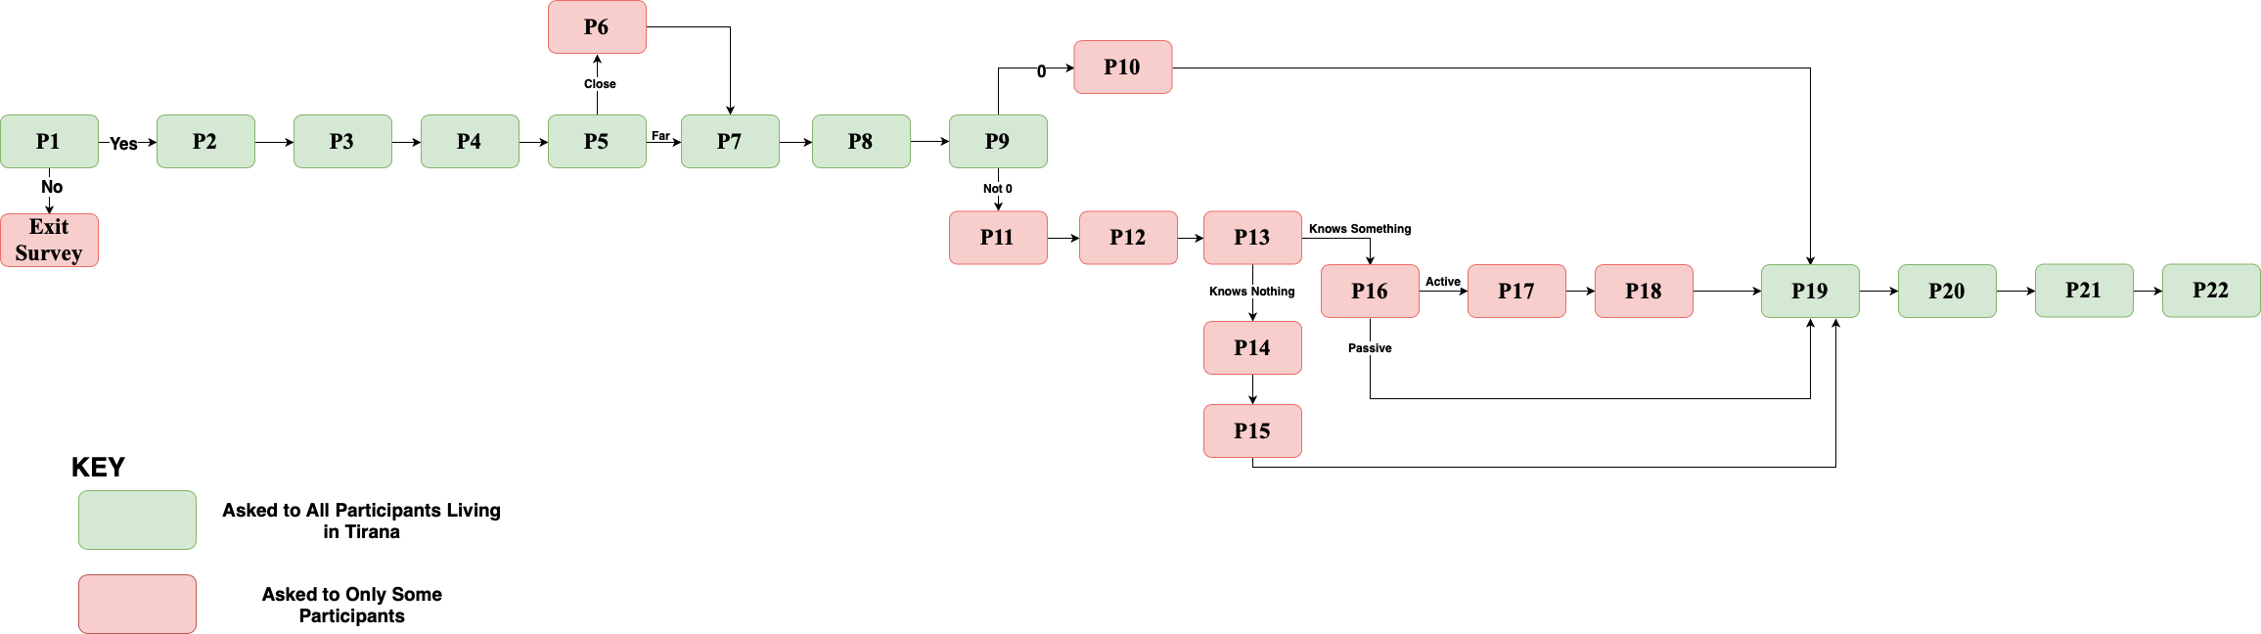

**Figure G.1: Survey Logic**

**Table G.2: Public Survey Questionnaire in Albanian**

|  |  |
| --- | --- |
| Numër | Pyetje |
| C1 | A jetoni në Tiranë? (Po, Jo) |
| C2 | Në cilën njësi administrative jetoni? ((1) Ali Demi, (2) Bulevardi Bajram Curri, Bulevardi Zhan D’Ark, Qyteti Studenti, Sauku (3) Brryli, Xhamlliku (4) Kinostudio, Babrru, Allias (5) Blloku, Selita, Tirana e Re (6) Kombinati, Yzberishti (7) 21 Dhjetori, Ish-Fusha e Aviacionit (8) Selvia, Medreseja (9) Lagjia e Trenit, Brraka, Don Bosko (zona e sipërme) (10) Qendra e Tiranës (11) Lapraka, Instituti, Don Bosko (zona e poshtme) |
| C3 | Sa vjeç/e jeni? (Nën 18, 18-20, 21-30, 31-40, 41-50, 51-60, 60+) |
| C4 | Çfarë gjinie keni? ( Mashkull, Femër, Tjetër) |
| C5 | Sa afër jush ndodhet pastrimi kimik? (Unë jetoj sipër/afër një pastrimi kimik, Jetoj në të njëjtën rrugë ku ndodhet pastrimi kimik, Në lagjen time ndodhet një pastrim kimik. Nuk ka asnjë pastrim kimik afër banesës sime, Nuk e di ku ndodhet pastrimi kimik më i afërt) |
| C6 | A keni ndonjë histori specifike positive apo negative si pasojë e të jetuarit pranë një pastrimi kimik? (Nëse “Jo” mos e plotësoni) |
| C7 | Sa të rëndësishëm janë për ju faktorët e mëposhtëm kur zgjidhni pastrimin kimik ku do shkoni? (Çmimi, Cilësia e pastrimit kimik, Vendndodhja, Sjellja miqësore, Disponibiliteti për detergjentët alternativë, Reputacioni) |
| C8 | A ka faktorë të tjerë që ndikojnë në zgjedhjen tuaj? (Nëse “Jo” mos e plotësoni) |
| C9 | Në një muaj mesatarisht, sa shpesh shkoni në pastrim kimik? (0, 1, 2, 3, 4, 5+) |
| C10 | Pse nuk shkoni në pastrim kimik? (Zgjidhni më shumë se një mundësi) (Çmimi i lartë, E panevojshme, Janë shumë larg, Rreziku për shëndetin, Shqetësimi për mjedisin, Tjetër) |
| C11 | Çfarë artikujsh çoni në pastrim kimik? (Zgjidhni më shumë se një mundësi) (Bluza, Pantallona, Kostume/Fustane dasme, Funde, Qilima, Çarçafë, Mbulesa tavoline, Peceta, Mobilie, Tjetër) |
| C12 | Sa shpenzoni mesatarisht për çdo pastrim kimik? |
| C13 | Cila nga fjalitë e mëposhtme përshkruan më mirë njohurinë tuaj me procesin e pastrimit kimik? (Kam njohuri për detergjentët dhe proceset në pastrimin kimik, Kam njohuri për detergjentët, Kam njohuri për proceset e pastrimit kimik, Nuk kam njohuri as per detergjentët as për proceset e pastrimit kimik) |
| C14 | Çfarë do t’ju nxiste për tu informuar më shumë për procesin e pastrimit kimik? (Zgjidhni më shumë se një mundësi) (Diferenca e çmimit, Shqetësimi për mjedisin, Problemet shëndetësore, Tjetër) |
| C15 | A jeni të shqetësuar për rrezikun nga pastrimi kimik (Po, Pak, Jo) |
| C16 | Si e morët këtë informacion? (Zgjidhni më shumë se një mundësi) ( Nëpërmjet leximit të tabelave informuese, Duke parë nëpër faqe internet, Nëpërmjet klientëve të pastrimit kimik, Duke pyetur në pastrim kimik, Tjetër) |
| C17 | Pse zgjodhët që të bëni kërkime mbi këtë temë? (Zgjidhni më shumë se një mundësi) (Të isha i/e sigurt që rrobat mund të pastroheshin kimikisht, Nga kurioziteti, Nga shqetësimi për sigurinë e pastrimit kimik, Tjetër) |
| C18 | Sa ndikon ky informacion në zgjedhjen tuaj për të çuar rrobat në pastrim kimik? (Aspak, Pak, Shumë, Është aspekti më i rëndësishëm në zgjedhjen time) |
| C19 | (Ju lutemi përgjigjuni pyetjeve E saktë/e gabuar në bazë të informacionit që keni)  Perkloroetileni është një kimikat i dëmshëm  Perkloroetileni mund të shkaktojë dhimbje koke dhe përzierje  Perkloroetileni ndikon në ataket kardiake  Perkloroetileni është kancerogjen  Nëse nuk punoni direkt me perkloroetilenin, nuk jeni të rrezikuar nga asnjë efekt i tij  Disa pastrime kimike përdorin ujë për veshje të veçanta  Të gjitha pastrimet kimike përdorin të njëjtin detergjent për të pastruar rrobat  Pastrimet kimike i marrin vetë përsipër pastrimin e rrobave pa i dërguar diku tjetër  Janë disa ligje që zbatohen për pastrimet kimike  Nëse i çoj rrobat në pastrim kimik, jam i/e ekspozuar ndaj efekteve negative në shëndet  Nëse jeton afër një pastrimi kimik, mund të ekspozohesh ndaj kimikateve toksike  Blerja e ushqimit afër një pastrimi kimik mund të jetë potencialisht e kontaminuar nga kimikatet  Ka rreziqe të mëdha mjedisore nga përdorimi i perkloroetilenit |
| C20 | Sa i/e gatshëm/e do të ishit për të paguar për pastrim kimik nëse do t’a dinit se rrobat tuaja janë pastruar në mënyrë të sigurt dhe miqësore me mjedisin? (Nuk jam i/e gatshëm të paguaj më shumë (100% e çmimit normal), Jam i/e gatshëm të paguaj pak më shumë (~133% e çmimit normal), Jam i/e gatshëm të paguaj tepër (~166% e çmimit normal), Jam i/e gatshëm të paguaj dyfishin (200% e çmimit normal), Paratë nuk janë problem (>200% e çmimit normal)) |
| C21 | Perkloroetileni është një kimikat që përdoret në pastrimin kimik i cili është i njohur si shkaktar i disa efekteve duke përfshirë rritjen e rrezikut nga kanceri dhe problemet neurologjike. Gjithashtu ka treguar që shkakton probleme të mëdha mjedisore rreth bizneseve të pastrimeve kimike, të cilat nuk e trajtojnë në mënyrën e duhur; përfshirë ndotjen e tokës dhe ujërave nëntokësorë përreth bizneseve pastrimeve kimike |
| C22 | Duke marrë parasysh këtë informacion, sa të prirur jeni që të bëni ndryshimet e mëposhtme (Nuk do të shkoj në pastrime kimike, Do të kërkoj për pastrime kimike që nuk e përdorin këtë detergjent, Do të laj më tepër rroba vetë, Do të pyes në pastrimin kimik se çfarë detergjenti përdorin, Do t’i kërkoj pastrimit kimik që të konsiderojnë metodat alternative të pastrimit kimik |

# 

# 

# Appendix H: Dry Cleaning Chemical Distributor Interview Guide

**Interview Subject:**

**Date and Time:**

**Attendees:**

**Location:**

**Table H.1: Dry Cleaning Chemical Distributor Guiding Questions in English**

|  |  |
| --- | --- |
| Number | Questions |
| D1 | How long has this business been operating? |
| D2 | How many dry cleaners in Tirana, approximately, have you sold alternatives to? |
| D3 | Have you changed your stock during the time the store has been open? |
| D4 | What kinds of items have you added or stopped selling? Why? |
| D5 | Is this store a chain or is there only one in Albania? |
| D6 | What alternatives for perchlorethylene do you sell? |
| D7 | Are there any other vendors for alternatives to perchlorethylene? |
| D8 | Do dry cleaners, in your experience, generally order chemicals in person or remotely? |
| D9 | How do you deliver the chemicals to the dry cleaner? |
| D10 | What sort of packaging do the chemicals come in? |
| D11 | What are the most commonly used alternatives to perc? |
| D12 | Why do customers buy alternatives to perchlorethylene? |
| D13 | Is it to use alternatives alongside perc? Or to replace perchlorethylene entirely? |
| D14 | How expensive is each alternative to perchlorethylene based dry cleaning equipment? |
| D15 | Is it possible to change chemicals without changing the machine if the dry cleaner is currently using perc? |
| D16 | What kind of marketing material do you have for the alternatives? |
| D17 | What would you do if a customer came in and said they wanted to learn more about alternatives? |
| D18 | Do you give any kind of training when you sell your products? |
| D19 | Hazardous spill training? |
| D20 | Protective equipment training? |
| D21 | What other kinds of training do you offer? |
| D22 | Are your customers generally knowledgeable about alternatives? |
| D23 | Are they open to alternatives? |

**Table H.2: Dry Cleaning Chemical Distributor Guiding Questions in Albanian**

|  |  |
| --- | --- |
| Numër | Pyetje |
| D1 | Prej sa kohësh funksionon ky biznes? |
| D2 | Sa është numri i klientëve që ju frekuentojnë rregullisht? |
| D3 | A i keni ndryshuar produktet tuaja që prej kohës kur është hapur biznesi? |
| D4 | Çfarë lloj produktesh keni shtuar ose nuk shisni më? Pse? |
| D5 | A ka ky biznes pika të tjers shitjeje apo është i ventmi në Sheipëri? |
| D6 | Çfarë produktesh alternativë ndaj përkloroetilenin shisni? |
| D7 | A ke dijeni për biznese të tjera që shesin artikuj alternativë ndaj perkloroetilenit? |
| D8 | Në bazë eksperiencës suaj, si i pororsisin detergjentët pastrimet kimike? |
| D9 | Si i transportoni detergjentët në pastrimin kimik? |
| D10 | Në çfarë lloj paketimi vijnë detergjentët? |
| D11 | Cilat janë produktet alternativat më të zakonshme ndaj perkloroetilenit? |
| D12 | Pse i lerjnë klientët? |
| D13 | A i përdorin produktet alternative përveç perkloroetilenit? Apo e zëvendësonjnë plotësisht? |
| D14 | Sa e shretnjtë është secila pajisje e pastrimit kimik bazuar në produktet alternative ndaj perkloroetilenit? |
| D15 | A është e mundat të ndryshosh detergjentët pa ndryshuar makinerinë nëse pastrimi kimik po përdor perkloroetilenit aktualisht? |
| D16 | Cilat janë format e reklamimit për artikujt alternativë? |
| D17 | Çfarë do të bënit nëse një klient vjen dhe kërkon të dijë më shumë për produktet alternative? |
| D18 | A bëni ndonjë lloj trajnimi kur shisni produktet? |
| D19 | Trajnime për derdhjet e rrezikshme të kimikateve? |
| D20 | Trajnimi për pajisje mbrojtëse? |
| D21 | Çfarë trajnimesh të tjera ofroni? |
| D22 | A janë në prgjithësi klientët t informuar pr produktet alternative? |
| D23 | A janë ata mikpritës ndaj artikujve alternative? |

# 

# Appendix I: Dry Cleaner Interview Guide

**Name of Dry Cleaner and Relation (owner or employee):**

**Date and Time:**

**Attendees:**

**Location:**

**Table I.1: Dry Cleaning Guiding Questions in English**

|  |  |
| --- | --- |
| Number | Questions |
| E1 | Is this business a family business? |
| E2 | How do you dry clean clothes? |
| E3 | What kinds of detergents have you used? (For spot cleaning, etc) |
| E4 | Why do you use the solvent(s) you use? |
| E5 | Do different kinds of clothing need different chemicals, in your experience? |
| E6 | What do you do with waste water? Do you treat your waste water? |
| E7 | What do you do with the dirt from the machines? |
| E8 | Where do you buy your solvents? |
| E9 | How much do you spend on each solvent per year? |
| E10 | Do they offer any “green” solvents? |
| E11 | Have you considered buying any other solvents? |
| E12 | What alternative solvents do you know about and what do you know about them? |
| E13 | Do you ever research ways to reduce cost in your business? Where do you research this? |
| E14 | Where do you keep your solvent? |
| E15 | Have you ever had a solvent tank or machine leak? What did you do? What would you do if your solvent tank had a leak? |
| E16 | Who does machine maintenance? |
| E17 | Does the person who does the maintenance wear gloves? A mask? |
| E18 | Have you ever noticed frequently getting headaches during or after working long periods? Have you or other people working here had similar problems? |

**Table I.2: Dry Cleaning Guiding Questions in Albanian**

|  |  |
| --- | --- |
| Numër | Pyetje |
| E1 | A jeni biznes familiar? |
| E2 | Si i pastroni veshjet? |
| E3 | Çfarë detergjentësh përdorni? |
| E4 | Pse përdorni këtë solvent? |
| E5 | Në bazë të eksperiencës suaj, a përdorni detergjentë të ndryshëm për veshje të veçanta? |
| E6 | Si veproni me ujin e përdorur? A e trajtoni ujin pas procesit të pastrimit kimik? |
| E7 | Ku imbani detergjentët tuaj? (Where do your detergents come from) |
| E8 | Ku i blini detergjentët? |
| E9 | Sa shpënzoni për detergjentët në vit? |
| E10 | A ofron tregu ndonjë detergjentë “ekologjik”? |
| E11 | A e keni marrë në konsideratë blerjen e një detergjentë tjetër? |
| E12 | Çfarë detergjentësh alterhativë njihni? Çfarë dini për ta? |
| E13 | A keni bërë kërkime mbi mënyrat e zvogëlimit të kostove në biznesin tuaj? Ku e keni bërë këtë kërkim? |
| E14 | Si veproni me mbetjet pas përdorimir të makinerisë? |
| E15 | Keni patur ndonjëherë rrjedhje të detergjentit nga fuçia ose makineria? Çfarë do të bënit nëse ka rrjedhje të detergjentit nga fuçia ose makineria? |
| E16 | Kush e kontrollon funksionimin e makinerisë? |
| E17 | A përdorin doreza? Maskë? |
| E18 | A keni dhimbje të shpeshta të kokës? Keni gjatë apo pas një dite të gjatë pune? A kanë edhe punonjësit a tjerë të njëjtat simptoma si ju? |

# Appendix J: Figures Not Used

**Survey Graphs:**

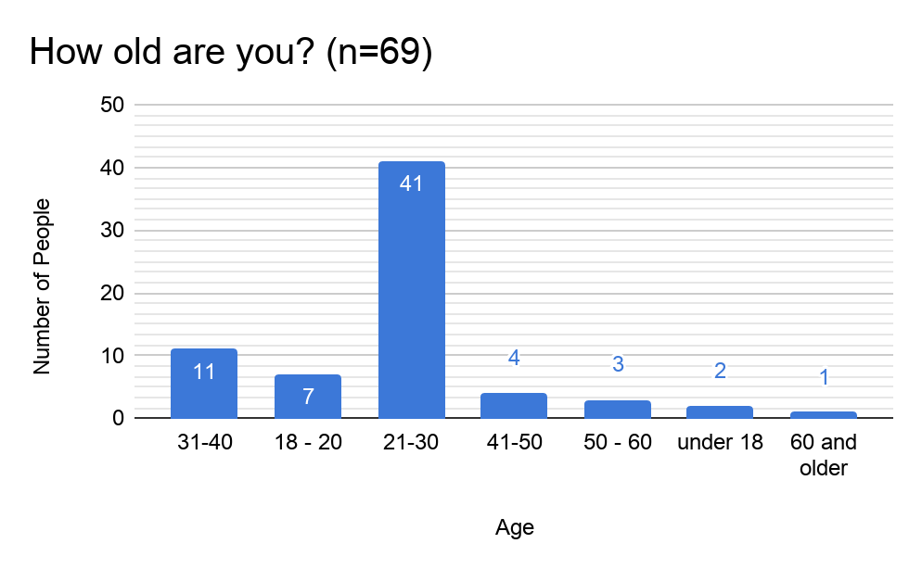

**Figure J.1: Age of Respondents**

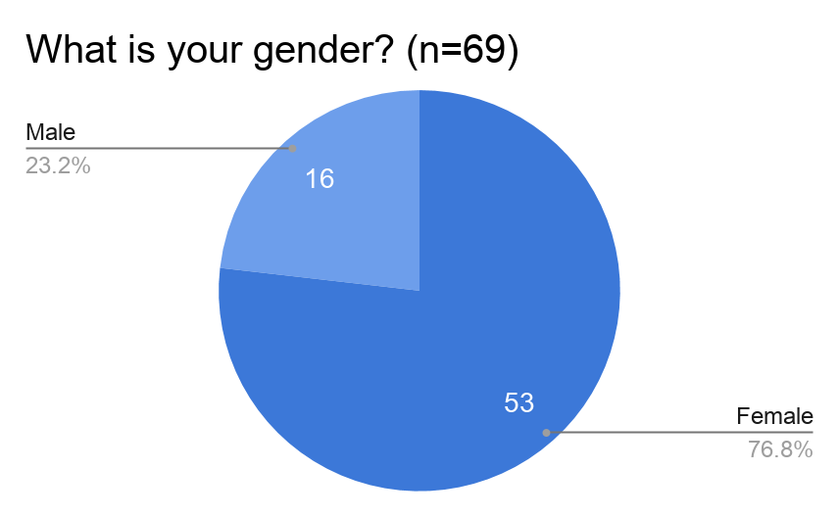

**Figure J.2: Gender of Respondents (Male, Female, Other)**

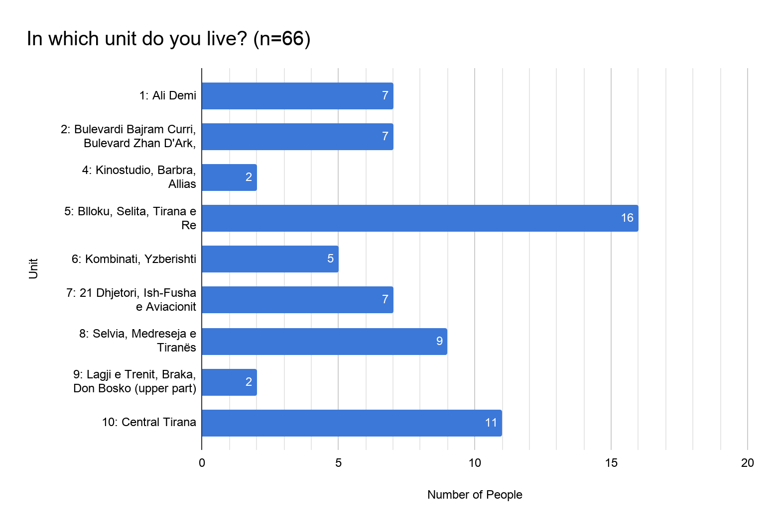

**Figure J.3: Residence of Respondents**

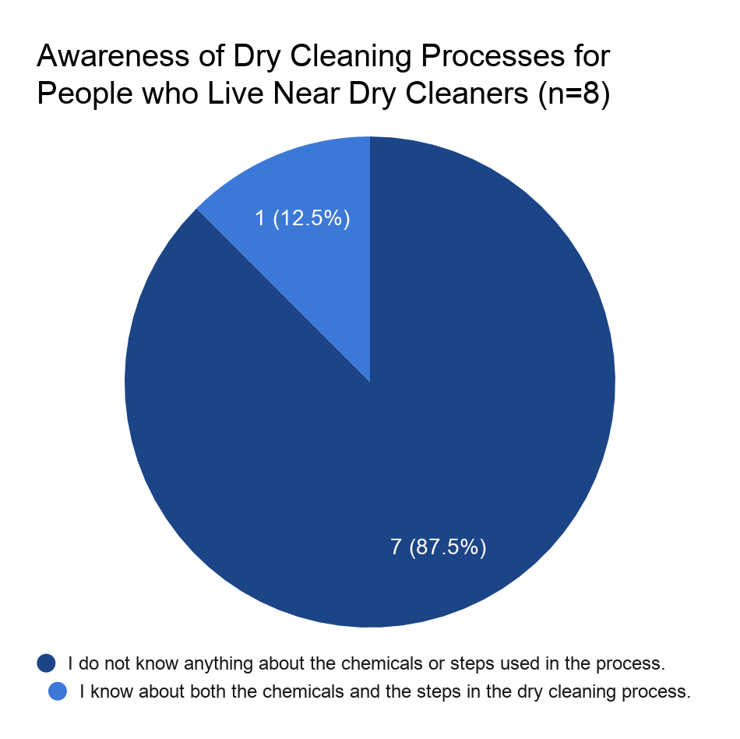

**Figure J.4: Awareness of Dry Cleaning Practices for People Who Live Near Dry Cleaners**

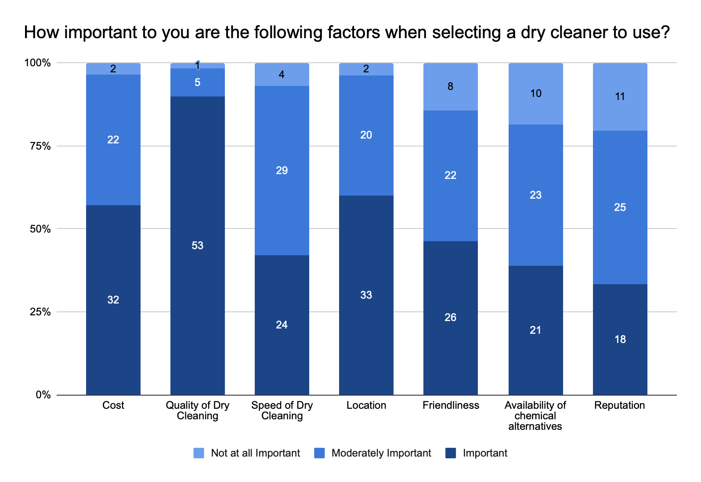

**Figure J.5: Importance of Factors to Respondents**

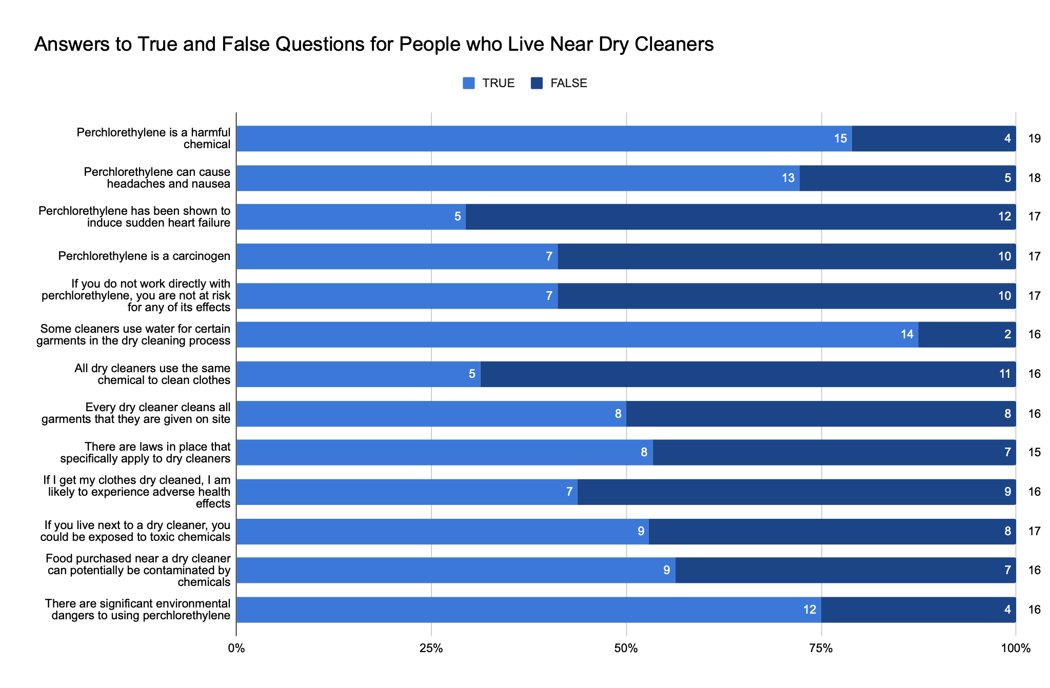

**Figure J.6: True/False Results for Respondents Who Live Near Dry Cleaners**

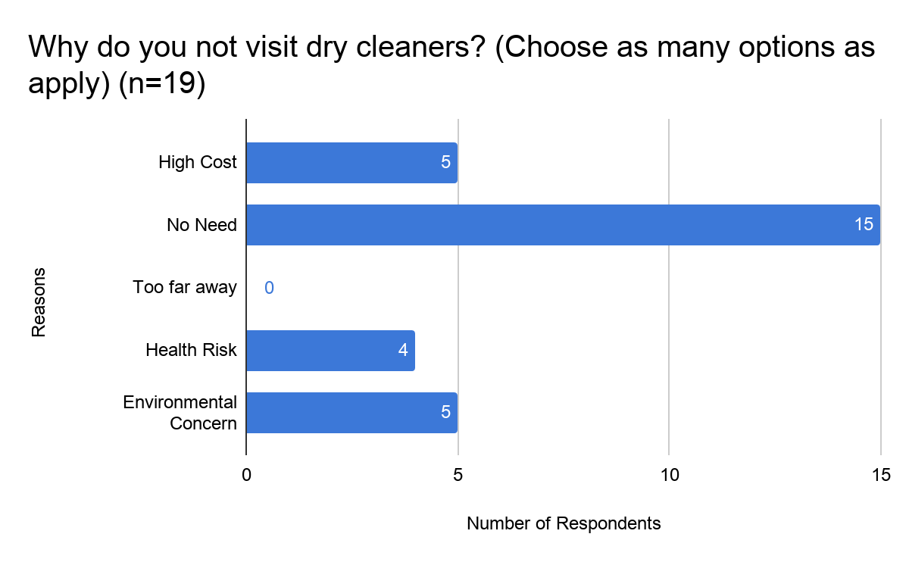

**Figure J.7: Respondent’s Reasoning for not Using Dry Cleaners**

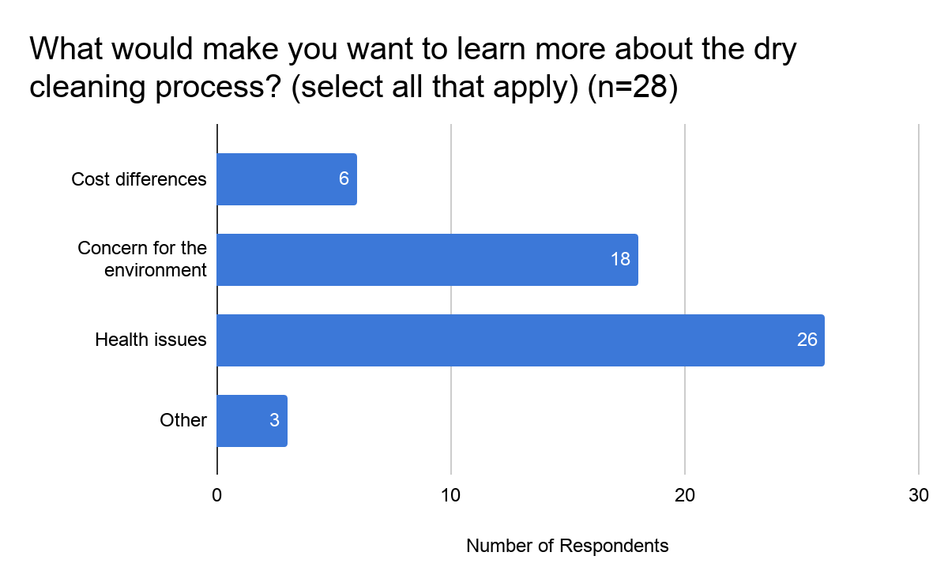

**Figure J.8: Reasons to Learn More About Dry Cleaning Processes**

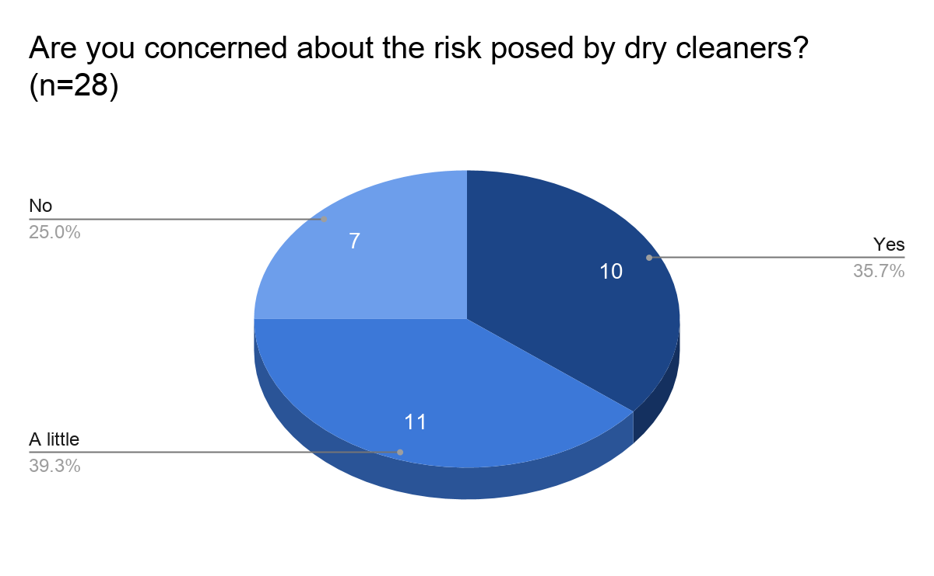

**Figure J.9: Concern About the Risks of Dry Cleaning**

# Appendix K: Deliverables

**Awareness Campaign Materials:**

These materials are (untranslated) flyers designed to be distributed as part of a potential activism campaign run by EDEN Center. The goal of this campaign would be to inform the public of the dangers of perchloroethylene, *without* directly attacking dry cleaners. The idea of the campaign is to remedy the fact that dry cleaners do not see adequate support for changing their machines and practices to greener alternatives. These materials could either be distributed digitally through EDEN Center’s social media, or physically as a printed flyer.

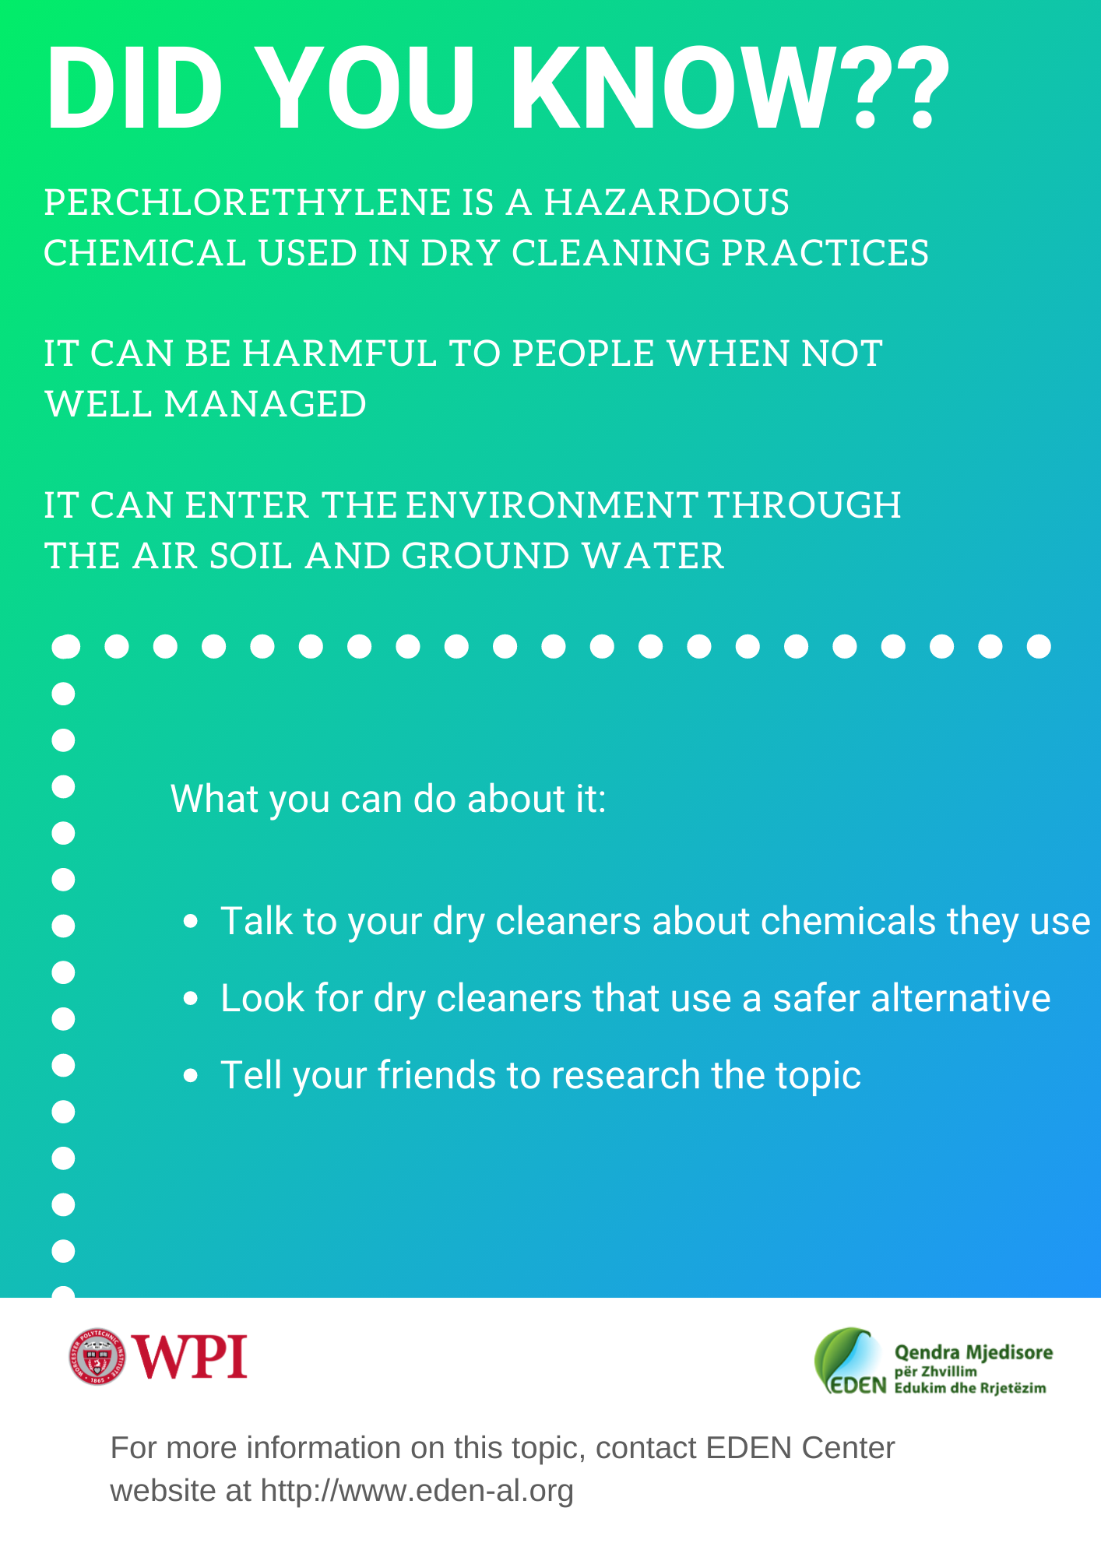

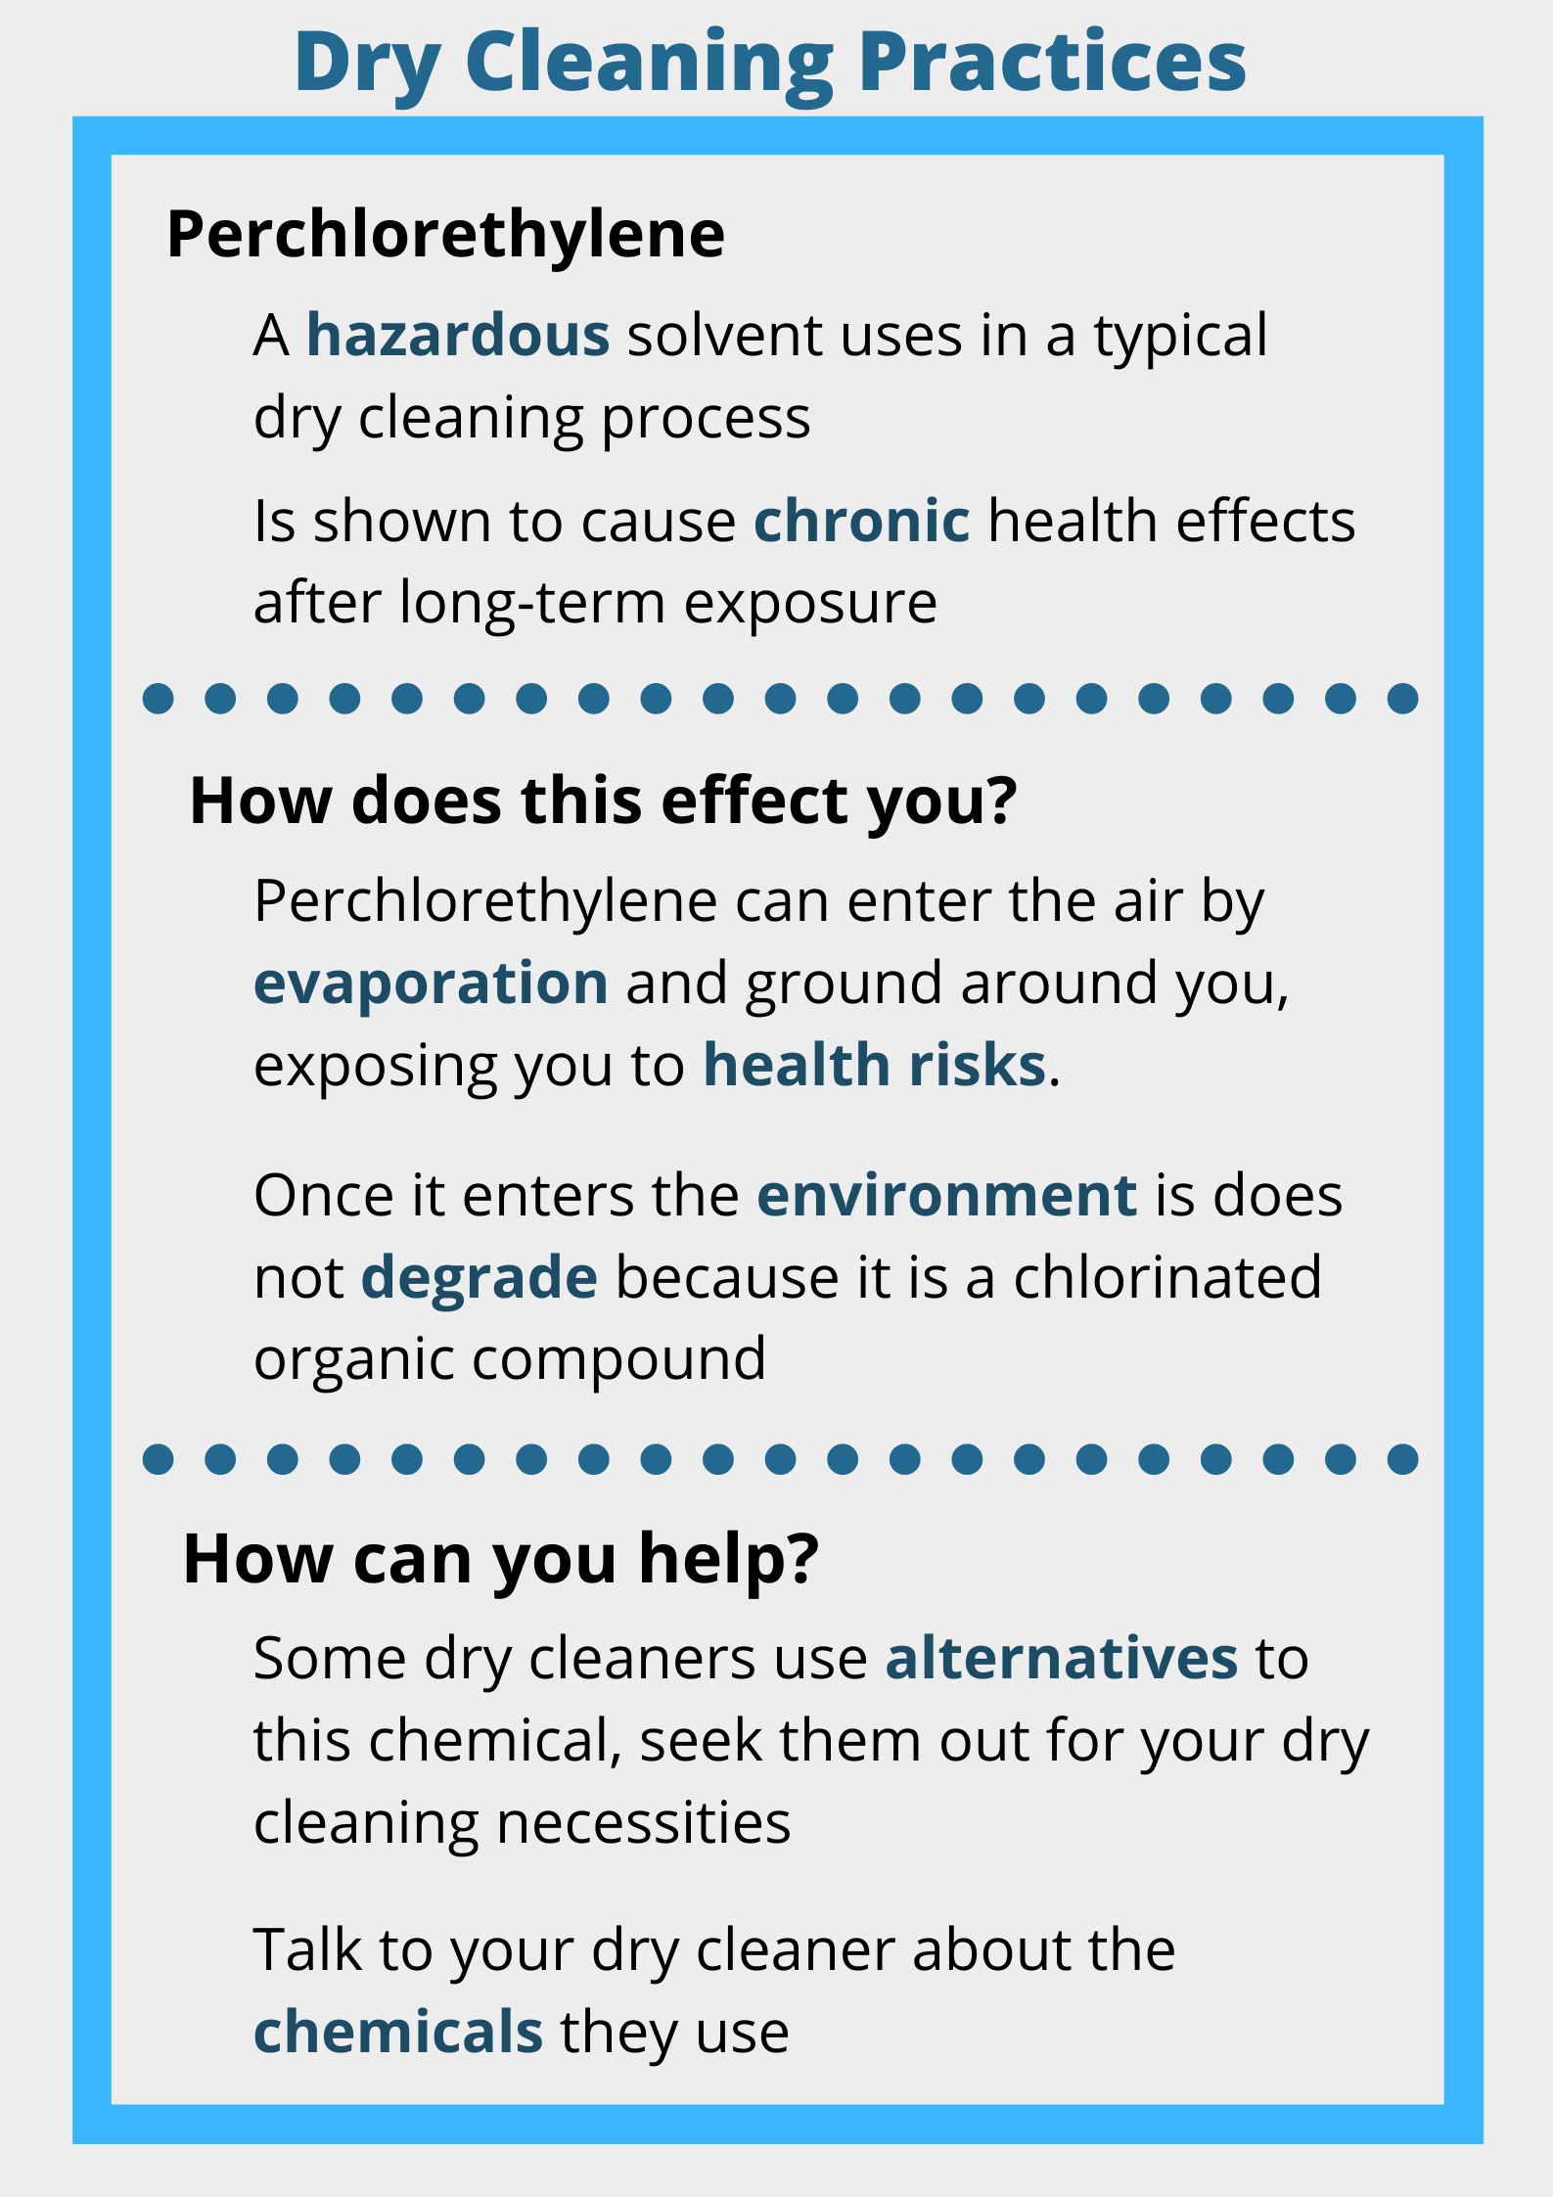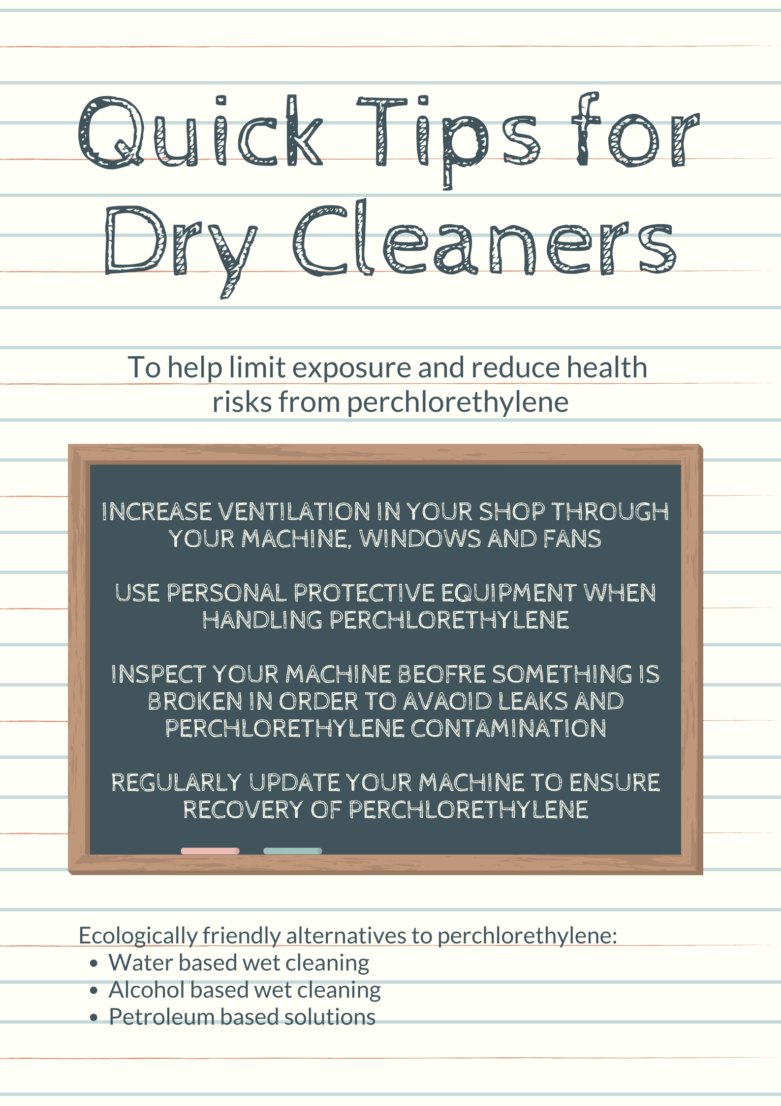

Dry Cleaning Safety Fact Sheet